Final Year Project Report

TEXCHAIN

#### BESE (Batch: 2017-18)

**Project Advisor**

**Submitted by**

Dr. Muhammad Mubashir Khan

Associate Professor, Department of Computer Science & Information Technology, NEDUET

Javeria Zafar SE-040

Maryam Nadeem SE-026



DEPARTMENT OF SOFTWARE ENGINEERING

**NED University of Engineering and Technology, Karachi**

**PREFACE**

This report comprises the summary of our work that we have achieved during our Final Year Project (FYP). We have chosen to develop a system through which any brand of textile industry can get to know the story behind their manufactured products. They can give orders to manufactures to get their products manufactured. They can trace the whole chain behind their products i.e. what kind of raw materials used and what is their origin. Similarly Manufactures can give orders of raw materials that will be used in their products to different suppliers through this system. This solution will bring a level of trust, faith and security among these entities i.e. brands, manufacturers and raw materials suppliers.

.

# ACKNOWLEDGMENT

In the name of Almighty Allah, the most merciful and the most beneficial, without whose blessings this would never have been possible.

First and above all we would like to thank Almighty Allah (SWT) for providing us this opportunity and blessings to finish this study successfully. We owe this project to many persons who helped and guided us during the development of this project. We would like to express our special appreciation and gratitude to our internal advisor **Dr. Muhammad Mubashir Khan** and **Dr. Muhammad Wasif,** PMP, Assistant Professor NEDUETfor their warm encouragement, thoughtful guidance and advices. Without their guidance this would not have been possible to achieve our goal. We highly admire the support, guidance, encourage, motivation of all of our teachers who taught and helped us during our academic time. We would also sincerely appreciate the whole- hearted co-operation and valuable help rendered by the non-teaching staff of university.

# GROUP MEMBERS



JAVERIA ZAFAR SE-040

A certified Full Stack Developer and Cloud Engineer with industrial experience in backend development, client dealing and business analysis.

* Group Leader
* Blockchain Smart Contract Development
* Block chain integration
* Backend architecture designing
* Database designing
* System integration
* Frontend Development
* Architectural & Research Work
* API Integration and testing
* Server-Side Backend Development

Immediate Contact: 0336-8534174, [javeriazafar06@gmail.com](mailto:javeriazafar06@gmail.com)



MARYAM NADEEM ABDULAH SE-026

A Certified Full Stack Developer with expertise in developing scalable frontend architecture.

* Frontend Development
* UI/UX Design and GUI
* API Integration
* Server-Side Development

Immediate Contact: 0334-3355821, [maryamnadeem821@gmail.com](mailto:maryamnadeem821@gmail.com)

### 

### NED University of Engineering and Technology, Karachi

**DEPARTMENT OF SOFTWARE ENGINEERING**

**CERTIFICATE OF COMPLETION**

This is to certify that the following students

|  |  |
| --- | --- |
| JAVERIA ZAFAR | SE-040 |
| MARYAM NADEEM | SE-026 |

have successfully completed their final year project titled

**TEXCHAIN**

in the partial fulfillment for the requirements of the Degree of Bachelor of Software Engineering during the academic session 2016-2017.

|  |  |
| --- | --- |
| **Dr. Muhammad Mubashir Khan**  Associate Professor, Department of  Computer Science & Information Technology, NEDUET | **Professor Dr. Najmi Ghani Haider** Chairman, Department of Software Engineering, NEDUET |

# ABSTRACT

**Opportunity:** Do you ever think about the back story of apparels that you are wearing? What kind of adventure have they been through? Quality is the main aspect that is the fundamental necessity of the textile industry. Now imagine if a new industry enters the market that does not know the supplier’s integrity in the supply of materials due to zero trust. So, will the industry be able to buy materials and goods from this supplier? How will a brand which is new in the market will be assured or build confidence to trust multiple manufacturing industries around them?

Therefore, our system aims to make life easier for both actors by applying a technology that can create trust between the system actors involved.

**Mission:** Information is the lifeblood of every supply chain. We plan to make the textile industry's supply chain transparent to both brands and manufacturers by developing a platform for the textile industry where the manufacturer has complete transparency about where the raw material gets into the whole system.

**Our Solution:** It covers the origin of the raw material which enters the entire system via the supplier to ensure the quality in relation to the requirements claimed by the supplier. It helps the manufacturer not only in purchasing the material from the supplier through a transparent and traceable process, but also the brands that buy the product from the manufacturers. We plan to craft a system that will help industries use modern technology to take their supply chain management to a whole new level.

**Market Focus:** For consumers, our target market would be focused around stakeholders in textile supply chain process i.e. Manufacturers, suppliers, Clients. For businesses, we initially aim to target small and medium scale enterprises having little to no technological solutions deployed for their sales and inventory management.

# TABLE OF CONTENTS

Contents

Final Year Project Report 1

PREFACE 2

ACKNOWLEDGMENT 3

GROUP MEMBERS 4

ABSTRACT 6

TABLE OF CONTENTS 8

LIST OF TABLES 11

LIST OF FIGURES 12

CHAPTER 1 – INTRODUCTION 17

* 1. Goals and objectives 17
  2. System statement of scope 17
  3. System context 18
  4. Theoretical Background (of project) 21
  5. Technology & Tools/hardware components (used in the Project) 22

CHAPTER 2 – USAGE SCENARIO / USER INTERACTION 26

* 1. 2.1 User profiles 26
  2. 2.2 Use-cases 26
     1. 2.2.1 Client-manufacturer: 27
     2. 2.2.2 Manufacturer-Supplier 28
     3. 2.2.3 Admin Panel: 29
     4. 2.2.4 Supplier Panel: 29
     5. 2.2.5 Manufacturer Panel: 29
     6. 2.2.6 Brand/Client Panel: 29

CHAPTER 3 – FUNCTIONAL AND DATA DESCRIPTION 31

* 1. System Architecture 31
     1. Architecture model 31
     2. Subsystem/modules overview 34
  2. Data Description 44

Major data objects 44

3.2.2 System level data model 51

* 1. System Interface Description 52

CHAPTER 4 - SUBSYSTEM/MODULE DESCRIPTION 63

* 1. Description of Authentication Module 64

Authentication Module Scope 65

* + 1. Authentication Module Flow diagram 65
    2. Authentication Module Components 66
    3. Restrictions or Limitations 67
  1. Description of User Creation Module 68
     1. Client Creation Module Scope 68
     2. Client Creation Module flow diagram 68
     3. Restrictions Limitations 69
  2. Description of Order raw material Module 69
     1. Order raw material Module Scope 70
     2. Order raw material Module flow diagram 70
     3. Order raw material Components 71
     4. Restrictions/Limitations 73
  3. Description for Raw material Authenticity Module 73
     1. Raw material Authenticity Module Scope 73

Raw material Authenticity Module flow diagram 74

* + 1. Restrictions/Limitations 74
  1. Description for Inventory Management Module 74
     1. Inventory Management Module Scope 75
     2. Inventory Management Module Flow Diagram 75
     3. Inventory Management Components 71
     4. Restrictions/ Limitations 76
  2. Description for Supply Chain Module 76
     1. Supply Chain Module Scope 76
     2. Supply Chain Flow Diagram 77
     3. Supply Chain Subcomponents 77
     4. Restrictions/ Limitations 80
  3. Description for Manufacturer Module 80
     1. Manufacturer Module Scope 80
     2. Manufacturer Module Flow Diagram 81
     3. Manufacturer Module sub-components 81
     4. Restrictions/ Limitations 83
  4. Description for Admin Module 84
     1. Admin Module Scope 84
     2. Admin Module Flow Diagram 84
  5. Admin Module Subcomponents 84
  6. Description for Supplier Module 80
     1. Supplier Module Scope 80
     2. Supplier Module Flow Diagram 81
     3. Supplier Module sub-components 81
     4. Restrictions/ Limitations 83
  7. Description for Brand Module 80
     1. Brand Module Scope 80
     2. Brand Module Flow Diagram 81
     3. Brand Module sub-components 81
     4. Restrictions/ Limitations 83

CHAPTER 5 - BEHAVIORAL MODEL AND DESCRIPTION 89

* 1. Description for system behavior 89
     1. Events/interrupts 90
     2. States 92
  2. Control specifications 101
     1. Control specifications for Brand/Client: 101
     2. Control specifications for Supplier 101
     3. Control specifications for Manufacturer: 101
     4. Control specifications for Admin: 102

CHAPTER 6 - SYSTEM PROTOTYPE MODELLING 103

* 1. Description of System Modelling Approach 103
  2. Prototyping Requirements 103

CHAPTER 7 - SYSTEM ESTIMATES AND ACTUAL OUTCOMES 115

* 1. System Estimates and Actual Outcomes 115

Historical Data used for estimates 115

Estimation based on COCOMO II 115

* 1. Actual Results and Deviation from Estimates 118
  2. System Resources (Required and Used) 119
     1. Man-force Required and Used 119
     2. Hardware Required and Used 120
     3. Software/Tools Required and Used 120

CHAPTER 8 - TEST PLAN 121

* 1. System Test and Procedure 121
  2. Testing Strategy 122
     1. Unit Testing 122
     2. Integration Testing 125
     3. Validation Testing 126
     4. High-order Testing (System Testing) 126
  3. Testing Resources and Staffing 128
  4. Test Metrics 128
  5. Testing Tools and Environment 129

CHAPTER 9 - FUTURE ENHANCEMENTS AND RECOMMENDATIONS 130

CHAPTER 10 - CONCLUSION 131

APPENDICES 132

**LIST OF TABLES**

|  |  |
| --- | --- |
| Table 01 – Statistics | 117 |
| Table 02 – Estimated Costs  Table 03 Actual and Estimated Results | 117  117 |
| Table 04 – Man-force Required  Table 05 – Hardware Required and Used | 120  120 |
| Table 06 – Software/Tools Required and Used  Table 07 – Login test case | 121  124 |
| Table 08– Authentication Module test case  Table 09– Inventory Management test case  Table10–Stock Management test case  Table11–Search Functionality test case  Table12–Order Placement test case  Table13–Block Chain test case  Table14–Sales/Purchase Order test case  Table15–QR Code Scan test case  Table16–User creation Module test case  Table17–Manage User Module test case | 124  124  125  125  125  126  126  126  127  127 |

**LIST OF FIGURES**

|  |  |
| --- | --- |
| Figure 1.1 –Solution | 18 |
| Figure 1.2 – Market Share | 19 |
| Figure 1.3 – Emergence of technical textile products | 19 |
| Figure 2.1 – Use Case Client-Manufacturer | 20 |
| Figure 2.2 – Use Case Manufacturer-Supplier | 21 |
| Figure 2.3 – Use Case Admin Panel | 27 |
| Figure 2.4 – Use Case Supplier Panel | 28 |
| Figure 2.5 – Use Case Manufacturer Panel | 29 |
| Figure 2.6 – Use Case Brand/Client Panel | 30 |
| Figure 3.1 – System Architecture | 32 |
| Figure 3.2 – Block Chain Model | 37 |
| Figure 3.3 – ERD | 39 |
| Figure 3.4 – Brand Panel | 42 |
| Figure 3.5 – Profile Page | 43 |
| Figure 3.6 – Brand purchase order | 43 |
| Figure 3.7 – QR Code | 44 |
| Figure 3.8 – Scanner | 51 |
| Figure 3.9 – Manufacturer Panel | 52 |
| Figure 3.10 – Add New Products | 53 |
| Figure 3.11 – Delete Products | 54 |
| Figure 3.12 – Manage Stock | 54 |
| Figure 3.13– Edit Quantity | 55 |
| Figure 3.14–Manufcaturer Profile Page | 56 |
| Figure 3.15 – Brand Request | 56 |
| Figure 3.16 – Negotiate Request | 57 |

|  |  |
| --- | --- |
| Figure 3.17 – Order Raw Material | 57 |
| Figure 3.18 – Place Order Tab | 58 |
| Figure 3.19 – Order Details | 59 |
| Figure 3.20 – Sales Order | 59 |
| Figure 3.21 – Supplier Delivery Status | 60 |
| Figure 3.22 – Supplier Delivery Status QR Code | 60 |
| Figure 3.23 – QR Code Scanner Page | 61 |
| Figure 3.24 – Supplier’s Panel | 61 |
| Figure 3.25 – Add New Item | 62 |
| Figure 3.26 – Manufacturer’s Request | 62 |
| Figure 3.27 –Check Inventory | 65 |
| Figure 3.28 – Sales Order | 66 |
| Figure 3.29 – Main Sign In Page | 67 |
| Figure 3.30 – Admin Panel | 69 |
| Figure 3.31 – Add new User | 70 |
| Figure 4.1 –Authentication Module Flow diagram | 71 |
| Figure 4.2 – Authentication Module-Login component Flow diagram | 72 |
| Figure 4.3 – User Creation Flow diagram | 74 |
| Figure 4.4 – Order raw Material Flow diagram | 75 |
| Figure 4.5 – Raw Material Authenticity Flow diagram | 77 |
| Figure 4.6 – Supplier Inventory Management Flow diagram | 78 |
| Figure 4.7 – Manufacturer Inventory Management diagram | 79 |
| Figure 4.8 – Supply Chain Flow diagram | 81 |
| Figure 4.9 – Manufacturer Module Flow diagram | 82 |
| Figure 4.10 – Manufacturer Module–Manage Inventory Flow diagram | 83 |
| Figure 4.11 – Admin Module Flow diagram | 84 |
| Figure 4.12 – Admin Module- Manage Users Flow diagram | 85 |
| Figure 4.13 – Admin Module-Manage Company Profile Flow diagram | 86 |
| Figure 4.14 – Supplier Module Flow diagram | 87 |

|  |  |
| --- | --- |
| Figure 4.15 – Brand Module Flow diagram | 88 |
| Figure 5.1 – State Transition diagram | 95 |
| Figure 5.2 – Supplier Inventory Updated State diagram | 95 |
| Figure 5.3 – Manufacturer Inventory Updated State diagram | 96 |
| Figure 5.4 – Authenticated State diagram | 96 |
| Figure 5.5 – User Records Updated State diagram | 97 |
| Figure 6.1 – Main Supplier Page | 104 |
| Figure 6.2 – Supplier Inventory | 104 |
| Figure 6.3 – Supplier Request | 105 |
| Figure 6.4 – Supplier Negotiate | 105 |
| Figure 6.5 – Admin-Manage Supplier | 108 |
| Figure 6.6 – Admin Manage Manufacturer | 109 |
| Figure 6.7 – Admin Manage Brand | 110 |
| Figure 6.8 – Manufacturer Inventory | 110 |
| Figure 6.9 – Manufacturer Stock | 111 |
| Figure 6.10 – Manufacturer Profile | 111 |
| Figure 6.11 – Manufacturer Requests | 112 |
| Figure 6.12 – Manufacturer Negotiate | 112 |
| Figure 6.13 – Manufacturer Search Supplier | 113 |
| Figure 6.14 – Manufacturer Order raw Material | 113 |
| Figure 6.15 – Brand Panel | 114 |
| Figure 6.16 – Place Order | 114 |
| Figure 6.17 – Order Status  Figure 7.1– COCOMO Estimation  Figure 7.2 – COCOMO Estimation Results | 117  118  119 |

# CHAPTER 1 – INTRODUCTION

Quality is the main aspect that is the fundamental necessity of the textile industry. Textile and clothing industry is one of the oldest manufacturing industries and is a major contributor in the economic growth of developing countries. However, from past few decades, it has been criticized for its opaque, unsecured and untraceable nature of supply chain. Now imagine if a new industry enters the market that does not know the supplier’s integrity in the supply of materials due to zero trust. So, will the industry be able to buy materials and goods from this supplier? How will a brand which is new in the market will be assured or build confidence to trust multiple manufacturing industries around them? Therefore, our system aims to make life easier for both actors by applying a technology that can create trust between the system actors involved.

### Goals and objectives

People especially millennial tend to distrust the spurious claim of sustainability and so consumers can make or break any event. Huge firms’ selling point has now become the transparency in their supply chain. In this project we add the blockchain technology. As reported by Forbes, Blockchain implementation will facilitate more intelligent business processes because the trust would be distributed, and the processes would be truly transparent. That is why brands and manufacturers need to give their consumers what they demand. Moreover, it helps in managing the stocks for the suppliers.

### System statement of scope

* + - Authenticating the product’s supply chain via Block Chain Infrastructure.

The system will contain the databases and transactions for the material coming from the supplier and checking it through QR code. It will be installed at manufacturer side and making disabled few options for the client and the supplier. We will use blockchain which can fetch any information starting with suppliers, then manufacturers and client within seconds. Moreover, Sustainability and compliance of goods can also be tracked through information from the blockchain on the raw

material and manufacturing processes used to make it. Consumers can now scan the tag and

discover the history of any garment.

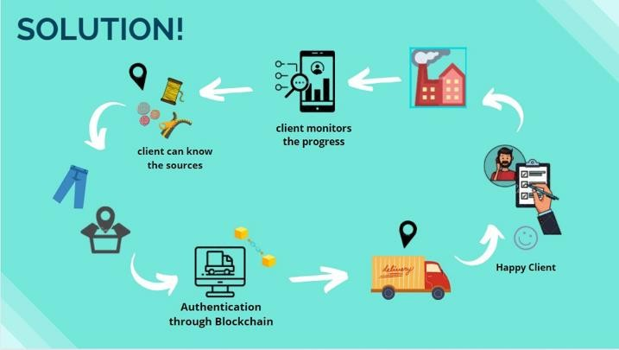

*Figure 1.1- Solution*

* + - Inventory Management:

When the manufacturing company takes in raw material from suppliers, they are unable to keep track of how much stock they already have in the warehouse of a particular item. Since it is not managed, they mistakenly order more items however it already is available in store. Thus, we kept this issue under consideration and made the stock management per merchandizer feasible for the company.

### System context

**Industry Type:** Textile Industry

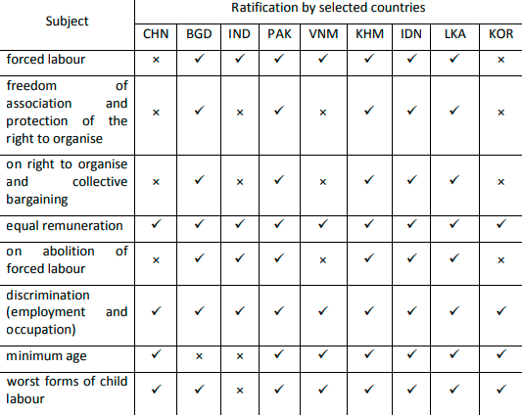

*Table 1.1- Statistics*

In 2013, the U.S. Customs and Border Protection (CBP), in collaboration with federal and nearby companies, conducted “Operation Red Zone.” In this, almost $17.3 million really well worth of faux wearing apparels like jerseys and ball caps were seized. Though government organizations do their excellent to triumph over counterfeit issues, they best control to seize a few.

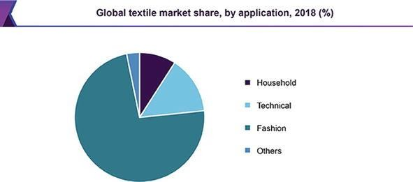

*Figure 1.2-Market Share*

The textile manufacturing processes are largely required by the fashion segment in the global textile market. The large amount of textile products, demanded by fashion, accounted for more than 65% of textile product market. Fashion market is followed by technical textiles and household products. Grand View Research indicated fashion, technical textiles, and household as the top three sectors by application for the global textile market in Figure 1.2

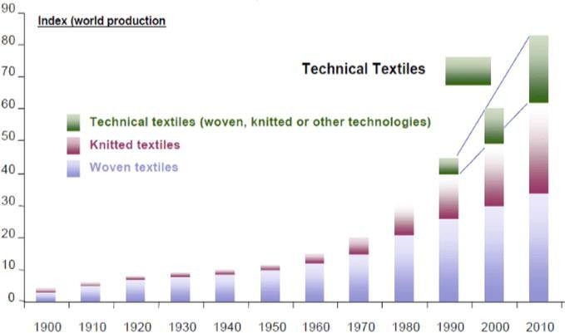

*Figure 1.3- Emergence of technical textile products*

The emergence of technical textile products was realized in the 1990s, in addition to the conventional woven and knitted textile articles. However, since then technical textiles showed phenomenal growth in Figure 1.3

**Blockchain: the solution for transparency in product supply chains:** We came across a white paper published by a UK based startup company by the name of Provenance that aims to solve the problem of transparency in the supply chain of different items through blockchain. This inspired us to adopt this strategy to implement transparency in textile supply chain in order to ensure authenticity of raw material being used in clothes manufacturing.

Our target market is categorized into two domains: the consumers and the businesses.

**Consumers:** Consumers are different brands/clients that will take our services to order their

products

**Businesses:** Initially, we aim to target small and medium scale industries that have not yet integrated computerized systems in their factories.

### Theoretical Background (of project)

In the past, lack of transparency in a company’s supply chain was seen as a competitive advantage. Businesses wanted to keep insight into their suppliers and manufactures as opaque as possible so that if no one knew where the supplies were coming from, no one could build identical apparel. Being engineering students, we came up with the idea to bring revolution to the textile industry with new emerging technologies. We first talked to our teachers about this challenging idea and went to have a discussion with a small-scale textile industry. After getting meaningful feedback from this experience, we then further refined our idea into a business model. Upon receiving favorable reviews and support from various stakeholders including industry and academia, we decided to take this idea further into the implementation stage.

We visited industry experts for their opinion. They appreciated our initiatives and efforts and suggested improvements on our product. This allowed us to incorporate the suggestions and improve our design and business logics.

Finally, with our tireless efforts, we finally got in deal with Zillion Exports We had worked on the implementation under their supervision and planned to bring it in the industry very soon.

### Technology & Tools/hardware components (used in the Project)

Throughout the design, implementation and testing phase of TexChain application we have used variety of tools and technology that helped us produce a complete running reminder application.

#### NODE JS

Node.JS is an open-source, cross-platform, back-end JavaScript runtime environment that runs on the V8 engine and executes JavaScript code outside a web browser. It brings event- driven programming to web servers, enabling development of fast web servers in JavaScript. We used this for all database related activities.

* + 1. **Ethereum**

Ethereum is a decentralized, open-source blockchain with smart contract functionality. Ether is the native cryptocurrency of the platform. After Bitcoin, it is the largest cryptocurrency by market capitalization. It enabled us to easily build our blockchain application**.**

* + 1. **Smart Contracts**

Smart Contracts are the agreement between two parties who are trading assets or performing transactions on the blockchain. It adds the business logic to the blockchain world. We used the solidity language to develop and implement our supply chain authentication logic using ERC721 Non Fungible Token standard.

#### NEXT JS

Next.js is an open-source development framework built on top of Node.js enabling React based web applications functionalities such as server-side rendering and generating static websites. We used it to develop the user interface (GUI front-end) of our application to give a professional look and great experience to our users. We integrated it with our Node JS application to call APIs.

#### Visual Studio Code

Visual Studio Code is a powerful source code editor developed by Microsoft for different platforms that comes with helpful GUI, syntax highlighter, auto-indentation and much more. We used it to write an efficient and well-organized code for React JS.

#### MYSQL Workbench

MySQL Workbench is a visual database design tool that integrates SQL development, administration, database design, creation and maintenance into a single integrated development environment for the MySQL database system. We have used this to design our database and manage it through different functions of it.

#### Postman

Postman is a collaboration platform for API development. We used it to build REST API calls, constructing HTTP requests with data and reading responses in an organized way. API testing was also done using it.

#### Infura Endpoint

Infura is a public node that is connected to all the public test networks of Ethereum as well as the main net. We deployed our smart contract to Rinkeby Test Network.

#### Google Sheet

Google sheets is an online spreadsheet program that helped us to smartly keep track of our daily/weekly tasks and mark their statuses in a shared document/sheet. Also we have used this to manage our research documents.

#### Trello

Trello is a web-based, list-making application. It is a kind of management tool. We have created our project board on this. It also helped us to keep our daily/weekly tasks and assign group member deadline to a particular task. We have also uploaded our all important documents on it like reports, presentations, research material etc.

#### Draw.io

Draw.io is a free online platform to create and edit diagrams of various categories with collaboration. We created organogram, work breakdown structure, architectural and other diagrams on it. for designing UML diagrams. We designed our use case, UML, state and data

diagrams using it in an efficient, fast and flexible manner.

* + - * 1. EXPRESS framework

Express framework will help in navigation through the pages to further enhance the experience. This framework needs to be installed to ensure the flow of system. Addition of frameworks might complex the system development, but it is one of the essentials in blockchain projects.

* + - * 1. NODEMON

NODEMON It is a library responsible for starting and operating the server whenever it detects a change in information. The updating information is controlled at the front-end, but NODEMON helps us detect the changes and keeps the server engaged whenever needed.

#### Git Hub

GitHub, Inc. is a provider of Internet hosting for software development and version control using Git. It offers the distributed version control and source code management functionality of Git, plus its own features. We have used this to work on our project collaboratively and efficiently. We have created several versions of our project through this service.

**CHAPTER 2 – USAGE SCENARIO / USER INTERACTION**

Every product, software or a service is well-defined for a group of people or a community, the end users of TexChain are defined below:

### 2.1 User profiles

There are four main users of our application; Admin, Textile Industry (Manufacturers), Client (Consumer) and Supplier.

**End user/ Client:** Clients or end users that are going to use our application to place order and authenticate some products they have purchased.

**Supplier:** Supplier who will initiate the process by creating items on the blockchain which will be bought by manufacturer.

**Manufacturers:** Textile companies who would keep a track of their supply chain on our system to ensure there is no breach in the chain through some counterfeit material.

**Admin:** People of our company manage the users on our system.

### 2.2 Use-cases

All use-cases for the system are presented and descriptions of each use cases and diagram (if applicable).

##### 2.2.1 Client-Manufacturer

Details:

***Actors***: End User / Client and Manufacturer

* + - 1. Description and Priority

Client is the one who wants to get their products ready from a manufacturer. Through this application a client can work with the manufacturer.

User places order and the respective Manufacturer will receive and fulfill the order.

User can also verify authenticity of product by scanning QR Code. We have made a supply chain contract that will save the product status from supplier to the client end. He can check this status through QR Code scan. Client can also view the status of the past orders like pending orders, fulfilled orders etc. When a client gives an order to the manufacturer, the manufacturer receives that order and further negotiate with the client. Manufacturer can manage the product of their company (add, update or delete products). Any of these tasks performed would be punched to Blockchain. The details added by a manufacturer on the blockchain apparel supply chain are immutable and transparent, making the brand company trace the origin of the product.

* + - 1. Stimulus/Response Sequences
         * He can view the profile of the manufacturer he wants to work with.
         * He then gives the order of the products to that manufacturer.
         * Along with the order he can also send the sample of the product so that there will be no mistakes in order. If the sample gets approved from the manufacturer side, then they will start working on the client's order.
         * Also, time of completion, price and other important aspects will be negotiated and set at that time.
         * Manufacturer can view the order request coming from different clients from his dashboard.
         * Manufacturer can receive the sample coming from a client and if he agrees on that deal then the deal will be confirmed and processing on that order will be started.

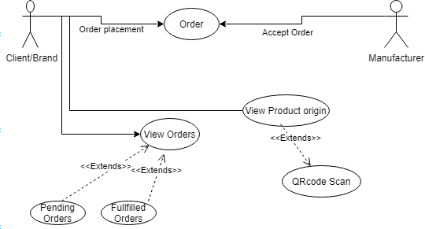

*Figure 2.1- Use Case Client-Manufacturer*

##### 

##### 2.2.2 Manufacturer-Supplier:

Details:

***Actors***: Manufacturer and Supplier

* + - 1. Description and Priority

After taking the order from the client, manufacturer will order all the raw materials that will be used in the making of the ordered products. Manufacturers would send the order details based on the raw materials’ requirement to various suppliers. This application works for all the entities involved in the supply chain of a particular product. Manufacturer, who is basically the producer of the product, will also be able to order the raw materials from different suppliers.

Stimulus/Response Sequences

* + - * + He can search through his dashboard for different suppliers of raw materials like buttons, zippers, threads, labels, tags etc.
        + He can also go through all the items a particular supplier is offering.
        + Then he can contact the supplier in a way that he can send a detailed attachment of the requirements and negotiate about the price of the item he wants to order i.e moving into the negotiation mode.
        + Then he can simply place the order of the item he wants.
        + Supplier will create the delivery of the required product and then manufacturer has to accept that delivery.
        + Manufacturer can also verify the originality of the raw material provided by supplier to the manufacturer through the QR code provided by the supplier. He can simply scan the QR code of a particular order.
        + Manufacturer can also view the status of the past orders from different suppliers like pending orders, fulfilled orders etc.

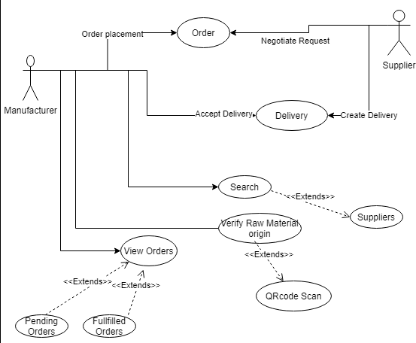

*Figure 2.2- Use Case Manufacturer-Supplier*

##### 2.2.3 Admin Panel

Details:

***Actors***: Admin **Description:**

Admin can create accounts for the clients of three categories: Client/Brand, Supplier and manufacturers. So that these users can use the application and collaborate each other efficiently. Only Admin has this authority to registered any kind of users in the application. He can create a new user by adding his/her credentials i.e name of the company, location, phone numbers etc. They can assign account addresses and private addresses to these users so that these users can access their dashboards by running supply chain contracts through these account addresses. Admin will provide a unique Password to all users so that they

can login in the application by using these passwords. Admin manage the data of these users i.e they can update their data, delete any user or add new users to the application. Admin can manage our company Profile. It may further upload company’s official documents.

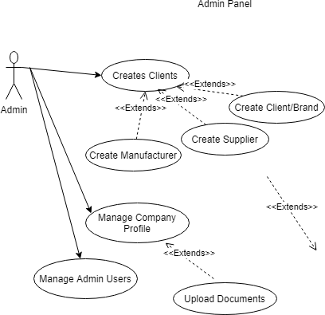

*Figure 2.3- Use Case Admin Panel*

##### 

##### 2.2.4 Supplier Panel

Details:

***Actors***: Supplier **Description:**

There is a separate dashboard for suppliers. When suppliers receive the order details, they can send their price quotes to the manufacturer. Once the manufacturer approves it, smart contracts notify suppliers to process the order. A supplier would then pack the order and add a QR code on boxes, containing information like fabric name, type and quantity. QR code’s hash ID would be saved on the blockchain, enabling a manufacturer to verify the authenticity of the material inside the box.

Supplier will update his profile from his dashboard and can manage the items to be shown on his side. Suppliers can manage their inventory on our systems and perform add, update and delete operations on the raw material which will be punched onto the blockchain. When they have any new material so they can simply add that product to their inventory so that this detail can be shown to the manufacturer. They can delete the product when the product is not available also, they can update any information of the product.

Supplier can view all the purchase orders of the past orders through purchase orders tab. This tab includes the details of all the past orders which include manufacturer name, date of the order, pricing etc.

Suppliers can also view their orders history as per the categories; fulfilled orders, pending orders or expired orders that have reached the reservation time limit and were never fulfilled.

Suppliers can manage the requests coming from manufacturer through manage request tab. They can see what kind of request are coming from manufacturers and then they can check availability of the product ordered so that they can further negotiate with the manufacturer about the pricing and dates of delivery. Also after confirming to the request, he will ship the order safely to the manufacturer’s premises.

When they make delivery completely, they can change the status of the order to delivery created so that manufacturer will be updated about this situation. Manufacturer will then

accept the delivery created when they actually receive the raw materials. In this way the whole two-way communication between the manufacturer and supplier will be completed. Supplier is the one who will initiate the supply chain contract, all the information will be updated on this contract and this information will be tracked by other entities.

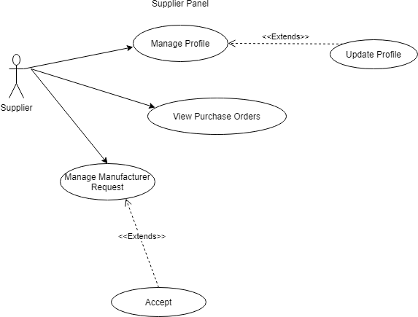

*Figure 2.4- Use Case Supplier Panel*

##### 

##### 2.2.5 Manufacturer Panel

Details:

***Actors***: Manufacturer **Description:**

Manufacturer can create the product when they have any new product available and add that product to their inventory. They will add all the details related to their product in this

inventory. Manufacturer can delete the product if a certain product is unavailable, they can also update the product if there is any change in their information.

If the ordered product is not available in their inventory, then they will create this product. They will order the raw material from different suppliers. For ordering the raw material the manufacturer will select any supplier and then go through all his product and order any product. Manufacturer can also check the status of their order by the QR code provided by the suppliers on each order which they can scan and just check the status of their products.

And if the product is available, he will negotiate with the client further. Also, he will update the status of the order, so that the client can view the progress of his orders. A manufacturer makes the product and links QR code with it, containing the details like raw materials used, the supplier’s information, the origin of production, manufacturing date, procedure and quality standards.

When Client wants to trace the order to its origin so he can do it by scanning the QR code provided by the manufacturer to the client. There will be a new QR code generated for each order, which will be provided to the client.

Manufacturer can also update their company profile so that the same profile will be shown to the client’s end.

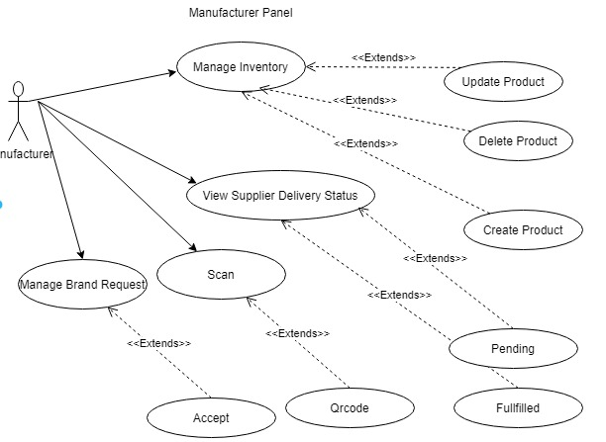

*Figure 2.5- Manufacturer Panel*

##### 2.2.6 Brand/Client Panel

Details:

***Actors***: Brand/Client **Description:**

Brands can order their product from manufacturer. For ordering they have to fill the form in which they have to specify the details about the products they want, the date of the order and some other details. By submitting this form, they will create a request and this request will be shown in the manufacturer panel When manufacturer will accept this request and provide a QR code to the brand of the particular order, brand can check the status of their

order by scanning the QR code. When they scan this QR code the whole chain behind the product will be shown to the brand. This chain including the raw materials used while manufacturing of the product, the kind of treatments provided to the product, the employees involved in the product. Through these details, the brand can know about the originality of their product. This will create a level of faith among the manufacturer and a brand.

When order will be completed by manufacturer, the status of the order will be changed to fulfilled, otherwise the order will remain as pending. Brand can also manage his profile by adding his details into the profile. He can also update or change the information he has provided in his profile page anytime. When brands scan the QR code of any particular order, the smart contract of blockchain will fetch the complete chain of the product that was initiated from the suppliers end to the manufacturer end to the brand.

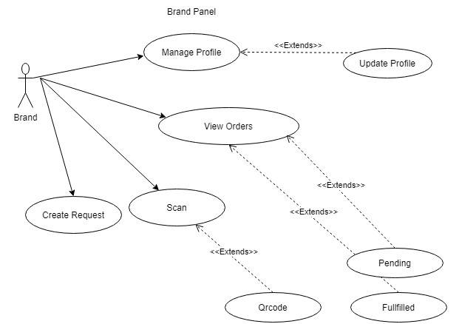

*Figure 2.6- Brand Panel*

# CHAPTER 3 – FUNCTIONAL AND DATA

**DESCRIPTION**

This section provides an outline of the TEXCHAIN model, its integral parts and major data objects involved and their relationship that flows in the system. It gives us basic understanding about system architecture, how the data objects interact with the system and the overall workflow. The overall running process and the data and interface description is briefly described in this section below.

### 3.1 System Architecture

In order to build a scalable, efficient and maintainable software system, we have built a layered architecture for separation of concern, scalability and maintenance. Each later is independent of each other as they are configured separately for each process. These independent layers can be replaced by multiple implementations if needed.

##### 3.1.1 Architecture model

Architecture of system is presented here. This includes detail description of system and system diagram.

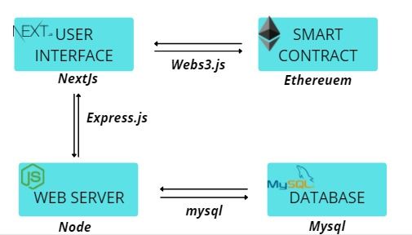

*Figure 3.1- System Architecture*

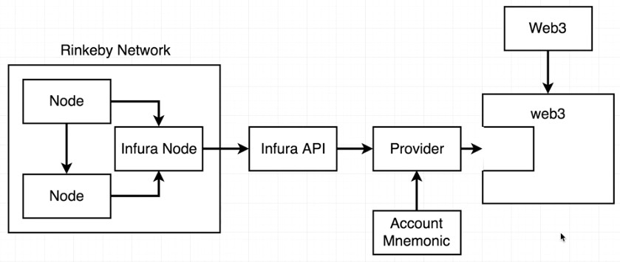

*Figure 3.2- Block Chain Model*

* + - 1. **Front-End Layer**

This layer is entry point for external interaction with the application. It incorporates all these technologies.

###### Next JS

Nextjs.org. Next. js is an open-source development framework built on top of Node. js enabling React based web applications functionalities such as server-side rendering and generating static websites.

###### AXIOS

Axios is a framework that forms as a middleware between the ReactJS and the NodeJS to carry out the transactions to MySQL database that contains the information of the system. It helps NodeJS and ReactJS interact smoothly so that they can keep interacting with one another when the information on screen needs to be updated rapidly.

###### WEB 3.JS

Web3.js is a collection of libraries that allow you to interact with a local or remote Ethereum node using HTTP, IPC or WebSocket. In order to interact with the Ethereum network, we need to send json-rpc calls to an Ethereum node, which is what web3.js does under the hood.

###### Redux

Redux is a library or a pattern which is used for the management of the state of the applications. It provides a centralized data storing facility called a “store” which is used across the entire application, but this store or the data inside the store can only be modified or updated in a predictable and particular manner. It consists of three main components i.e., Stores, Reducers and Actions.

#### React-Redux

As we are using react and redux together, so react-redux is a library which binds redux with our UI library, react. It is necessary to bind react with redux in order to interact with the store from our react components.

#### Back-End Layer

This layer handles database interaction of the application, and the location where database related queries are done. It also describes the interaction of front-end with back-end.

###### Node JS

NodeJS is known to be a non-block and event driven JavaScript. The file format of the NodeJS is unified with other versions of JS i.e. JSON. The rationale for using it is the two- way connection it provides to the system.

###### My SQL Workbench

My SQL Workbench is a visual database design tool that integrates SQL development, administration, database design, creation and maintenance into a single integrated development environment for the MySQL database system. We have used this to design our database and manage it through different functions of it.

* + - * 1. EXPRESS framework

Express framework will help in navigation through the pages to further enhance the experience. This framework needs to be installed to ensure the flow of system. Addition of frameworks might complex the system development, but it is one of the essentials in blockchain projects.

* + - * 1. NODEMON

NODEMON It is a library responsible for starting and operating the server whenever it detects a change in information. The updating information is controlled at the front-end, but NODEMON helps us detect the changes and keeps the server engaged whenever needed.

* + - * 1. POSTMAN

POSTMAN framework POSTMAN is used for testing the system’s POST and GET requests. The implementation can’t be directly deployed and therefore needs to be tested with dummy requests and outgoing information. The testing is very crucial part in a blockchain system, because once deployed the records will keep adding to the chain, which means no tolerances for alteration to the working mechanism.

#### Blockchain Layer

This is our blockchain layer where our Next JS code interacts with the Ethereum blockchain and calls smart contract functions deployed on a public network.

The application will be using the multiple technologies such as ReactJs, NextJs and the Ethereum network.

* + - * 1. Solidity Smart contracts

Smart contracts on a blockchain can store arbitrary state and execute arbitrary computations. End clients interact with a smart contract through transactions. Such transactions with a smart contract can invoke other smart contracts. The difference between the JS declarations and solidity declarations is that, in solidity we have to declare the type of variable first and then set its scope for example public, so that it is viewable to everyone. As the contract service is used and each time a transaction is carried out, GAS will be charged, which means we can run the loops as Ethereum simply does not allow that.

* + - * 1. Ethereum

Ethereum is a decentralized, open-source blockchain with smart contract functionality. Ether is the native cryptocurrency of the platform; among cryptocurrencies, it is second only to Bitcoin in market capitalization.

* + - * 1. Infura

Infura provides the tools and infrastructure that allow developers to easily take their blockchain application from testing to scaled deployment - with simple, reliable access to Ethereum.

***3.1.2 Subsystem/Modules overview***

Our subsystems are categorized into four Modules.

* + - * The instantiation and deployment of smart contract
      * Validation of transaction hashes
      * Role Based Access Control
      * Blockhain module

**The instantiation and deployment of smart contract**

When the user with particular permissions like Supplier/Brand/Manufacturer/Admin enter the dashboard they execute the contract methods by first instantiating a web3 object using an instance of a provider in order to enjoy all that web3 has to offer. After which the contract can be instantiated to make transactions. These transactions make a unique transaction hash which can be seen on Rinkeby Transaction hash website under the contract address of our Smart Contract.

**Validation of transaction hashes**

When the user uses the contract method and transaction hash is generated, the Rinkeby EtherScan website lets us keep all our transactions at one place. Upon entering the transaction on EtherScan we can see the details of the transactions which are completely immutable in nature. That means whether any detail is modified in future, it may not decieve anybody as the first transaction made on blockchain remains there permanently and can be used to verify the modifications in the Ledger.

**Role-based Access Control**

Role based access controls refers to the restricting the access to the system to some authorized users. It is an access-control mechanism which is built around privileges and roles. As our application has multiple users including the super admin, manufacturers, supplier and the end-users that is the brand/client, so implementation of role-based access control was a must. The users in our application can only access features according to their roles and privileges assigned by us. Each user only sees or access features, which have been designed for them and has no control or access over features which do not concern them.

**Blockchain module**

Ethereum provides a set of integrated libraries like Web3, Accounts, Managed Accounts, ABI Translators, RPC Requests, Key Stores and HD Wallets to perform our transactions on the chain **Common Interfaces** Contains the contract operations for common deployment function and contract information for receiving the ABI, Bytecode and Transaction Receipts. The ABI and BYTECODE are key elements which are used to insatiate the contract.

The above diagram illustrates the process of deploying our smart contract on the Rinkeby or Ropsten Test Network. Infura is a freemium tool to manage our blockchain deployments on their node instead of building the blockchain architecture from scratch on our computers which would take days and are highly complex. Infura allows us to create a project on their website and use their generated API endpoint to connect to ethereum network. In order to communicate with the node, we need a Web3 provider with our Ethereum account injected in it. This is how we can communicate using our authenticated blockchain mechanism.



**3.2 Data Description**

Top-level data objects that will be managed/manipulated by the TEXCHAIN application are defined below:

##### 3.2.1 Major data objects

Data objects and their major attributes in TEXCHAIN application are described in this section: CLIENT:

{

"client_id": 1, "client_name": , "ManufacturerId": "lason", "manu_id": 1, "user_id":"2" , "description": "brand"

EMPLOYEE:

{

"employee_id": 1, "employee_name": "Ahmed" , "prod_lone_id": 1,

"machine_id": 1, "working_hour":"2"

}

INVENTORY:

{

"inventory_id": 1, "manu_id": "Ahmed" , "employee_id": 1,

"quantity_left": 1, "prod_id":"2",

"merch_id":"2",

"prod_id":"2", "shipment_date":"2", "order_date":"2",

"client_id":"2"

}

MANU_SALES_ORDER

{

"mso_id": 1,

"user_id":52,

"merchandizer": " JINNAH56", "upc": " SU800",

"descript": " need 67 cartons by monday " , "SCOCreatedAt": "2021-08-04 03:03:35" ,

"quantity": 1 ,

"status": " Request created ",

}

MANU_STOCK

{

"stock_id": 1, "batch_no": " B_0003", "upc": " SU800"

"merch_id": " JINNAH56", “item_left”: 1,

"CreatedAt": "2021-07-31 17:36:33"

}

MANUFACTURER

{

"manu_id": 1, "manu_name": " zillion", "user_id": 1, "description": " exporter", "image": "",

“tx”: “”,

“date” : “2021-08-25”

}

PRODUCT:

{

"product_id": 4,

"merch_id": "Talha002 javeria89 ", "employee_id": " " ,

"machine_id": " ", "createdAt": "22/4/2021",

“stitchcode”: “BR(BARTACK)”, “product_upc : “ZIL-001”, "cost_sku": 5,

"pattern " : " ", "quality_inspection":2, “sewing”: “passed”,

“cutting” : “passed”, "washing " : "pending", "finishing": "pending", “raw_item_upc”: “”

}

REQUEST_BY_BRAND:

{

"breq_id":10 ,

"sample": " Api Documentation.docx ",

"description": " i want 50 jeans by 22 october by dhl at UK " , "user_id": 36,

"RequestCreatedAt": "2021-07-22 15:41:12", “status”: “Delivered”,

“product_upc” : “ZIL-001”, "merchandizer": 7

}

REQUEST_BY_MANUFACTURER:

{

"req_id":17 ,

"quantity": 1, "upc": " SU800 " ,

"merchandizer": " Ahmed-001", "material": " zipper ", “description”: “need by monday”, “user_id” : 57,

"RequestCreatedAt": “2021-08-07 10:09:31”, "status": “Delivered” ,

“suser_id” : 52

}

SALES_ORDER:

{

"sales_order_id":18, "merch_id": 7,

"sample": " Api Documentation.docx " , "SOCreatedAt": " 2021-08-31 01:03:44",

"status": " Accept Delivery ", “product_upc”: “ZIL-001”, “req_id” : 10

}

SUPP_SALES_ORDER:

{

"sso_id":271, "upc": " SU800",

"merchandizer": " JINNAH56" ,

"material;": " zipper ",

"descript": " need 67 cartons by monday ", “POCreatedAt”: “2021-08-31 00:44:31”,

“quantity” : 2,

"user_id": 52

}

SUPPLIER_ITEM:

{

"item_id":48, "Suser_id": 52, "quantity": "632 " ,

"upc: " SU800",

"price": "400", “material”: “zipper”, “longitude” : “77 6”,

"latitude": “89 66 77” , "image " : " zipper.jpg ",

"ItemCreatedAt": "2021-07-31 14:53:36 "

}

USER

{

"user_id": 57,

"user_name": " Denim manufacturer ",

“privatekey” : " dd0771907b760c1cd6e19acc3bc51e7fe32d2661ab1fa7b4e52cef20cfc051f2 ", "role_id": 1,

"account_address": "0x6829b48374596ada2b7cba811697454ed950c71e ", "email": " [denim@gmail.com](mailto:denim@gmail.com) ",

“location” : " karachi ", "password":

"$2b$10$2yV7HmN1ReZRozbXYxMeyO9DwPqUXtySS.N.wI82MtKaBf4XEB8mC "

}

USER_ROLE

{

“role_id” : 1,

“role_name” : “manufacturer”

##### 3.2.2 System level data model

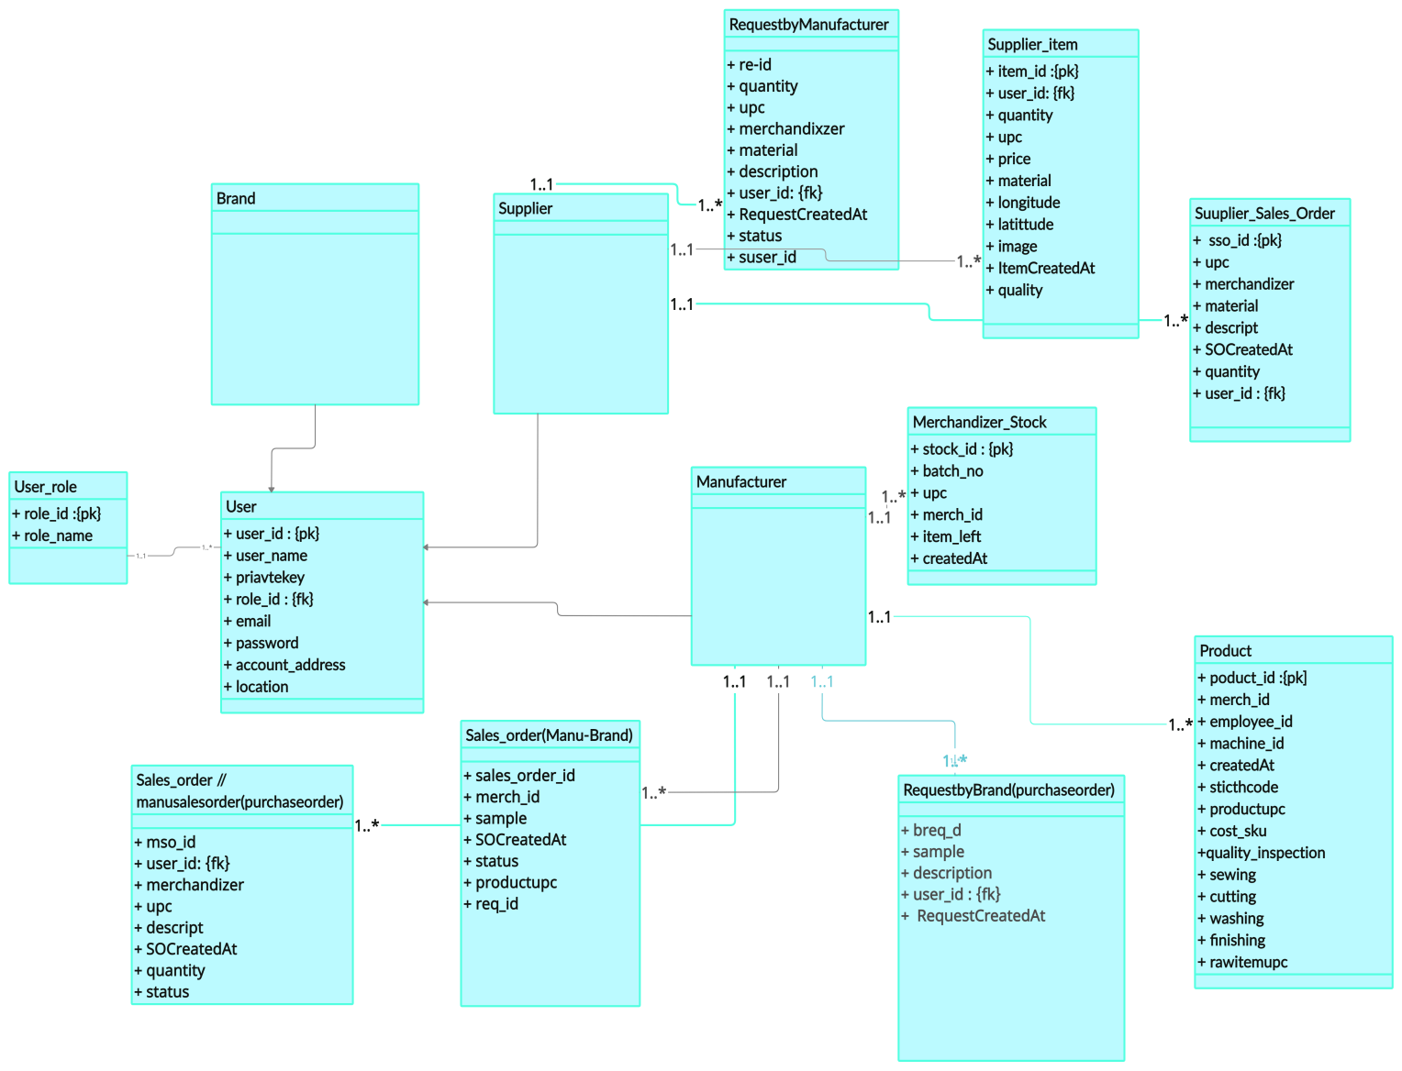

*Figure 3.3- ERD*

## 3.3 System Interface Description

The System’s interface(s) to the outside world are described.

The System’s interface is how the end users and other profiles of our system perceive TEXCHAIN application. It is a user-friendly web application.

Interface would be different for different user profiles or categories which is as follows:

##### 3.3.1 Client/Brand:

Brand can login through main page by the credentials given by administration. If sign in was successful, they will be directed to the brand Panel’s Order products page. Here they can give order to the manufacturer registered in this application. They can give any specification they want about

the product and can provide sample pictures also. Few details of the manufacturer is also shown on this page.

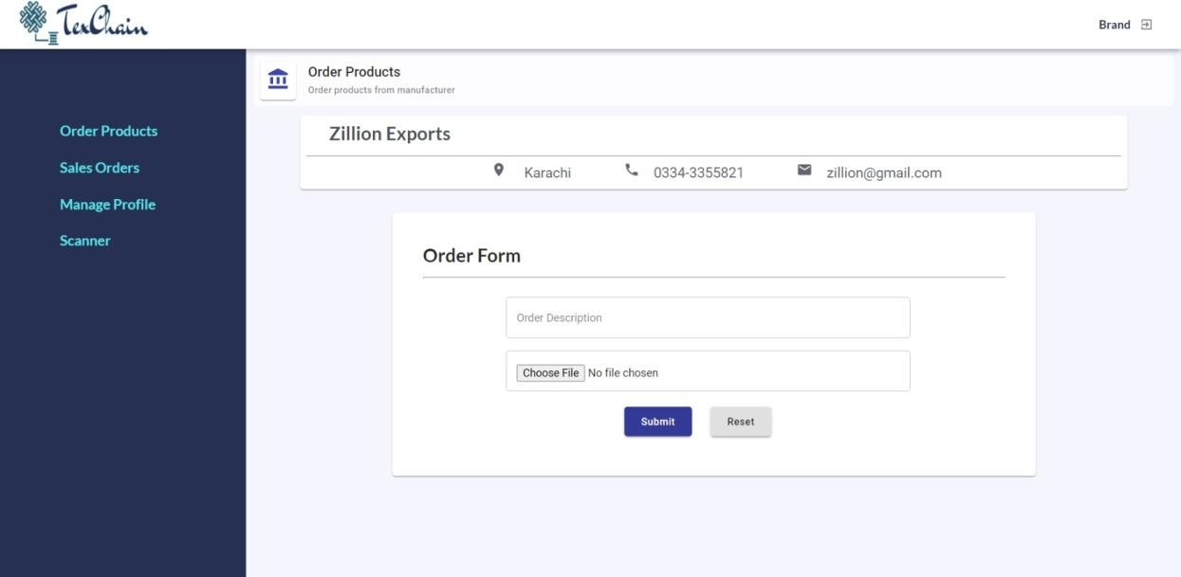

*Figure 3.4- Brand Panel*

There is also a profile page, where brand can enter their details and can also edit that profile information if they think there is any change.

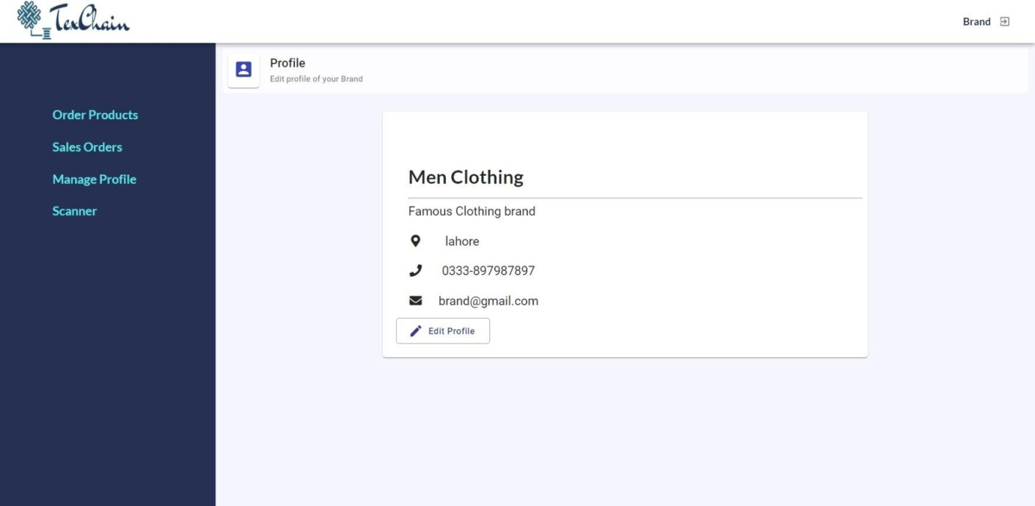

*Figure 3.5- Profile page*

From side menu they can navigate to any other page. This is a purchase order page. In this page all the orders of that brand will be listed like if any order is completed or some are in progress. The status of all order is shown with them.

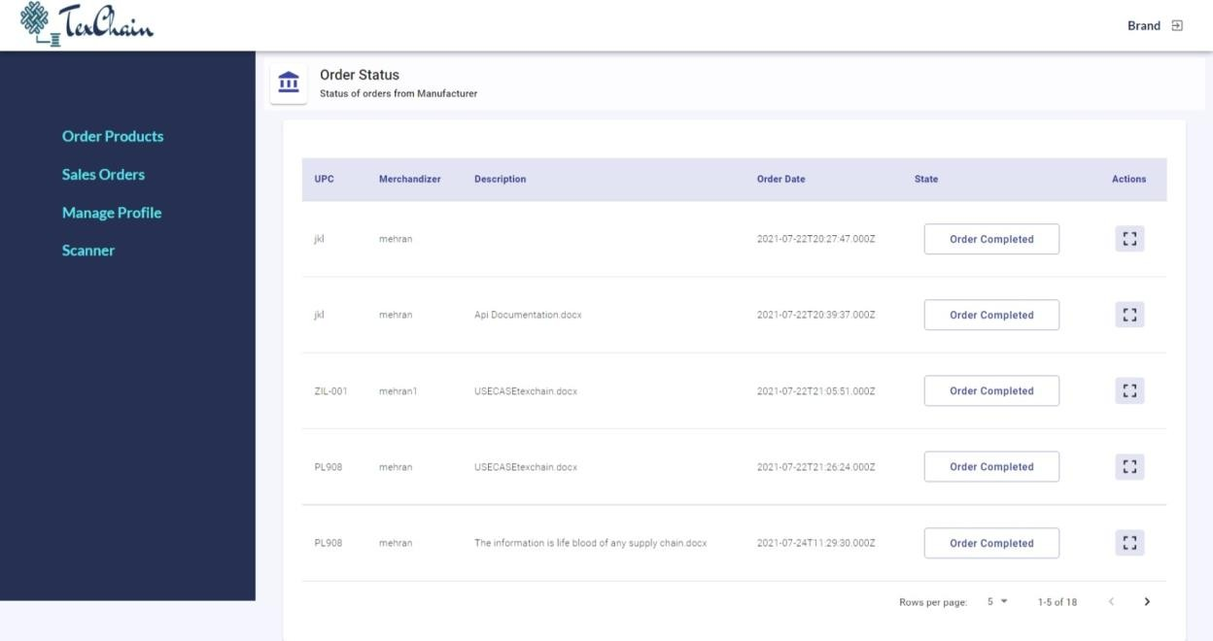

*Figure 3.6- Brand purchase orders*

A QR Code is also provided with all sales orders so that brands can track their product to its origin. They have to take picture of the QR code of the order which they want to track. And then scan that QR code later to know about the details of their product.

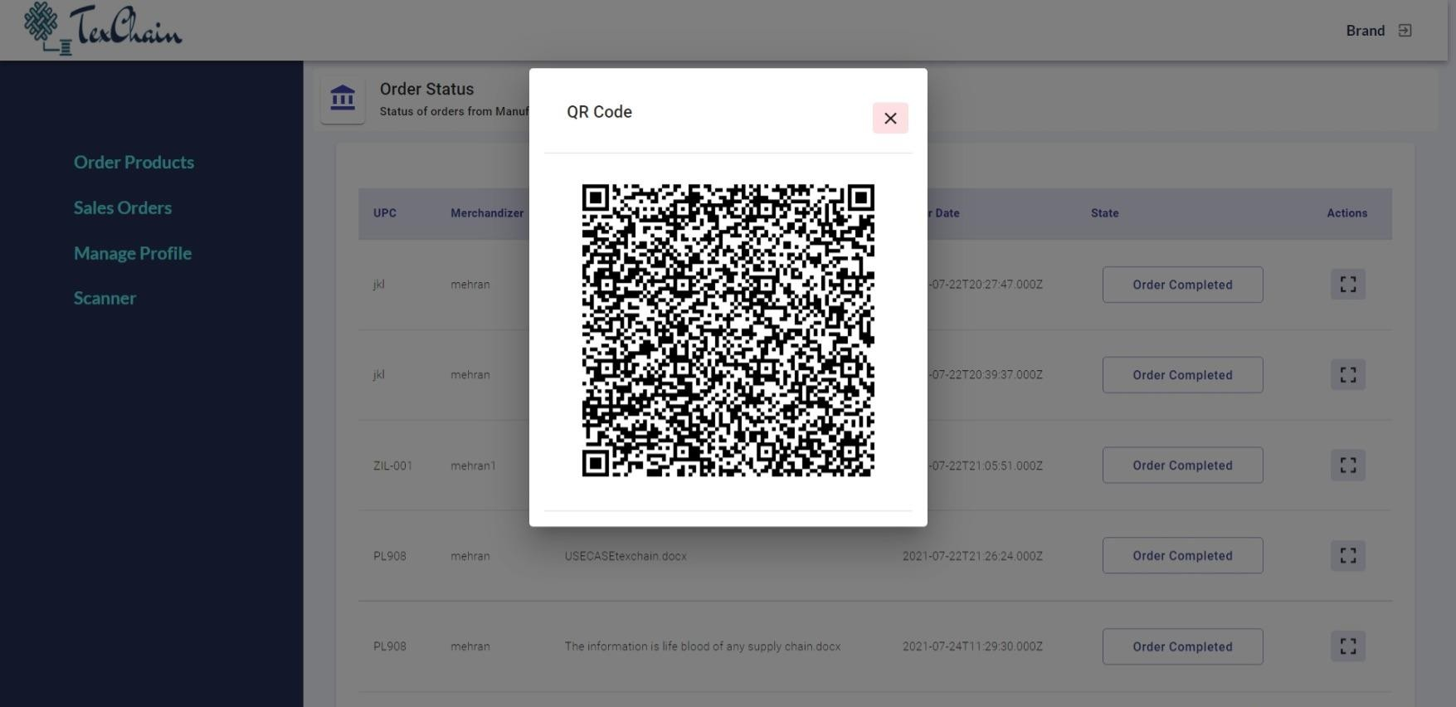

*Figure 3.7- QR Code*

There is a scanner page, in which brands can scan the QR code which was provided with every order. When they scan this QR code the whole chain of the particular product of the order will be shown to the brands, so that they can be remain informed about their product’s status. This whole functionality is implemented through the blockchain technology.

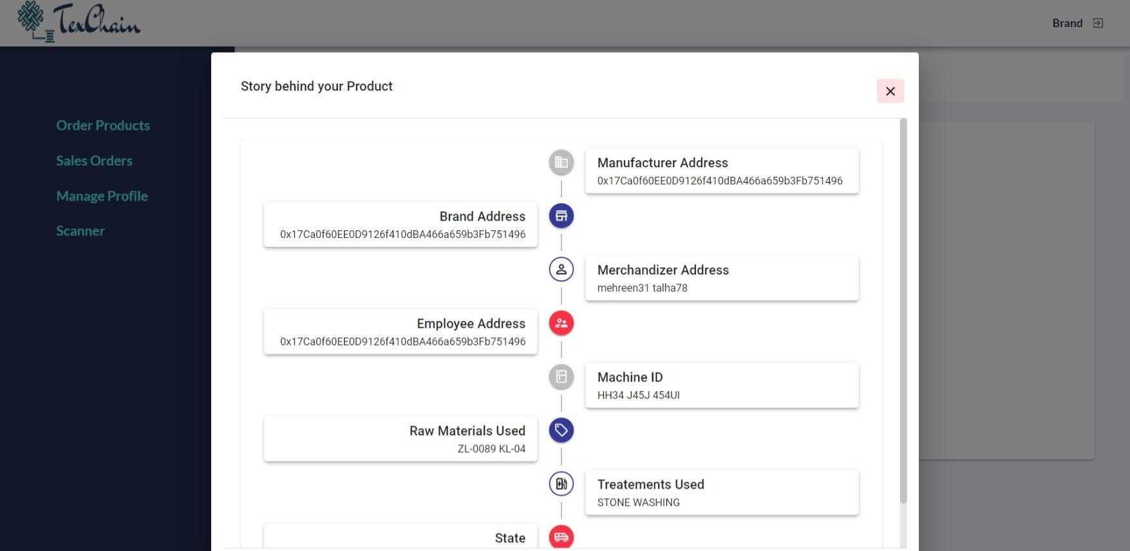

*Figure 3.8- Scanner*

##### 3.3.2 Manufacturer:

Manufacturer is the one who owns a manufacturing company. Brands gives order to manufacture their products to these manufacturers, and they in turn manufacture the product by using different raw materials and get the product delivered to supplier’s premises safely.

When manufacturer logged in with the credentials provided to them, manufacturer dashboard will get opened, where they can add completed products to the inventory. Also, they can edit and delete any product if they want. They can also search any particular product with product’s upc.

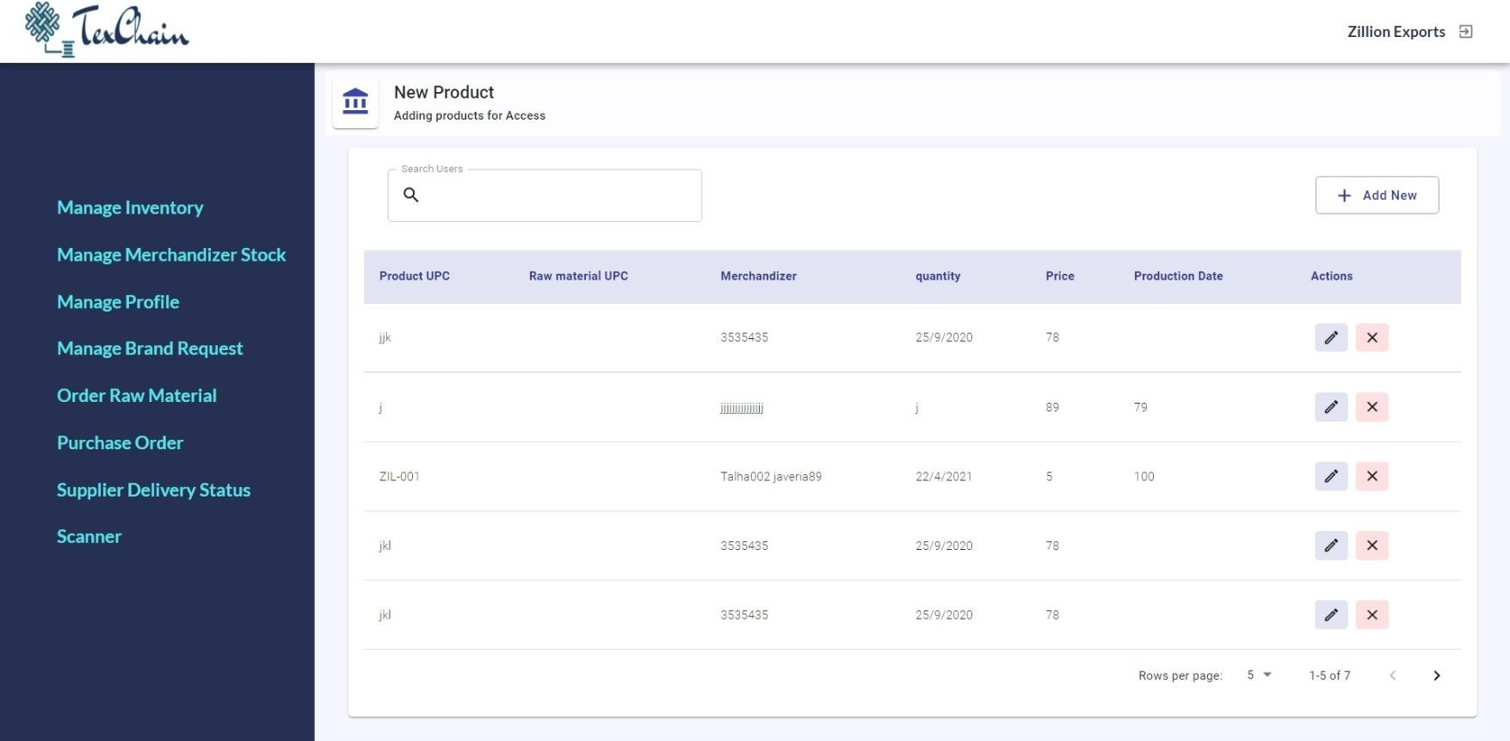

*Figure 3.9-Manufacturer panel*

Inventory Management module has the options to add, edit or delete products in the inventory. For already present products, he will be able to edit the information or delete it.

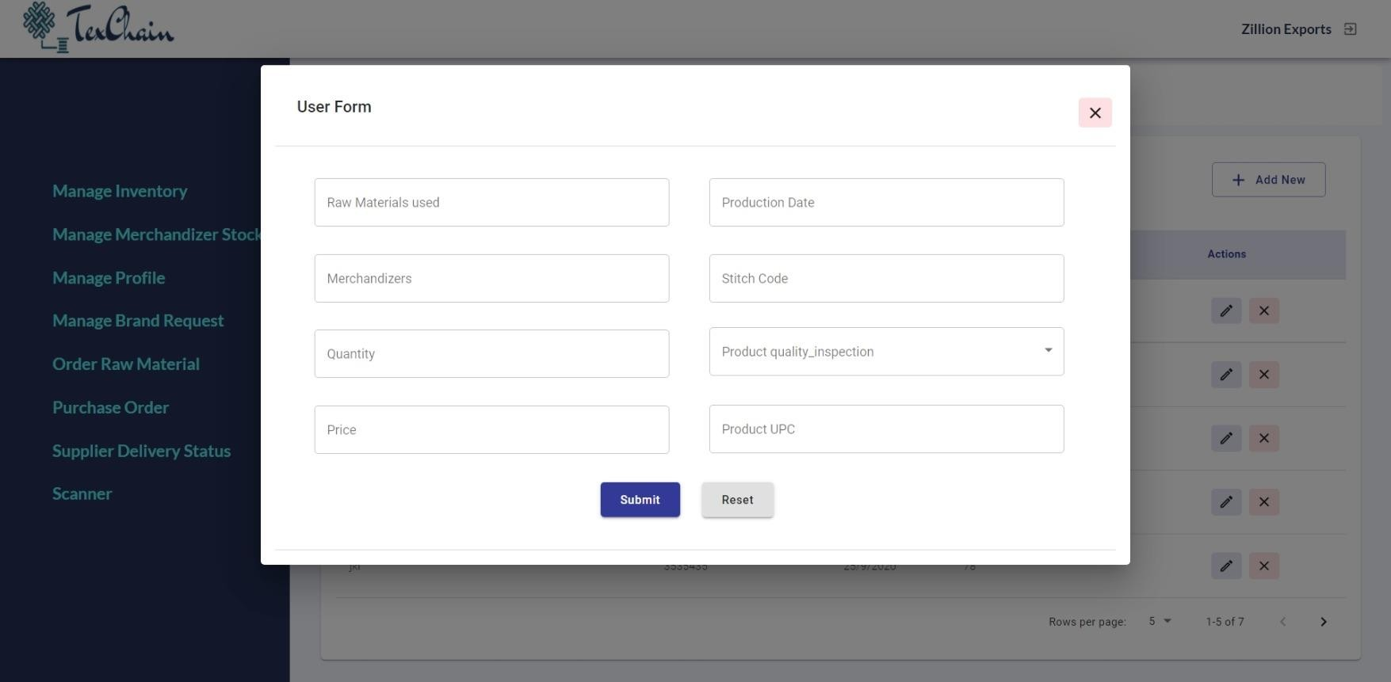

*Figure 3.10-Add New Product*

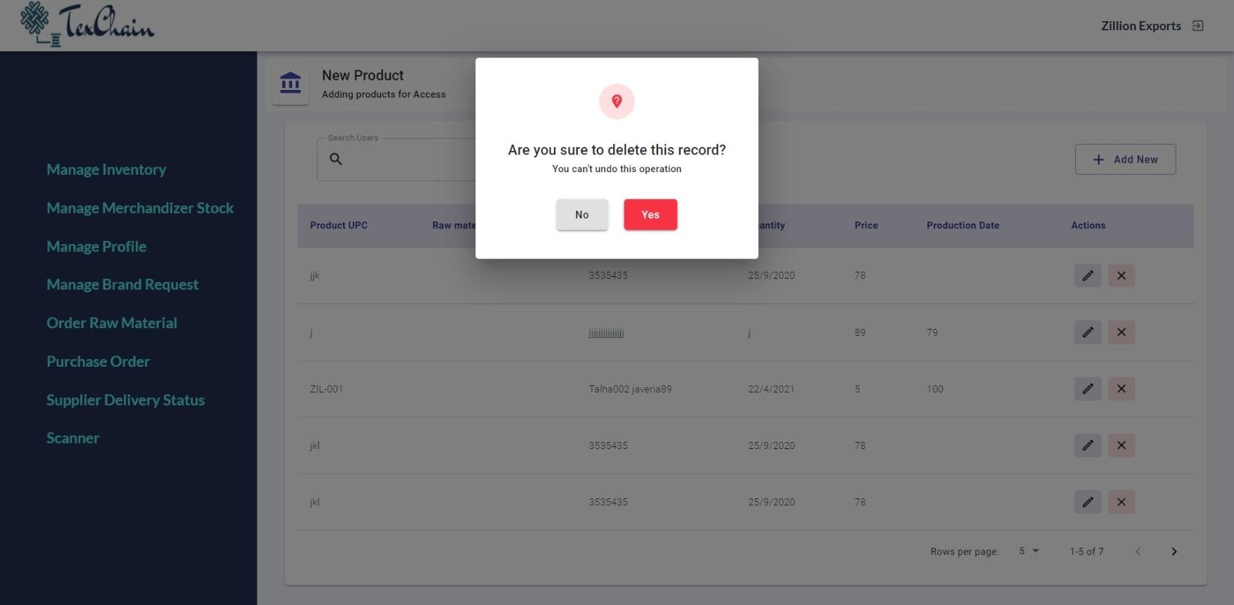

*Figure 3.11-Delete Product*

Merchandizer Stock is the record of all the raw materials manufacturer have. All the raw Materials which manufacturer had ordered from different suppliers is listed in this page. And if some is being used in the manufacturing of products, they can deduct it from here by editing its quantity. This helps manufacturer in efficient stock management.

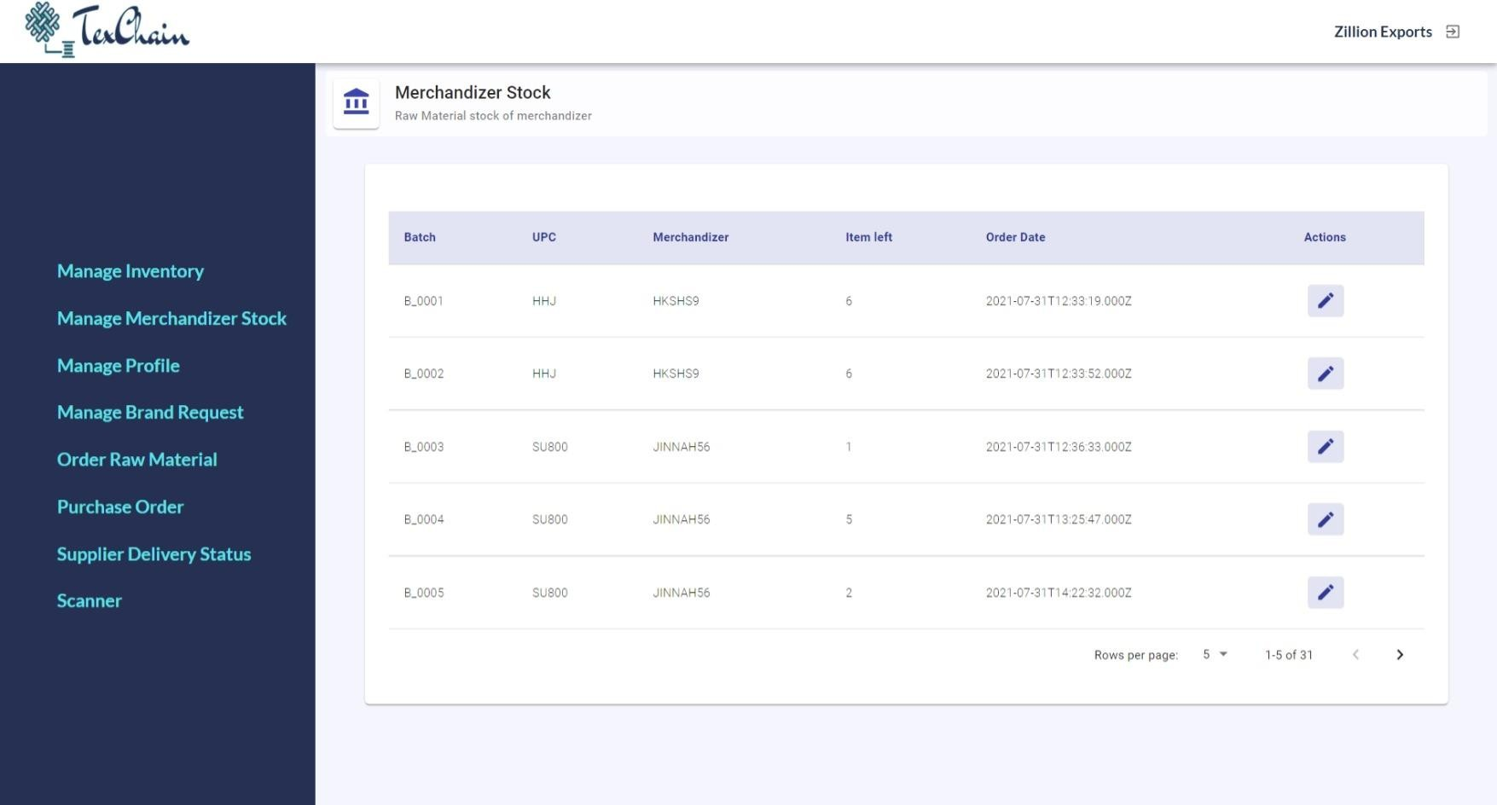

*Figure 3.12-Manage stock*

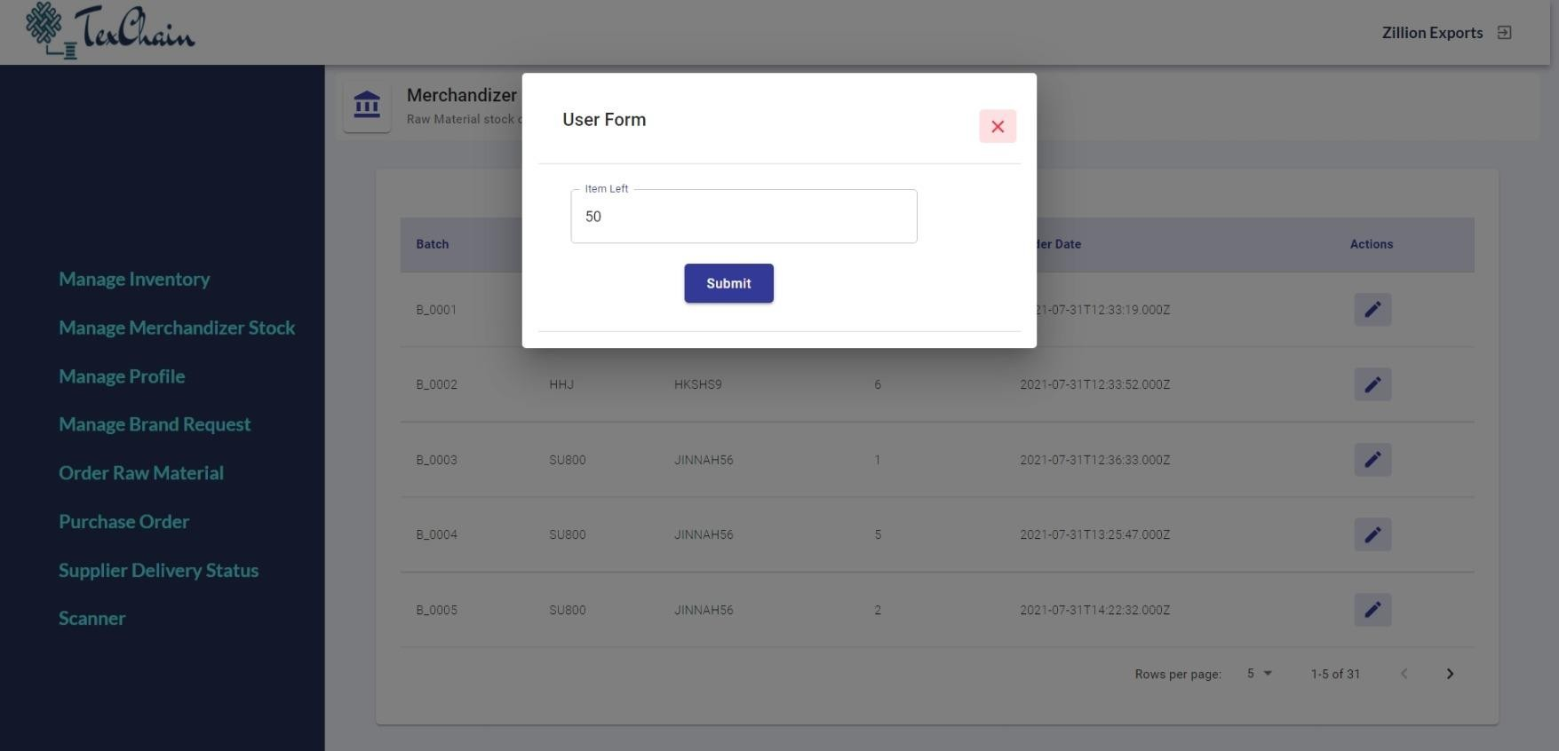

*Figure 3.13-Edit Quantity*

Manufacturer can have their respective details, in order that the brands can have knowledge about the manufacturer they are dealing with. This information is by default shown on this page because of the data provided at the time of registration. They can also edit their details if there is any change in information.

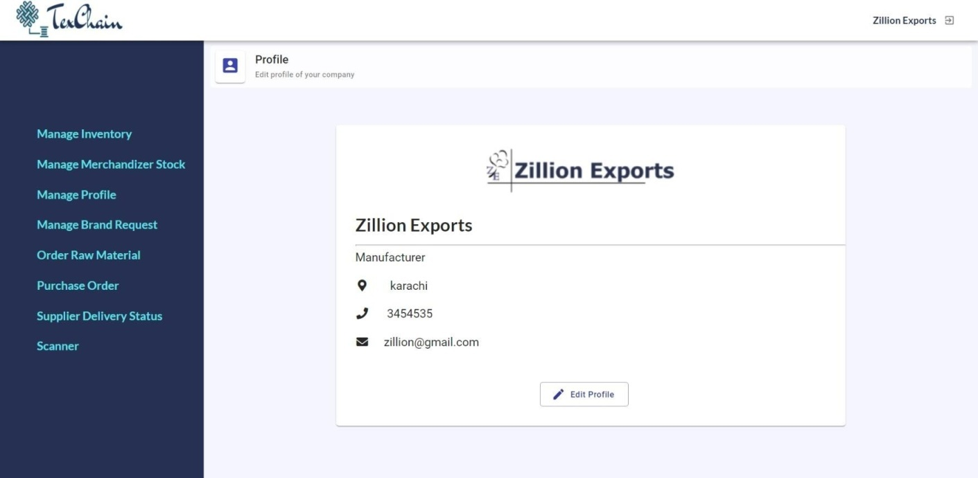

*Figure 3.14-Manufacturer Profile Page*

When any brand wants to place order, so they will create request and that request will be shown on this page. All the details of the order are displayed on that request. If brand provides any sample file of their order, manufacturer can download that file. They can also search any particular order by its name.

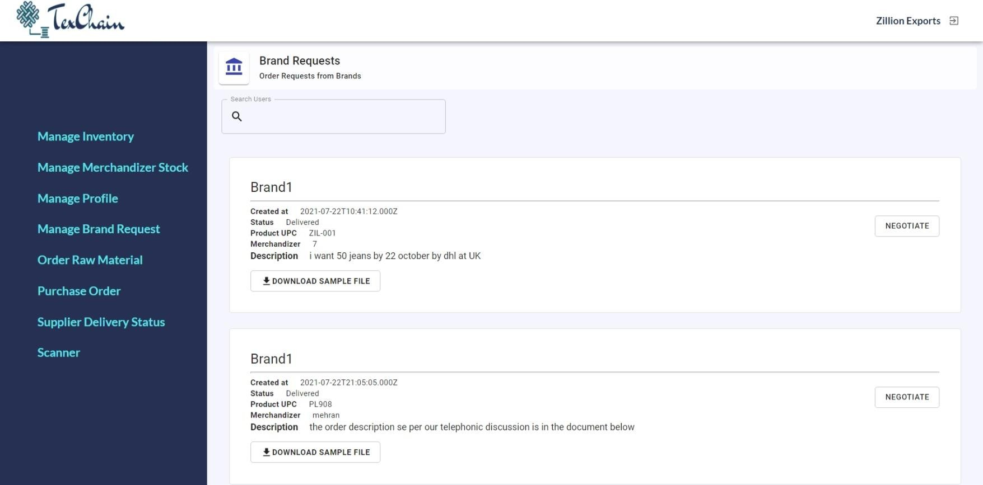

*Figure 3.15-Brand Request*

If manufacturer wants to accept that order, then they will click the negotiate button for proceeding with that order. They can select the product if they already had it in the inventory and then they can simply create the delivery by clicking that button.

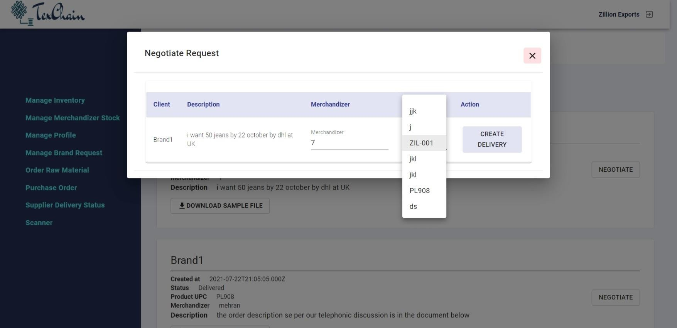

*Figure 3.16-Negotiate Request*

Manufacturer can order raw materials from different suppliers from this order raw material tab. In this tab the list of all available suppliers is available.

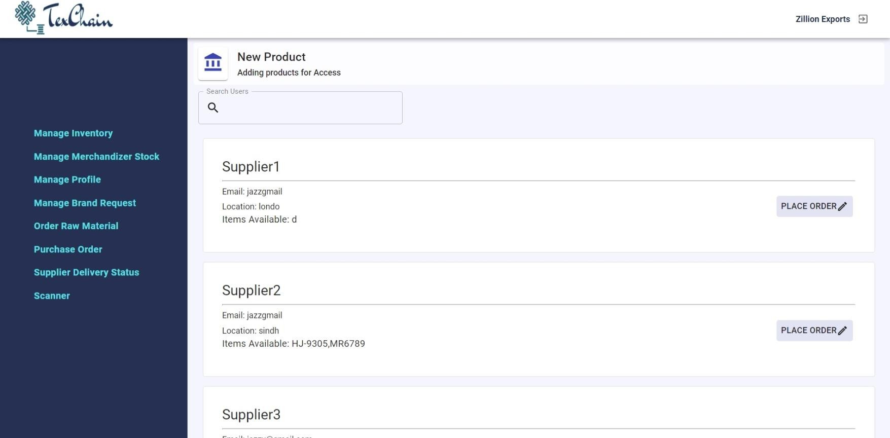

*Figure 3.17-Order Raw Material*

If manufacturer wants to place order on a particular supplier, they can create place order button. Then all of the products of that particular supplier are shown to the manufacturer.

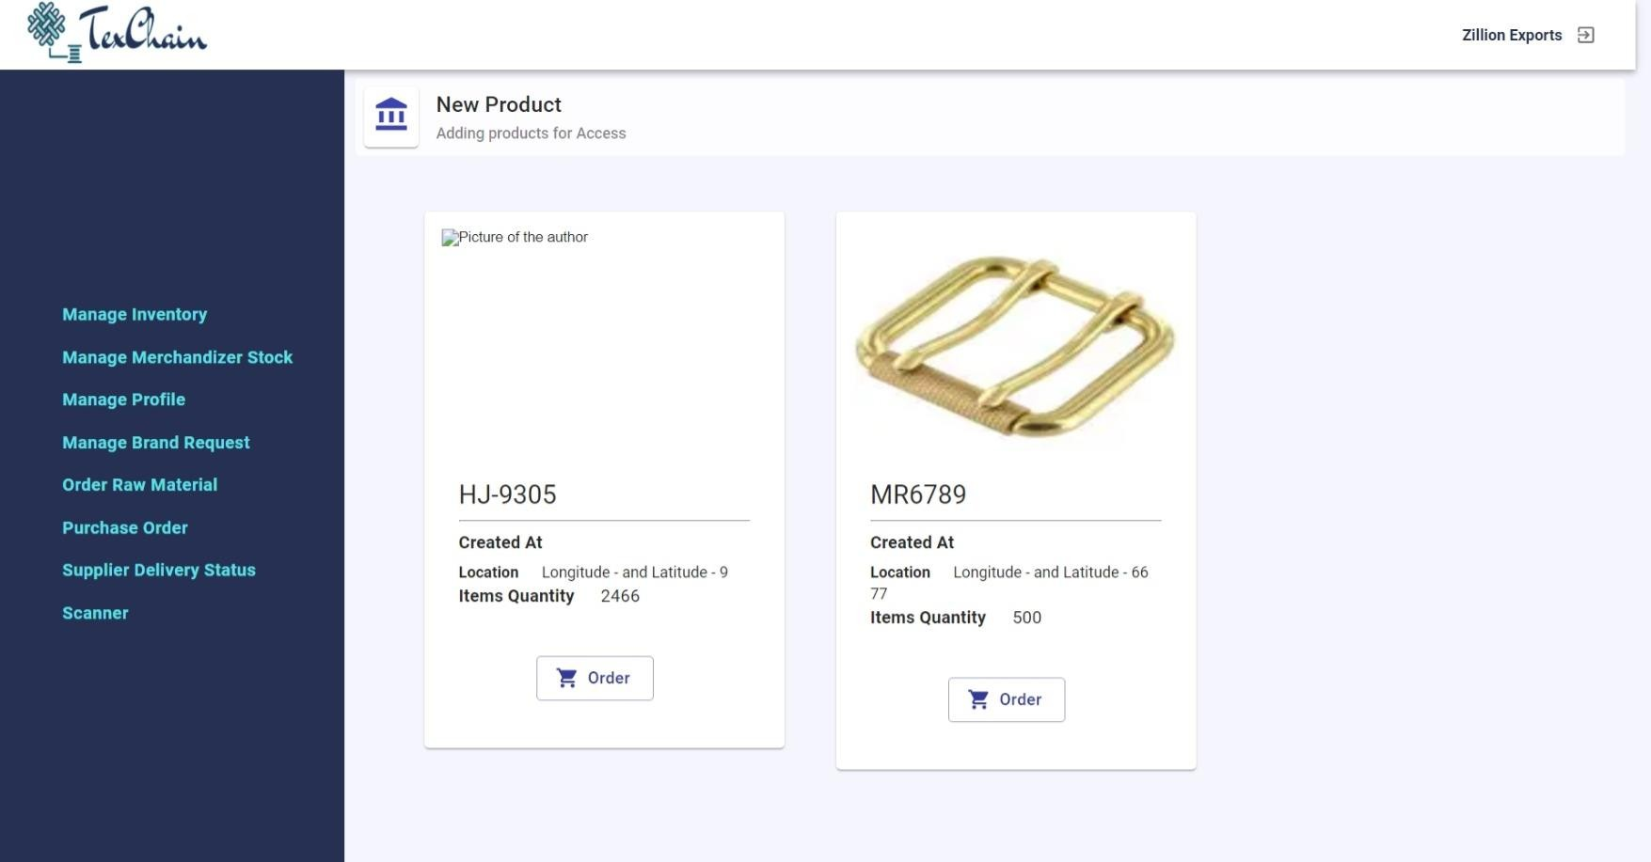

*Figure 3.18-Place Order Tab*

For ordering a particular product they can click on the order button. Then they can provide any extra requirements to that order. By submitting that order, order request will be shown to the supplier panel.

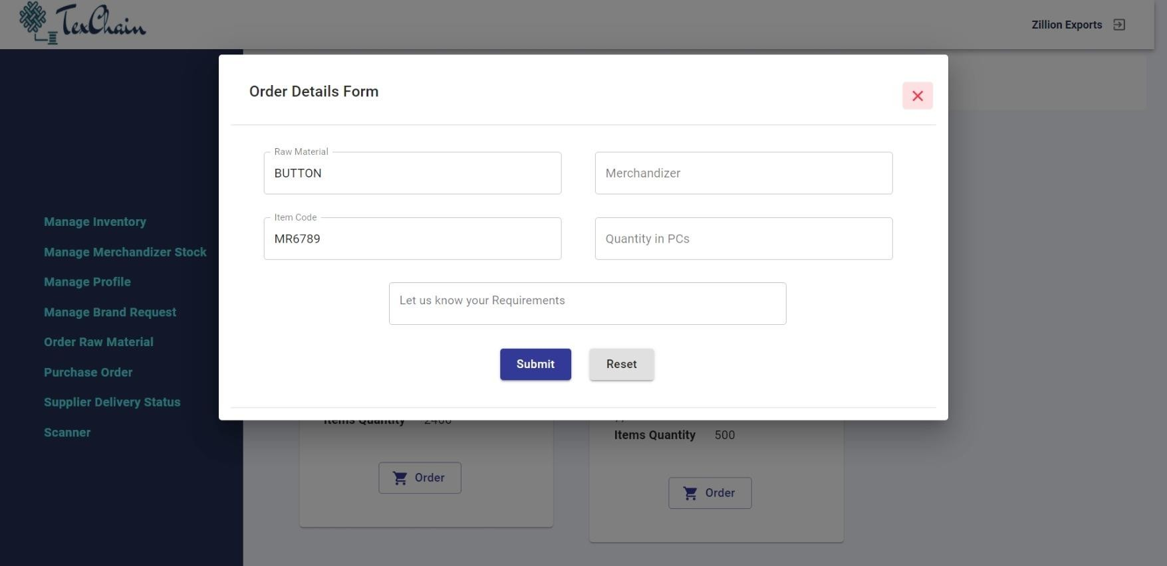

*Figure 3.19-Order Details*

This tab shows all the past sales. They can keep records of all the details of the order. The details include the ordered product upc, merchandizer involved in the sale, description of the sales, Order date, Status of the order and the sample document of that order.

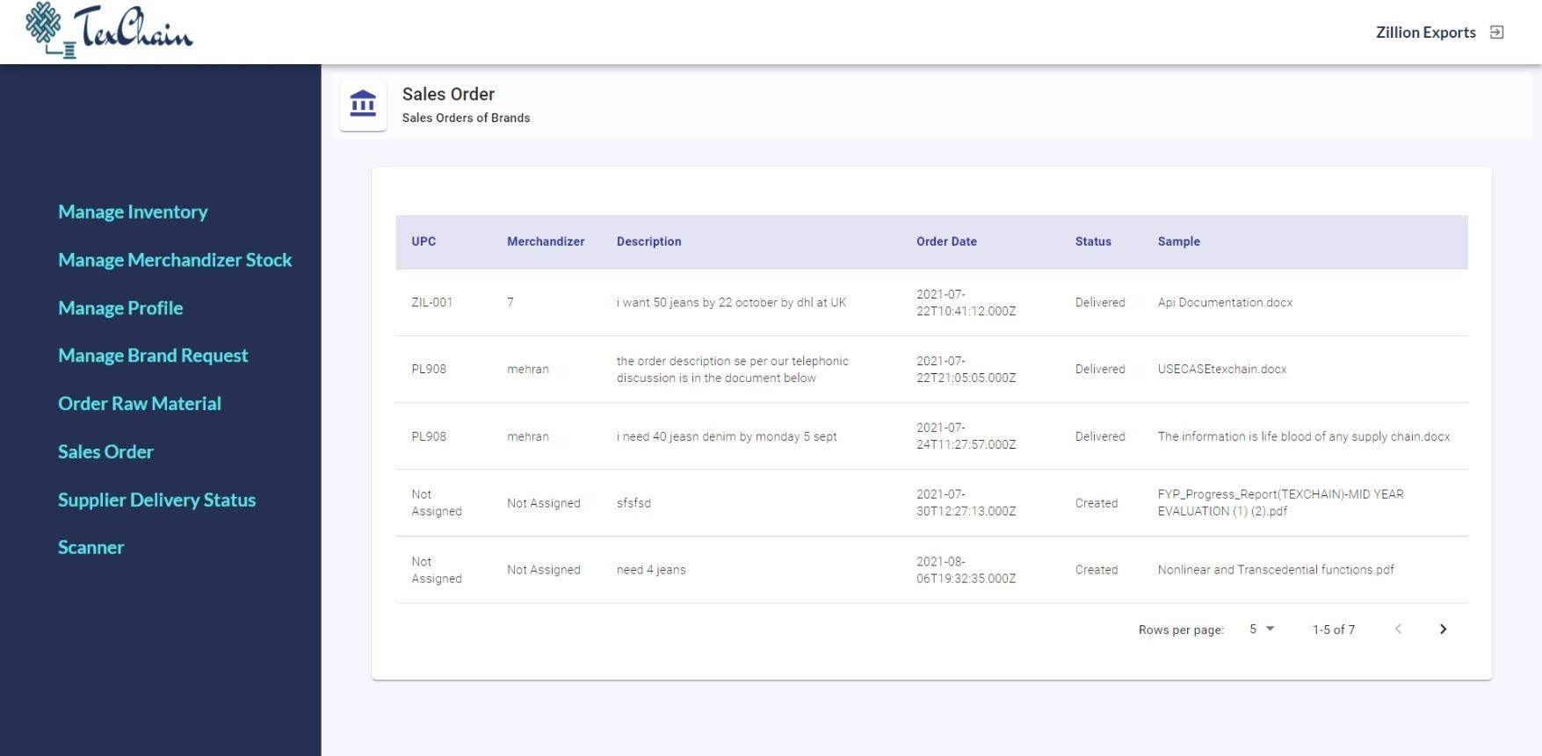

*Figure 3.20-Sales Order*

This supplier delivery status tab shows the details of the order that manufacturer gave to supplier. This includes all the details of that order including its status. Also, a QR code is provided with every order so that they can track their products' details further.

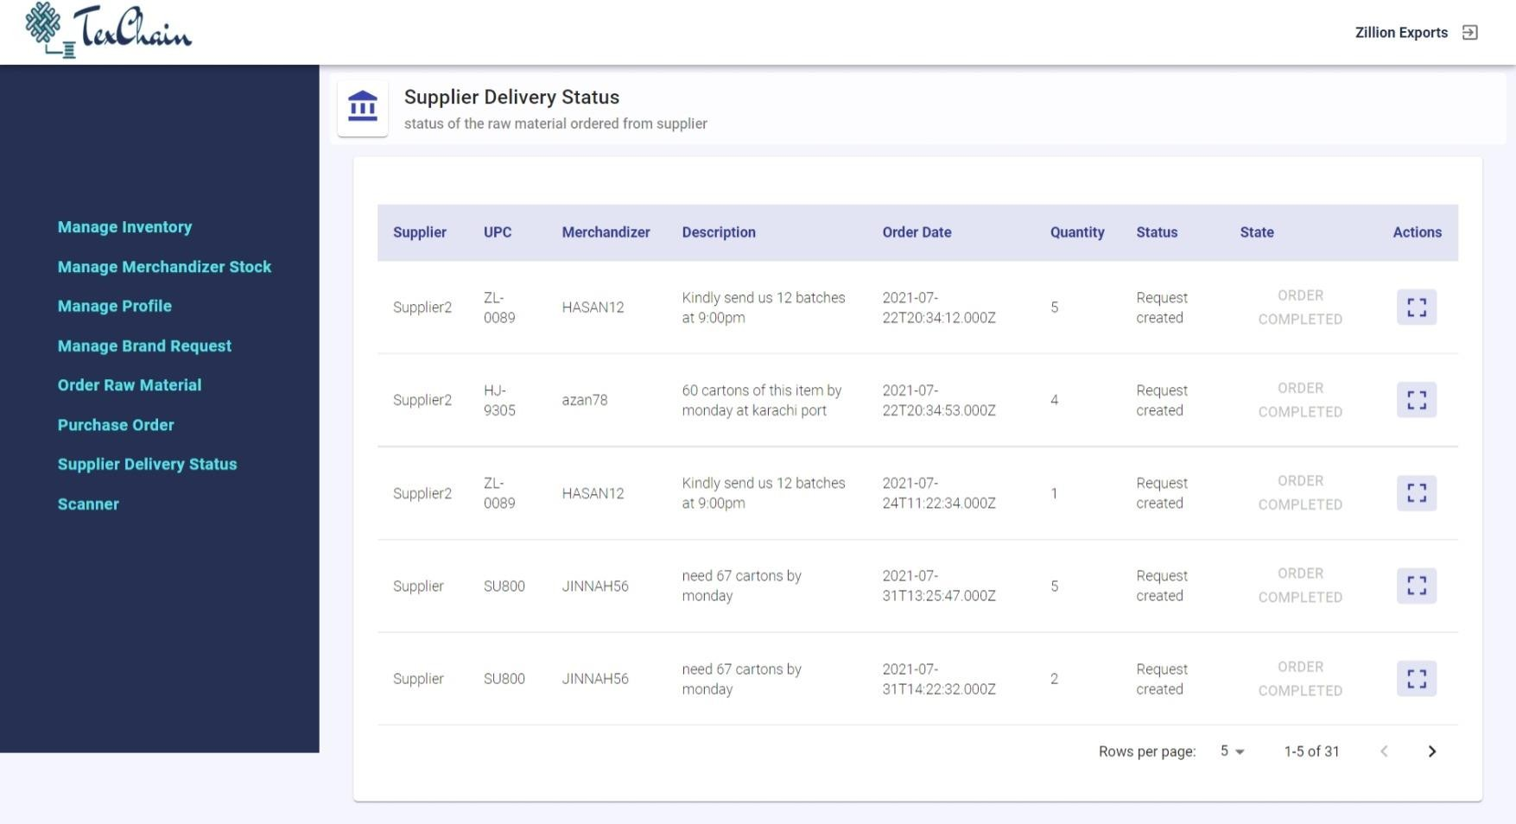

*Figure 3.21-Supplier Delivery Status*

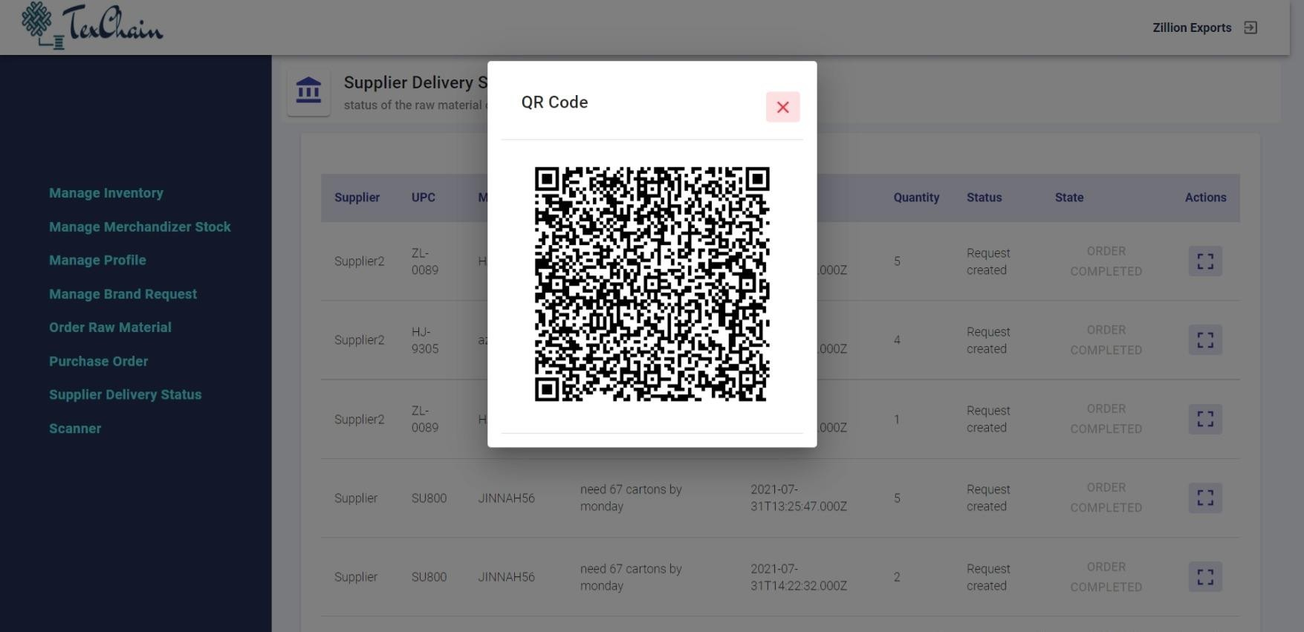

*Figure 3.22-Supplier Delivery Status QR Code*

This is the scanner page, in which they can scan the QR Code, provided in supplier delivery status tab. This will shows the complete details of the order, which includes manufacturer’s address, supplier name, supplier latitude and longitude, Price and time.

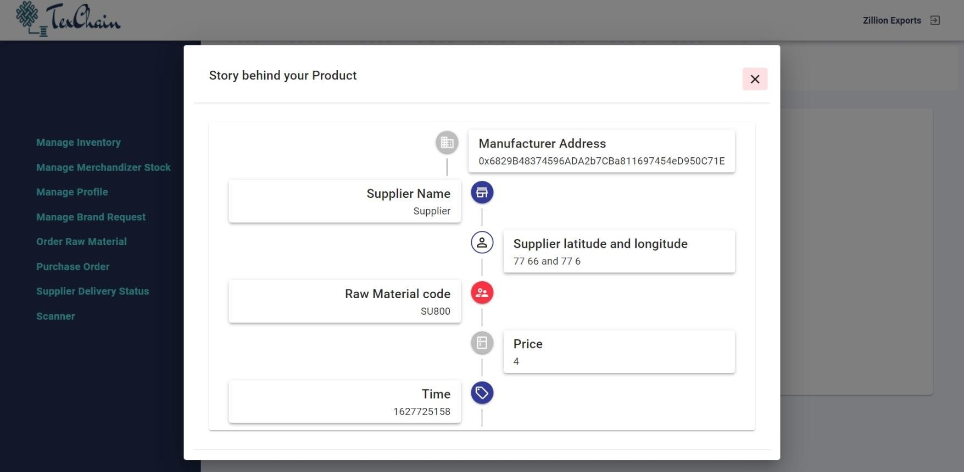

*Figure 3.23- QR Code Scanner page*

*3.3.3 Supplier:*

Supplier is the one who sale different kind of raw materials like zipper, button etc. In this system different type of suppliers are available. Once a supplier is logged in with his credentials, he will be directed to supplier panel. This is the tab, where there is a list of all products available to the supplier. They can edit their details, if there is any change or can delete a product.

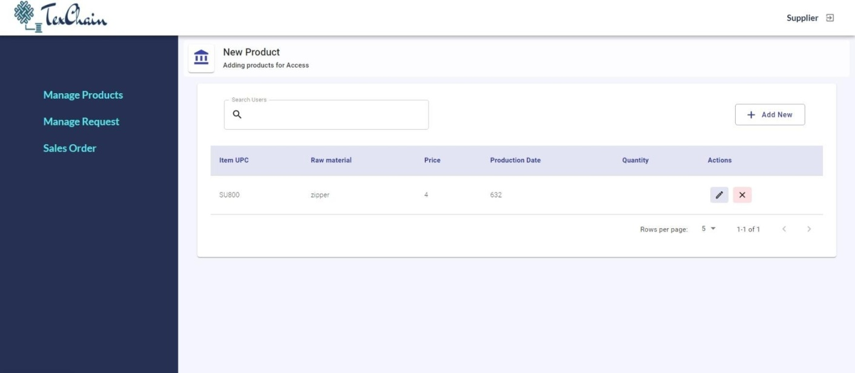

*Figure 3.24- Supplier’s Panel*

Supplier can add new items, if there is new stock available. They can add product by filling in details like item upc, latitude, longitude, production date, quantity, price, Materials used in total, Item's picture etc*.*

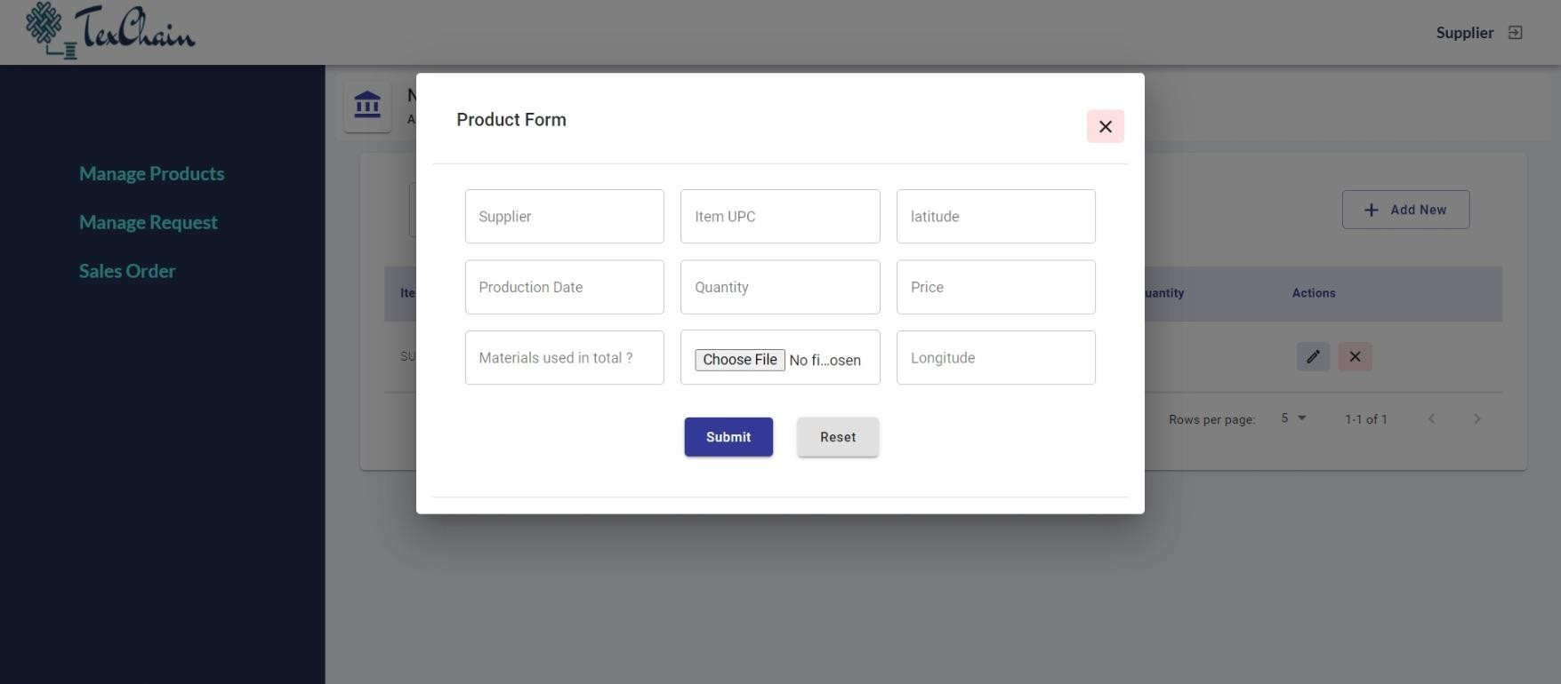

*Figure 3.25- Add New Item*

In this tab, all the requests of manufacturers will be shown. This will display the details of the order like material, upc, quantity required, status and description.

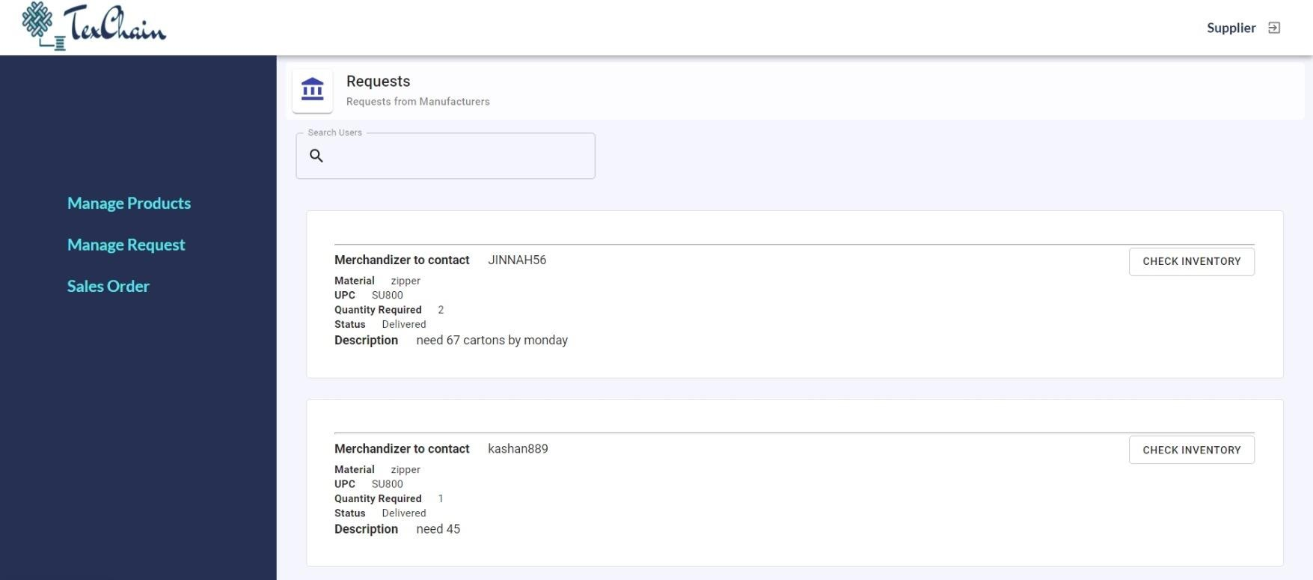

*Figure 3.26- Manufacturer’s request*

If Supplier wants to proceed with any order, they will click check inventory button in order to check whether an ordered product is available in the inventory or not and if it is available, they can simply create delivery.

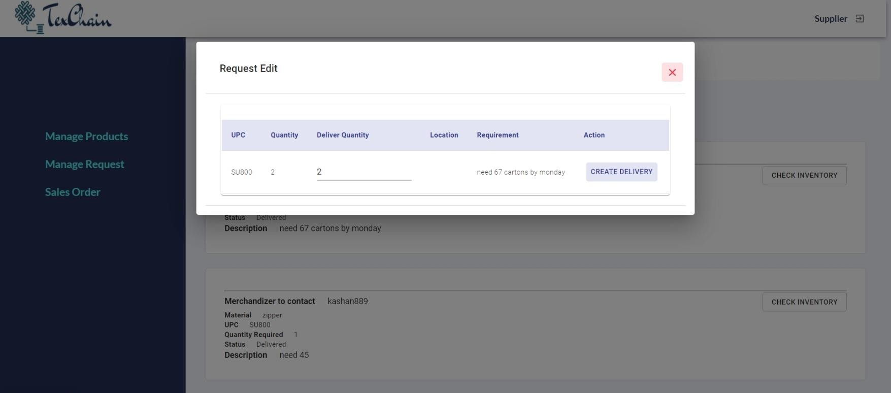

*Figure 3.27- Check Inventory*

Sales Order tab in supplier panel include all the sales record that a supplier has ever done. It includes details like upc, merchandizer, material, description, order date and quantity delivered.

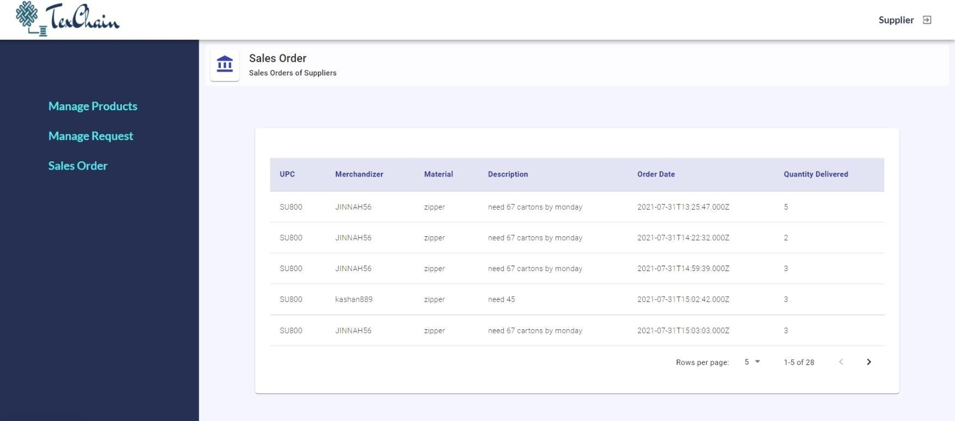

*Figure 3.28- Sales Order*

*3.3.4 Admin:*

This is the main login page of the application TexChain, which includes TexChain's name, it’s motive and a sign in form. In this sign in, form any kind of user whether he is manufacturer, supplier, brand or an admin can log in with their credentials. Once they are logged in, they will be automatically directed to their respective dashboards. This functionality is implemented through Role Based Access Control.

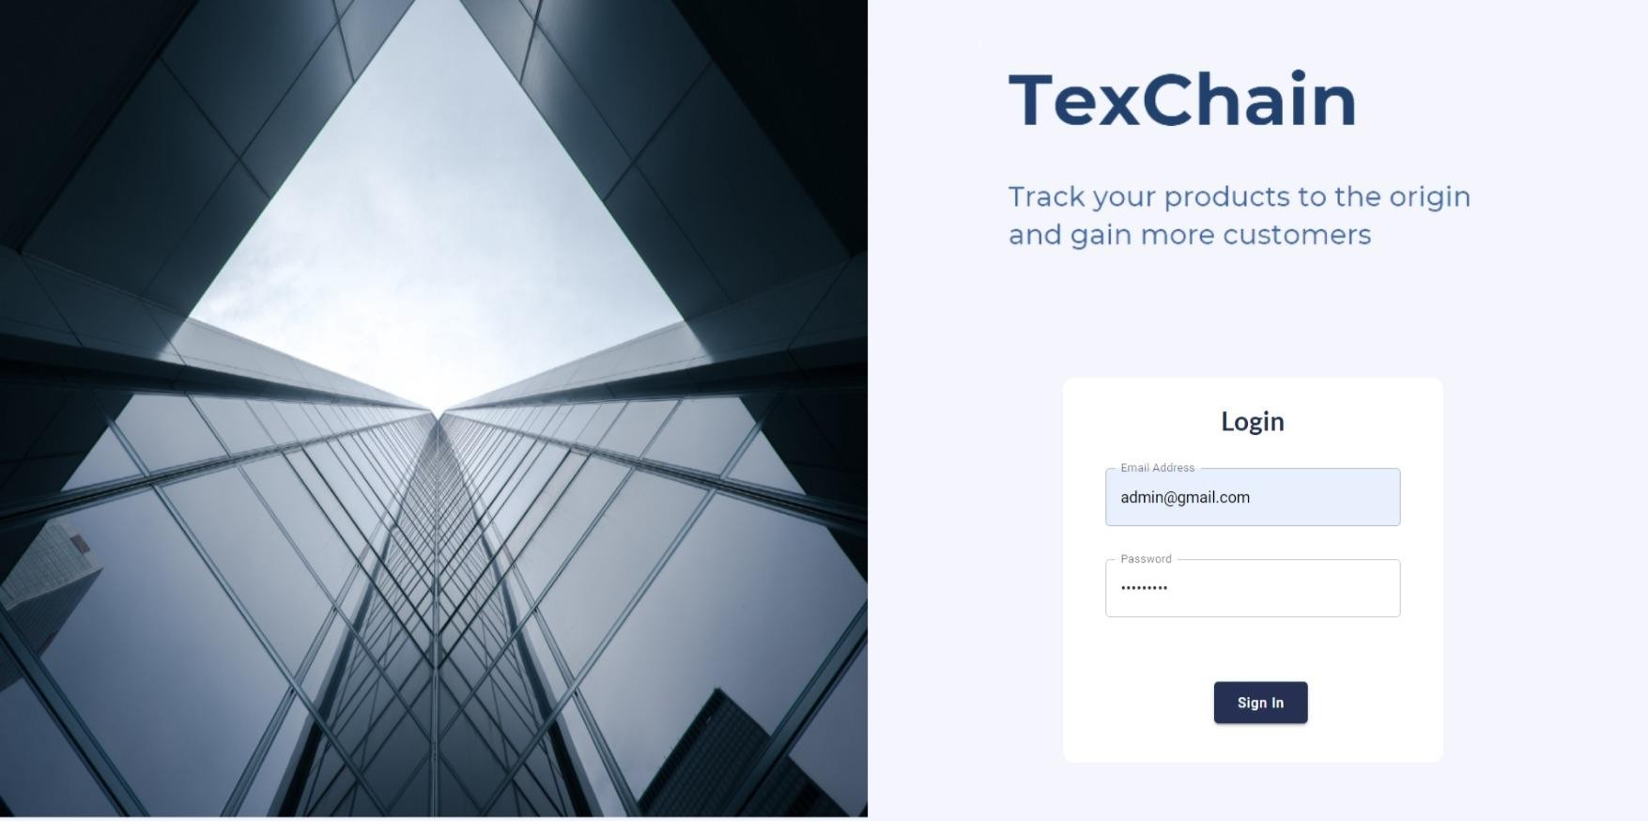

*Figure 3.29- Main Sign in Page*

Admin user lands on Admin Dashboard after logging-in with admin id/password.

Here is the list of all the users, they have ever registered to the system. They can edit the details of the users if there is any change in information. Also, they can delete any user, if the user is no longer linked to the application.

Admin may also update information related to the company by editing the form fields. Company documents are also uploaded with description and file extension (document type) with clickable icons to edit the name, description, replace file or download it.

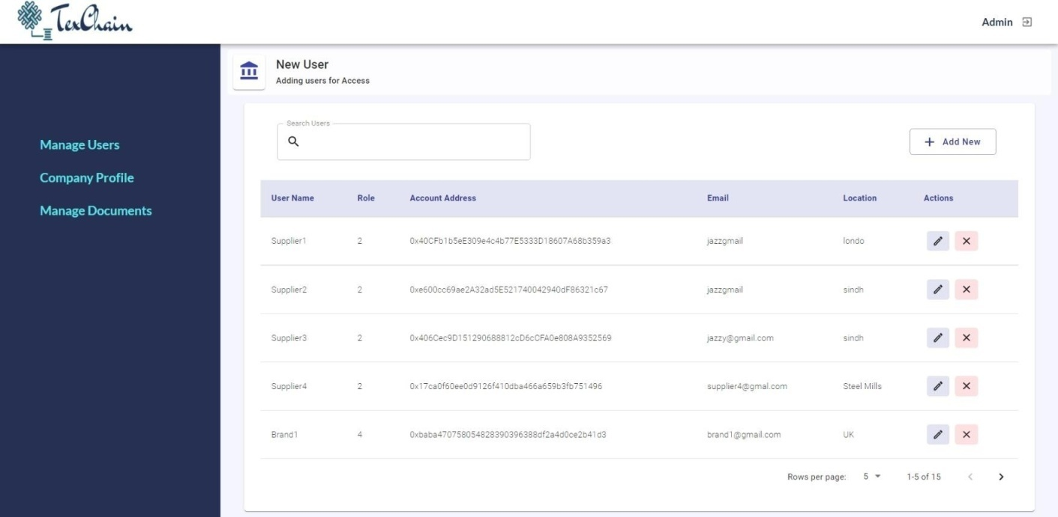

*Figure 3.30- Admin Panel*

Admin can add a new user to the application, by adding some details like username, giving them a unique password, their email address, their location. They can give an account address and a private key to each user, so that they can run the application through running smart contracts of blockchain. Admin will assign a role to each user like Manufacturer, supplier, brand and admin.

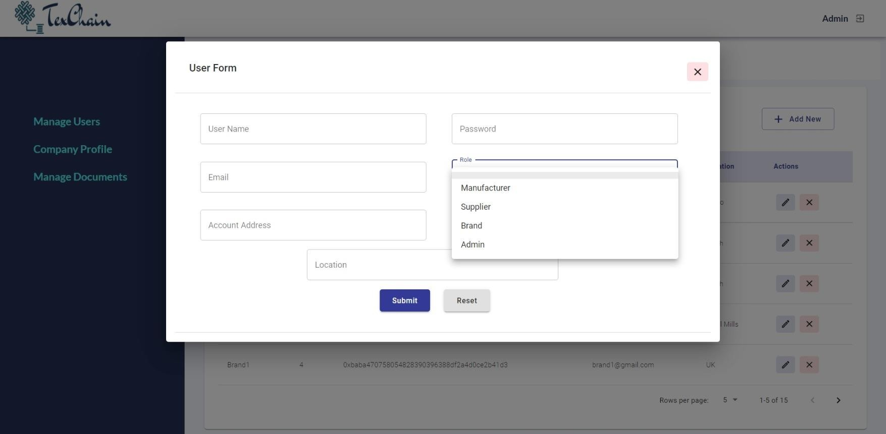

*Figure 3.31- Adding New User*

# CHAPTER 4 - SUBSYSTEM/MODULE DESCRIPTION

This section describes the main modules of our application, sub-modules and their components that are implemented in order to achieve required results. Our application TexChain is comprised of the following subsystem and their components.

* + - Authentication Module
      * Login component
    - User Creation Module
      * Manufacturer/Supplier/Brand/Admin
    - Order Raw Material Module
      * Search component
      * Place Order component
    - Raw Material Authenticity Module
    - Inventory Management Module
      * Supplier inventory management
      * Manufacturer inventory management
    - Supply Chain Module
      * Create raw materials
      * Create Product
      * Accept delivery from supplier
      * Accept delivery from Manufacturer
    - Manufacturer Module
      * Manage Inventory
      * Manage Merchandizer Stock
      * Manage Brand Request
      * Order Raw Materials
      * Supplier Delivery Status Check
      * Sales Order
    - Admin Module
      * Manage Users
      * Manage Company profile and documents
    - Supplier Module
      * Manage Products
      * Manage Requests
    - Brand Module
      * Place Order
      * Check Order Status

## Description of Authentication Module

JWT Authentication

In our application, we have used JSON Web Tokens (JWT’s) for authorization of users. JWT is an open standard (RFC 7519) that provides a secure method of transmitting data and information between parties as a JSON object. They are commonly used for authorization in applications.

In our application, when a user login’s, each request made by the user will include a JWT in its authorization attribute in the header of the request which allows the user to access routes and services that can be accessed with that token.

JSON Web Tokens consist of three parts:

* Header
* Payload
* Signature

Header:

Headers consist of two parts: the type of the token i.e., JWT and the algorithm which is used to sign the token. In our application, we are using SHA256 encryption algorithm for signing the token.

Payload:

The second part of the token is the payload, which contains the claims. Claims are attributes of an entity (mostly, the user) and some additional data. In our application, we are forming the payload using multiple claims and most of them are unique for each user. We have used the user-id, username and the type of the user which is trying to login to the system, as claims. If the password and user id entered by the user are correct and the user exists in our database, then a JWT token is returned to our front-end application for authorization.

Signature:

The last part of the token consists of a signed combination of the encrypted header, encrypted payload, a secret key and an algorithm specified in the header.

Hash Passwords:

In-order to protect the user credentials at all costs, we store user passwords in the passwords after using a one-way cryptographic hash function. If, in case, a hacker is able to hack our database, the person can never get hold of the user credentials because it is impossible to reverse a one-way hash. In order to hash the user credentials, we are using a package provided by React called as ‘bcrypt’ which hashes the passwords.

* + 1. ***Authentication Module Scope***

Role based access controls refers to the restricting the access to the system to some authorized users. It is an access-control mechanism which is built around privileges and roles.

As our application has multiple users including the admin, manufacturers, supplier and the brand/clients so implementation of role-based access control was a must. The users in our application can only access features according to their roles and privileges assigned by us. Each user only sees or access features, which have been designed for them and has no control or access over features which do not concern them. We have implemented role-based access control using React Js.

##### Authentication Module Flow diagram

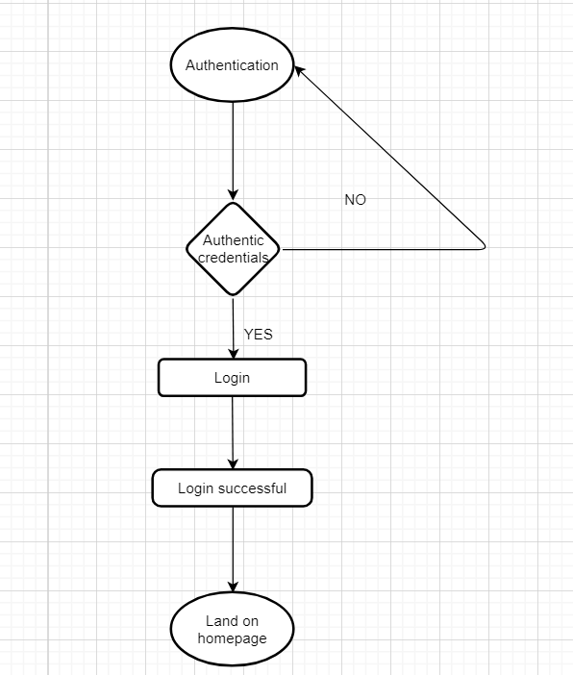

*Figure 4.1- Authentication module Flow diagram*

##### Authentication Module Components

The authentication module of TexChain application consists of one components that may be used according to the requirements.

There is only one component and that is:

* + - * Login Component

4.1.3.1 Authentication Module- Login Component Description

Login requires user to enter credentials (email and password). The user credentials are authenticated using JWT so that the user can only access features according to their roles and

privileges assigned by us. Password is hashed to match the hashed password stored in our database. On successful authentication, user is logged into the account.

If user clicks on Login, A small form is opened with fields to enter credentials (email and password). Each field is validated and authenticated to let the user login to their account. On successful login, user is redirected to their homepage.

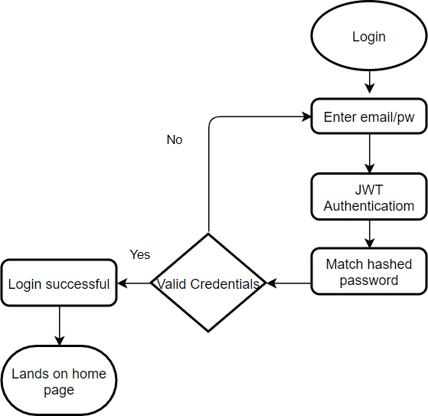

*Figure 4.2- Authentication module-Login component Flow diagram*

##### Restrictions or Limitations

The limitation of authentication module is that it can affect performance and since TexChain is a business-oriented application, the performance of our application has serious implications for the success of the business.

##### 4.1.5. Design Constraints

TexChain allows the user to sign in using email address. You need to enter the valid email address in order to get authenticated. It doesn’t allow the user to sign in using Facebook or phone number.

## Description of User Creation Module

This module covers the details regarding the creation of user accounts on the application. To initiate the procedure, user has to login with Admin user credentials.

User will then click on option to create the required type of User. There are three options available as per the categories of users which are supplier, manufacturer and brand/client.

The information entered including email, Name, password, account address, private key, location and other information is entered. The entered information is validated. Admin creates account of all the users and give them credentials of their accounts for them to sign in successfully.

##### Client Creation Module Scope

As per our business model, contracts with the clients (supplier, manufacturer and brand/client) are signed one-to-one in person to get registered on our system by Admin. Admin user creates accounts for the users on our system and provide details. This module covers this registration process on the application. The account credentials are then provided to the client for usage who then logins the application and access the granted features.

##### Client Creation Module flow diagram

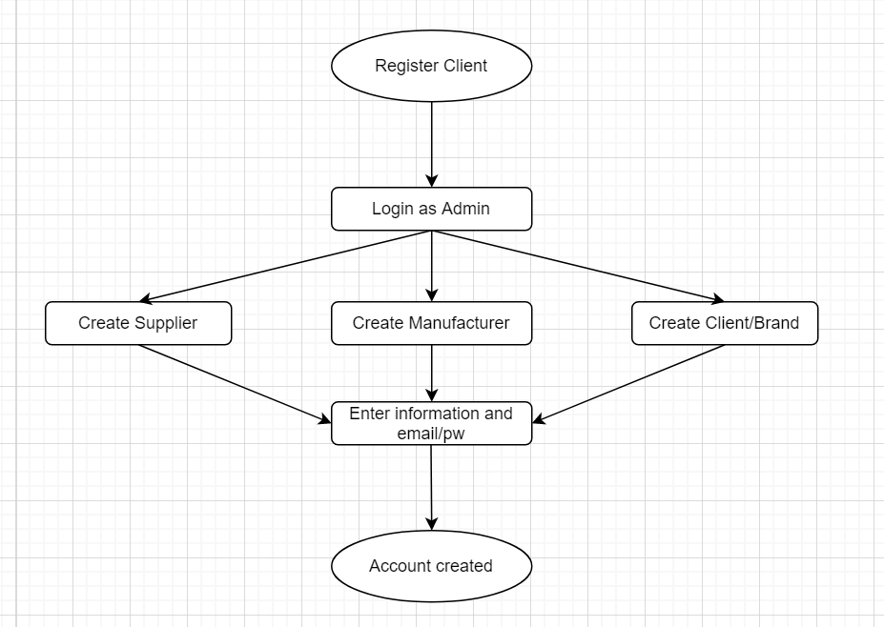

*Figure 4.3- User Creation module Flow diagram*

##### Restrictions Limitations

* + - 1. Performance Issues

Process may get slow due to many validations on the form fields in the creation modal.

* + - 1. Design Constraints

Only Admin user has access to create the client user accounts. Client cannot register themselves. They can only login to the application using the credentials provided by admin.

## Description of Order Raw material Module

To order raw materials from suppliers in our application, user must sign in as manufacturer and go to order raw materials tab. There will be a list of suppliers, that are currently registered in our system and offering varieties of raw materials.

After that there will two main works left for the manufacturer to order raw materials. First, he needs to search a supplier, that he wishes to deal with, through search bar at the top of page. Secondly, for placing order to that searched supplier, he needs to click place order button, after that it will show all the raw materials that supplier is offering. To order any of them, he needs to click button order, give some additional requirements and the order will be placed.

##### Order Raw Material Module Scope

Order Raw Material module covers the mechanism to enable manufacturers to order raw materials, which they need in the manufacturing of any product. It let them to first their required supplier by their name and secondly let them place order of that item very easily and also let them trace the raw materials authentically by scanning it through QR code provided to them.

##### 

##### Order Raw Material Module flow diagram

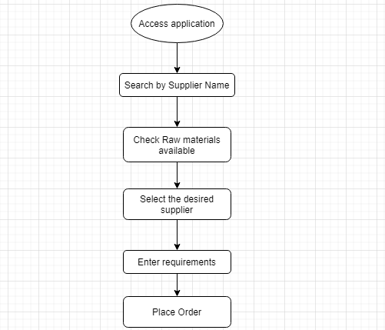

*Figure 4.4- Order Raw material Flow diagram*

##### 

##### Order Raw Material Module Components

Order Raw Material module consists of two major components:

-Search Component

-Place Order Component

* + - 1. Description of Search Component

Search component enables user to search suppliers available in the application. There will be the list of all the suppliers available that are registered in the system. But to order from any supplier, they need to search a particular supplier by their name. through the search bar provided at the top of the page, that supplier by its name.

Search Component Interface Description

Search component interface consists of a Search bar at the top of the page, with the name mentioned on it as 'Search’. Manufacturer then enters the item name; results are shown once the user hits enter which include the name of that supplier, his email address, location and all the items available he has in his stock. Also, there will be a place order button along with it, by clicking on which manufacturer, can proceed further with the ordering process.

* + - 1. Description for Place Order Component

After searching a supplier, manufacturer will look on his products available, and can order any of them, by providing some requirements. In this way the order process will be completed.

* + - * 1. Place Order Component Interface Description

After searching the supplier, manufacturer may choose any of the raw material available at that supplier. Then he can choose one and place his order. Once he clicks place order button, a modal will appear with a form in it, which include the details of the product and let the manufacturer include any additional requirements. In this way order will be placed.

##### 

##### Restrictions/Limitations

* + - 1. Performance Issues

Search may get slow if user enters the supplier's name completely wrong, and eventually do not show any result.

* + - 1. Design constraints

To place order user has to login on our application to only allow placing of orders from authentic users.

## 

## Description for Raw Material Authenticity Module

In this module, manufacturer after ordering raw materials from suppliers, can authenticate the item, by scanning QR code provided to them.

##### Raw Material Authenticity Module Scope

We track the supply chain of the raw materials from manufacturer supplier to manufacturer’s premises by scanning the QR code provided to the manufacturer with every order. The supply chain is recorded on the immutable ledger of blockchain which helps the manufacturer to know the journey of their purchased item.

##### Raw Material Authenticity Module flow diagram

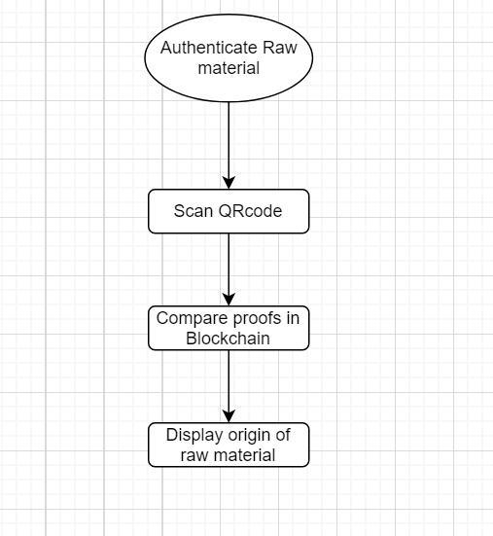

*Figure 4.5- Raw material Authenticity module Flow diagram*

##### 

##### Restrictions/Limitations

* + - 1. Performance Issues

As blockchain is slower at times, the validation and authentication process might take a few seconds.

* + - 1. Design constraints

The user needs to log in as manufacturer to scan QR codes of a particular order.

## Description for Inventory Management Module

To manage inventory, manufacturers logins with the credentials provided by admin. manufacturer then goes to Manage products. Option to add new items to inventory is available, if user selects to add a new product, a create medicine modal (form) is opened. User enters the product name and fill other details such as quantity. In another case, user might not want to create a new item and instead view existing records to perform actions such as edit or delete. If user selects to edit, he may edit details or update the quantity. After confirming the edit operation, inventory item is updated. Similarly, on clicking on delete option, user is asked to confirm its choice. Confirmation message is displayed after each successful operation.

##### Inventory Management Module Scope

Inventory Management module is for our manufacturer and suppliers. Supplier can manage his raw materials by adding them into his inventory and perform other operations onto it. Also manufacturer can manage is completed products by adding them in inventory and perform operations.

##### Inventory Management Module Components

There are two entities in the system, to whom the work of inventory management is assigned I.e., manufactures to manage their products and suppliers to manage their raw materials.

* Supplier Inventory management
* Manufacturer inventory management.

* + - 1. Supplier Inventory Management Module Flow diagram

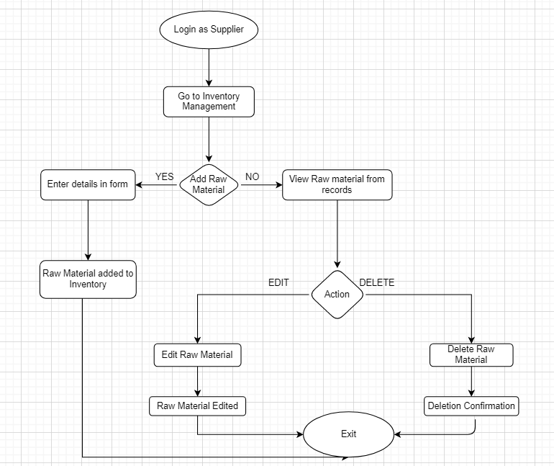

*Figure-4.6 Supplier Inventory Management Module Flow Diagram*

* + - 1. Manufacturer Inventory Management Module flow diagram

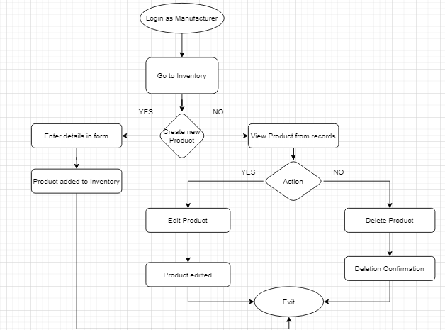

*Figure-4.7 Manufacturer Inventory Management Module Flow Diagram*

##### Restrictions/ Limitations

* + - 1. Performance Issues

API is optimized to process the query faster, so no performance bottlenecks experienced.

* + - 1. Design Constraints

Manufacturer and Supplier has access to inventory management, and they will manage their inventories separately in their dedicated dashboards.

## Description for Supply Chain Module

Supply chain punches the user performed actions to blockchain. The actions that are punched to blockchain are product Creation by manufacturers and suppliers and acceptance of delivery. Each user has to login in order to perform the concerned actions. For each of these actions, transactions on blockchain are created.

##### Supply Chain Module Scope

Supply Chain module ensures the supply chain management of products on our system. It ensures each related action is punched to blockchain so that it can be tracked later to ensure supply of authentic product in the chain to brand or manufacturer, be it from manufacturer to brand or from supplier to manufacturer.

##### Supply Chain Flow Diagram

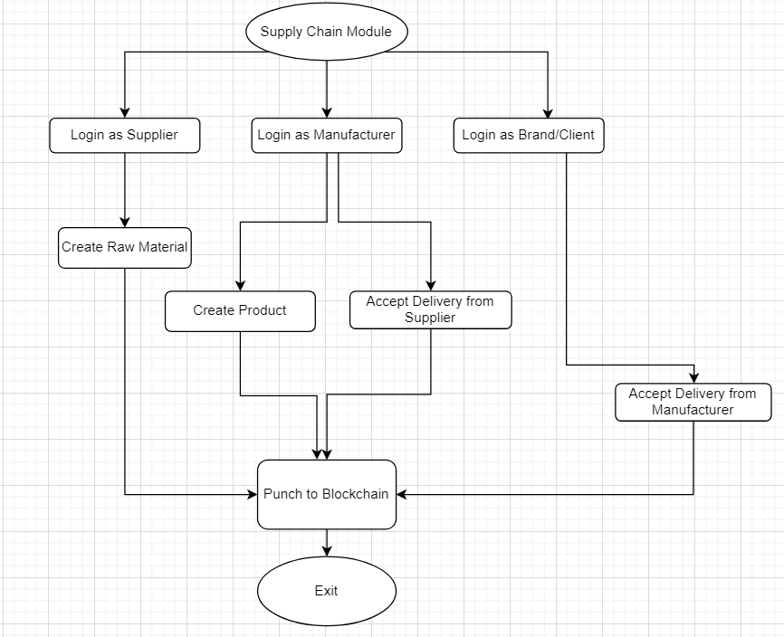

*4.8 Supply Chain Module Flow Diagram*

##### 

##### Supply Chain Subcomponents

Supply chain module consists of the following subcomponents:

* Create Raw Materials
* Create Products
* Accept Delivery from Supplier
* Accept Delivery from Manufacturer
  + - 1. Description for Create Raw materials

Supplier creates raw materials they have, so that manufacturer registered on the system can purchase these items. To create raw material, user is required to login as supplier with credentials provided by admin. User then goes to Manage Products tab. Where there is a list of already existing raw materials of that supplier. To add newly arrived raw materials, supplier must click on add new button, a modal will appear with some fields in it. Supplier must fill all the information about the product and click submit button. In this way new raw material is created. And this activity is punched to the blockchain, in order to track it later.

* + - 1. Description for Create Product

Manufacturer creates products that are completed in their warehouse, so that brands registered on the system can purchase these products. To create a product, user is required to login as manufacturer with credentials provided by admin. User then goes to Manage Products tab. Where there is a list of already existing products of that manufacturer. To add newly completed products, supplier must click on add new button, a modal will appear with some fields in it. Manufacturer must fill all the information about the product and click submit button. In this way new product is created. And this activity is punched to the blockchain, in order to track it later.

* + - 1. Description for Accept delivery from Supplier

When a manufacturer place order of raw materials to supplier, supplier can view that incoming request, can check the availability of the raw material in his inventory. If the product is available, then he will negotiate with that request and accept the offer eventually. He then will create a delivery to the manufacturer. This will be notified to the manufacturer that a delivery is created from the supplier and when they received the delivery of product, they will accept that delivery by clicking accept delivery

* + - 1. Description for Accept delivery from Manufacturer.

When a brand places order of products to supplier, manufacturer can view that incoming request, can check the availability of that product in his inventory. If the product is available, then he will negotiate with that request and accept the offer eventually. He then will create a delivery to the brand. This will be notified to the brand that a delivery is created from the manufacturer and when they received the delivery of product, they will accept that delivery by clicking accept delivery button. This Information will also be punched to blockchain so that it can be traced by brand that when this delivery was created and what are its other details.

##### Restrictions/ Limitations

* + - 1. Performance Issues

Supply chain performance might get slow with increasing number of transactions on blockchain.

* + - 1. Design Constraints

Every action performed creates transactions on blockchain to ensure consistency of the supply chain.

## Description for Manufacturer Module

A logged in manufacturer has various options available. Some of these are to manage products, ordering raw materials and dealing with brands request. Manage products deals with add, edit and delete operations on products whereas manage request lets manufacturer deals with different brands and manufacturers can also order raw materials from different suppliers.

##### Manufacturer Module Scope

Our system enables manufacturers to manage the products of their own company using our application. This also allows them to connect to suppliers and brands they already deal with that are present on our system.

***Manufacturer Module Flow Diagram***

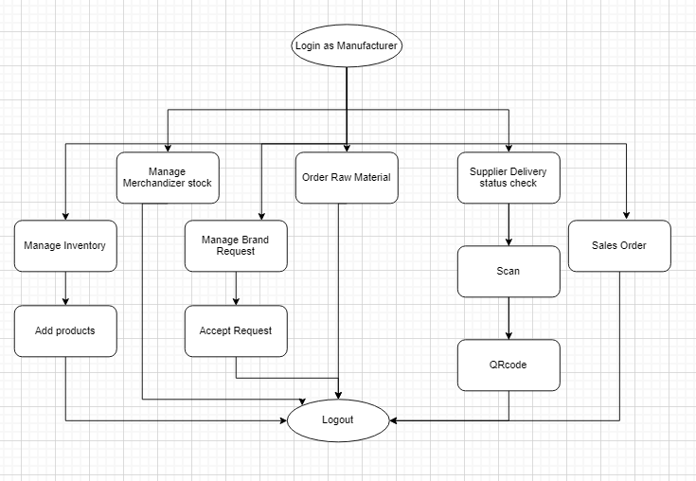

* 1. *Figure-4.9 Manufacturer Module Flow Diagram*

##### Manufacturer Module sub-components

Manufacturer module consists of two subcomponents:

* Manage Inventory
* Manage Merchandizer Stock
* Manage Brand Request
* Order Raw Materials
* Supplier Delivery Status Check
* Sales Order
  + - 1. Description for Manage Inventory

Manufacturer manages inventory in terms of creating new products (those they already completed working on) change the already existing ones their system. They can edit the existing information

of the product, delete a particular product, if it is not available anymore and can search a particular product from his inventory.

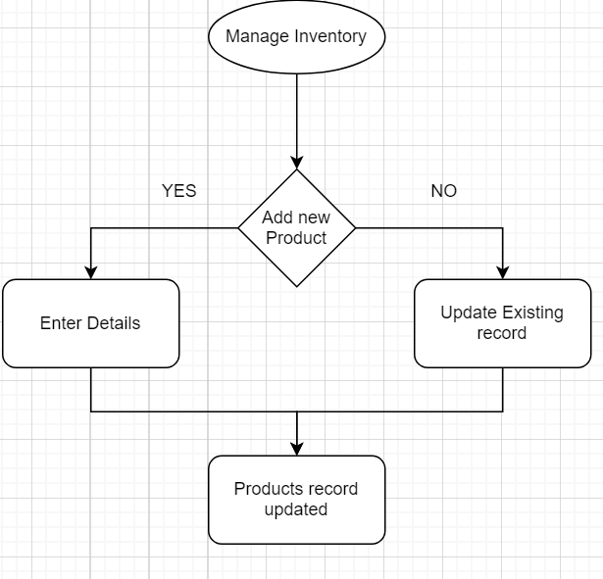

*Figure-4.10 Manage inventory Flow Diagram*

* + - 1. Description for Manage Merchandizer Stock.

Manufacturer can also manage their stock i.e., raw materials. When they purchase any new product from supplier they add it in their merchandizer stock, and when they user any raw material in the making of any of their product they deduct that product from these merchandizer stock table. They can edit the quantity of these raw materials when they use any of the item.

* + - 1. Description for Manage Brand Request.

Manufacturer can also manage the order requests coming from brands. When brands place their order, by filling in the details about the order and other requirements, their requests are received by manufacturers. In manufacturer panel there is a list of brands request, which includes request from different brands with their status like if the request is fulfilled status would be order completed, if it's in process status would be pending. After receiving requests manufacturer check their inventory if the product is already available or otherwise, they start to manufacture the product and change the status of order to pending. When they deliver the product to brands, they click on create a delivery. And when brands receive the completed order, they click on accept delivery and the status of the order changed to completed. During this whole process brands can track the product anytime they want through the scan of QR code provided to them.

* + - 1. Description for Manage Brand Request.

When manufacturer needs any raw material for the manufacturing of the product, they go to order raw materials tab, where there is a list of suppliers available. They select their required supplier and view the items they are offering. They then select any one item and order them by filling in some details. This request will then receive by supplier, and they then fulfil this order.

* + - 1. Description for Supplier Delivery Status Check

When manufacturers place order of raw material a record is created in supplier delivery status tab. Where there are all the details of the order and this status of the order like pending, completed etc. Also, a QR code is provided with every order. They can open the QR code of any supplier, take the picture of that code and go to the scanner tab. In the scanner tab, they scan the QR code, a modal will appear showing all the details of the order. In these ways, manufacturer can check the status of their order and can track them easily.

* + - 1. Description for Sales Order

When manufacturers deal with any brands and are involved in the sales to the brand, the whole data of that dealing will be stored in this sales order tab, so that they can keep record of what kind of sales are done in the past. The sales order includes details of the order like upc of product, merchandizer name, description of the order, order date, status of the order and a sample document that is provided for that order by brand.

##### Restrictions/ Limitations

* + - 1. Performance Issues

As the no of products and items records will increase over time, the time for fetching the database might increase.

* + - 1. Design Constraints

Products of a manufacturer’s own company are only visible. Manufacturer user is restricted to view products manufactured by other companies.

## 

## Description for Admin Module

A logged in Admin user will be redirected to Dashboard where it is able to perform multiple operations which include management of all medicines existing on our system, management of other admin users to update the granted access or even create new or remove the existing ones. Admin can also update the company information and official documents.

##### Admin Module Scope

Just like any other application, admin user is the administrator who has access to perform management operations such management of users and update the information related to application and our organization.

##### 

##### Admin Module Flow Diagram

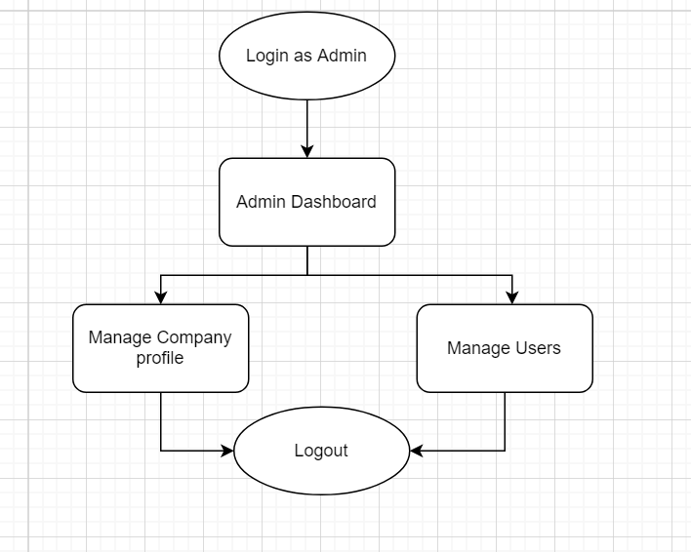

*4.11 Admin Module Flow Diagram*

##### Admin Module Subcomponents

Admin module consists of following subcomponents:

* Manage Users
* Manage Company profile and documents
  + - 1. Description for Manage Users

Admin can manage other admin user currently present on the system. It has access to update any of these by either editing the related information or updating the granted access or even deleting a user completely.

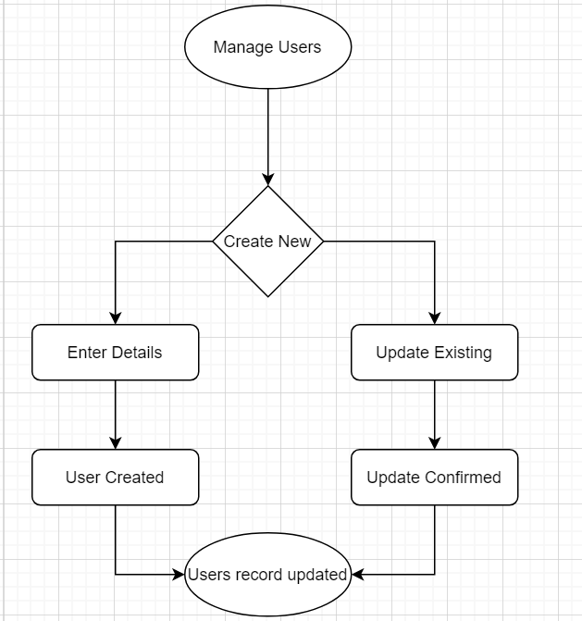

* 1. *Figure-4.12 Admin Module Manage Users Component Flow Diagram*

User logins as Admin using the credentials (email/password). He then selects to go to Manage Users. Here, if he chooses to create a new admin user, a form is opened which on filling out with valid information in the fields adds the newly created admin user to the records. User can also view other users and update them by performing operations such as edit and delete.

4.8.3.3 Description for Manage Company Profile and documents

Company Profile contains information that is related to our organization ‘TexChain’.

Admin can update the initially entered details or upload official documents of our company. Multiple actions such as download, upload, edit are also available for the documents.

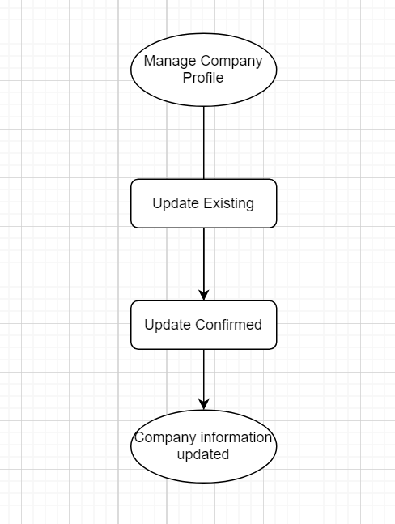

*Figure-4.13 Admin Module Manage company profile and documents Flow Diagram*

Admin logins to the application and goes to Company Profile. User confirms the edit, and the

company profile gets updated.

Similarly, he can view the list of company documents. Add new document option is also available which on click, asks for the description, name and file attachment to upload the document file. For any update in the documents or profile information, user sees a confirmation message.

##### Restrictions/ Limitations

* + - 1. Performance Issues

As the no of users will increase over time, the time for fetching the data and create accounts of blockchain will increase.

Design Constraints

Admin can’t be able to see the products and other details of their products. As the functions of users are only visible to that user only.

## Description for Supplier Module

There are so many suppliers registered on our system. So, each supplier must sign in with their own credentials. Once they logged in, they can perform the two tasks which includes manage their raw materials inventory and manage requests from manufacturers

##### Supplier Module Scope

Just Supplier can create their raw materials, edit the details of existing and even delete if the item is unavailable. They can manage the requests coming from manufactures and fulfill their orders by creating delivery. There is also a sales orders tab where there is a record of all their orders with manufactures.

##### Supplier Module Flow Diagram

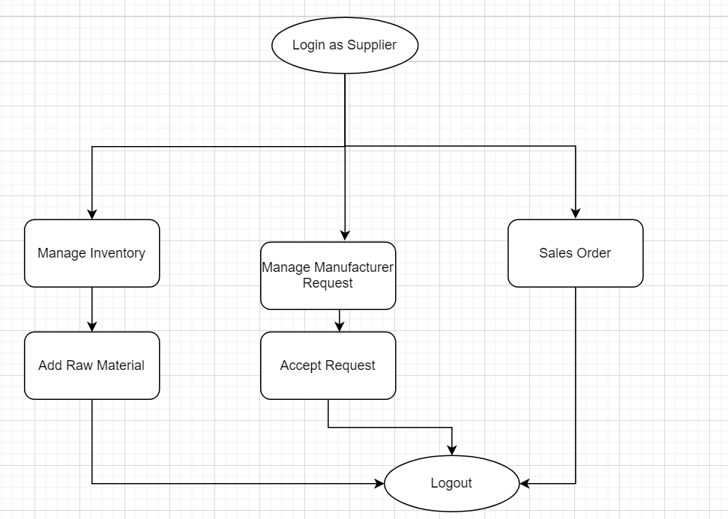

*4.14 Supplier Module Flow Diagram*

##### Supplier Module Subcomponents

Admin module consists of following subcomponents:

* Manage Products
* Manage Requests.
  + - 1. Description for Manage Products

Suppliers manages inventory in terms of creating new items (raw materials) when there is any new item in stock, they can edit the existing information of the item, delete a particular item.

* + - 1. Description for Manage Requests

Supplier can manage the order requests coming from manufacturers. When manufacturers place their order, by filling in the details about the order and other requirements, their requests are received by suppliers. In supplier panel there is a list of requests from manufacturers with their status like if the request is fulfilled status would be order completed, if it's in process status would be pending. After receiving requests supplier check their inventory if the item is available. When they deliver the item to manufacturers, they click on create a delivery. And when manufacturers receive the completed order, they click on accept delivery and the status of the order changed to completed. During this whole process manufacturers can track the item anytime they want through the scan of QR code provided to them.

##### Restrictions/ Limitations

* + - 1. Performance Issues

As the no of items and requests increases over time, the time for fetching the data from database will increase.

* + - 1. Design Constraints

Each supplier would only be able to see the products and requests of their own. They can’t see details of other suppliers registered in the system.

## Description for Brand Module

There are so many brands/clients registered on our system. The brands can be able to order the products from the manufacturer registered on our system and can track their product’s status to its origin.

##### Brand Module Scope

When brands want to get the product manufactured by the manufacturer registered in our system. They will place order of that product to manufacturer. Once, they place order they can track their product to its origin to know its manufacturing history and to check its status.

##### Brand Module Flow Diagram

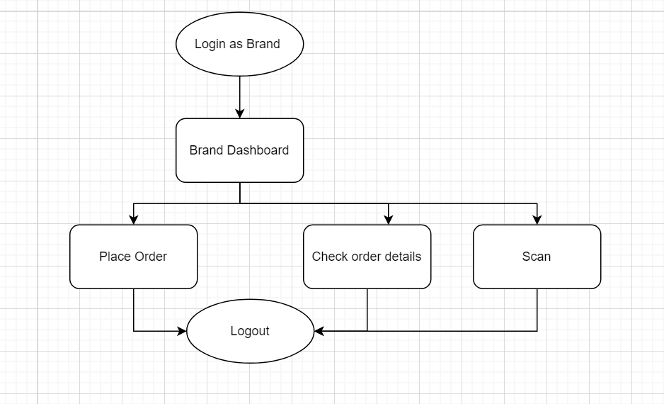

*4.15 Brand Module Flow Diagram*

##### Brand Module Subcomponents

Admin module consists of following subcomponents:

* Place Order
* Check Order Status
  + - 1. Description for Place Order

Brands, when wants to order some product to manufacturer they will place order by order tab. There is a form available at this tab. They need to fill up that form by providing the details of the order and sample pictures. Once they place the order, the requests will be received to the manufacturer of the order. All the orders they have placed are displayed in the purchase order tab.

***Description for Check Order Status***

When they place the order, all the details of the order are displayed in the purchase order tab in the form of list. This list includes some details of the order and its status which can be pending or completed. Also, a QR code will be provided with every order. They can open the QR code of the order they want to track and take picture of that. They can open a scanner tab and scan that QR code. A modal will appear which includes all the details regarding that order like what raw materials are used in that product, from whom these raw materials bought, what kind of processing are done on the product, at which stage the product is at etc. So, in this way brands can track the product to its origin completely.

##### Restrictions/ Limitations

* + - 1. Performance Issues

As the no of orders will increases over time, the time for fetching the data from database will increase.

* + - 1. Design Constraints

Each brand would only be able to see the order and order details of their own. They can’t see details of other brands registered in the system.

# CHAPTER 5 - BEHAVIORAL MODEL AND DESCRIPTION

## Description for system behavior

A detailed description of major events and states is presented in this section.

#### System behavior for Brand/Client:

Brand access the application through adding credentials on main page, when they successfully signed in, they will be directed to brand panel, where they can place order for the products, by adding details and requirements. They can also verify the authenticity of product by simply scanning the QR Code. Logged-in Brands can view the history of all the orders.

#### System behavior for Manufacturer:

Manufacturers are required to login with credentials provided by admin or owners of our organization. After logging in, Manufacturer is redirected to manufacturer panel, where they get notifications for the orders placed by brands. They, then check the delivery and try make delivery as soon as possible. They can order raw materials from list of suppliers available. And they have to manage the stock also to check how much raw materials is still needed to be ordered. Apart from this, they manage their inventory by creating new or updating the existing warehouse products. They can also add and update (edit/delete) options for the products.

#### System behavior for Admin:

Admin will login to the account by entering credentials and land on Admin Dashboard.

Admin dashboard has multiple limited options such as manage users, company profile can also be updated by the admin by editing information or uploading company documents. They create all the users of the systems, edit the user’s information and delete them.

##### Events/interrupts

A listing of events (control, items) that will cause behavioral change within the system is presented.

* + - * Authentication:

Authentication event provides access to the application. This event is considered as the main event of the application in terms of security. Authentication event has two possibilities. In case, the user enters valid credentials (email/password), the system will redirect the user to the homepage after logging in. If the user doesn’t provide valid credentials, he will be asked to retry.

* + - * Place Order:

Brand can place order for the product they want to order by providing some details for which a notification event for manufacturer is also triggered.

* + - * Scan QR Code of Product:

To verify the authenticity of product, brand scans the QR Code provided with every order.

* + - * Add, edit or delete inventory products:

Manufacturer user adds new products to the inventory, or edit the current products information or delete them if they are not available.

* + - * Manage Brand Request:

Manufacturer also have to deal with the request they are receiving from brands. If they have orders product available then they deliver it right away, or if they don’t have, they start to manufacture and change the status of the order

* + - * Order Raw Materials:

Manufacturer Order raw Materials from suppliers available in the system. They first select

the supplier, then their product and then order by filling form.

* + - * Scan QR code of item:

To verify the authenticity of raw material, manufacturer scans the QR code provided with every order.

* + - * Add, edit or delete inventory items:

Supplier user adds new items to the inventory, or edit the current items’ information or delete them if they are not available anymore.

* + - * Manage order request:

Supplier also have to deal with the request they are receiving from manufacturer. If they have the ordered item available then they have to deliver it right away.

* + - * Add or update users:

Admin user adds new users to the system, or update the current ones by edit or delete options.

* + - * Update Company Profile:

User updates the company profile by editing information or update documents by editing details or upload new ones. He also can select to download a document.

##### States

* + - * User logged in / Authenticated:

This state is achieved when the user triggers the authentication interrupt. The user stays in this state after entering the valid credentials i.e., username and password and then the user will have the specified access to the functionality of the application.

* + - * Order Placed:

Order is in placed state when brand confirms the order. Manufacturer will receive the request when place order event is triggered.

* + - * Product authenticated or unauthenticated:

QR Code scanned by the brand is processed and back tracked on supply chain. If track is found, product is authenticated and all movements of supply chain are displayed. Otherwise, product is unauthenticated.

* + - * Inventory updated:

Inventory is in updated state when manufacturer confirms to add, edit or delete an inventory product.

* + - * Order Completed/Pending:

When place order event is triggered, manufacturer will get that request. They have to fulfill the request, by sending the required product or manufacture the product. Also, he has to change the state to Order Completed or Pending respectively.

* + - * Order placed of Raw Materials:

Order is in placed state when manufacturer order the raw materials from list of suppliers available. Supplier will receive the request when order raw material event is triggered.

* + - * Raw material authenticated or unauthenticated:

QR Code scanned by the manufacturer is processed and back tracked on supply chain. If track is found, that item is authenticated and all movements of supply chain are displayed. Otherwise, item is unauthenticated.

* + - * Supplier Inventory updated:

Supplier Inventory is in updated state when supplier confirms to add, edit or delete an inventory item.

* + - * Raw Material Order Completed/Pending:

When order raw material event is triggered, supplier will get that request. He has to fulfill the request, by sending the required item or produce that item. Also, he has to change the state to Order Completed or Pending respectively.

* + - * User records updated:

User records are in updated state when user creates a new user or when it updates (edit/delete) it.

* + - * Company profile updated:

Company profile goes into updated state is when add or update(edit/delete) event is triggered on company information or documents. A document is in downloaded state when download button is clicked.

#### State Transition Diagrams

Depict the overall behavior of the system.

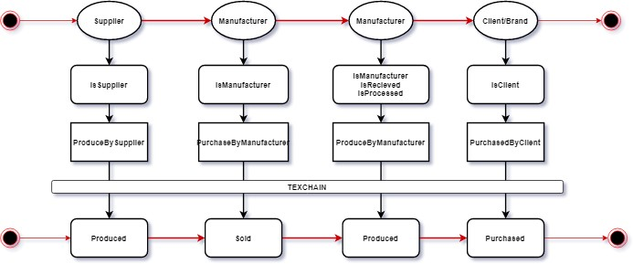

*Figure-5.1 State Transition Diagram*

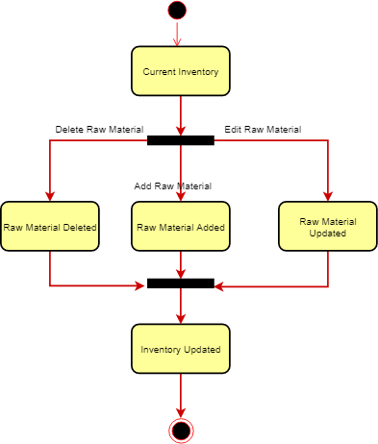

*Figure-5.2 Supplier Inventory Updated State Diagram*

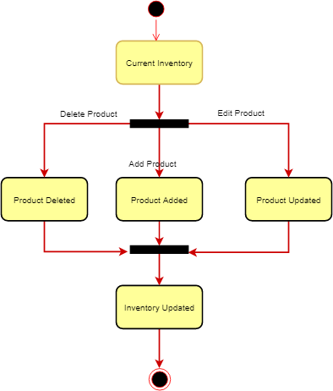

*Figure-5.3 Manufacturer Inventory Updated State Diagram*

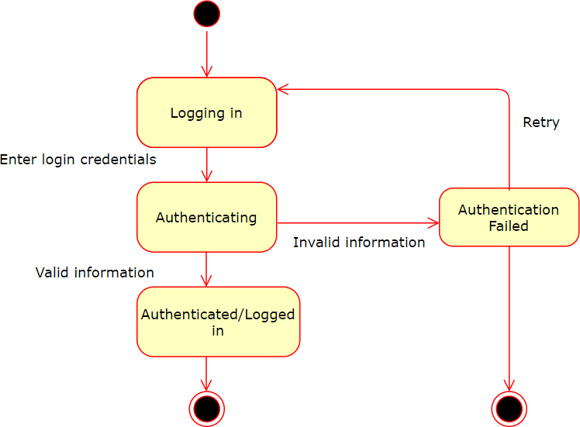

*Figure-5.4 Authenticated State Diagram*

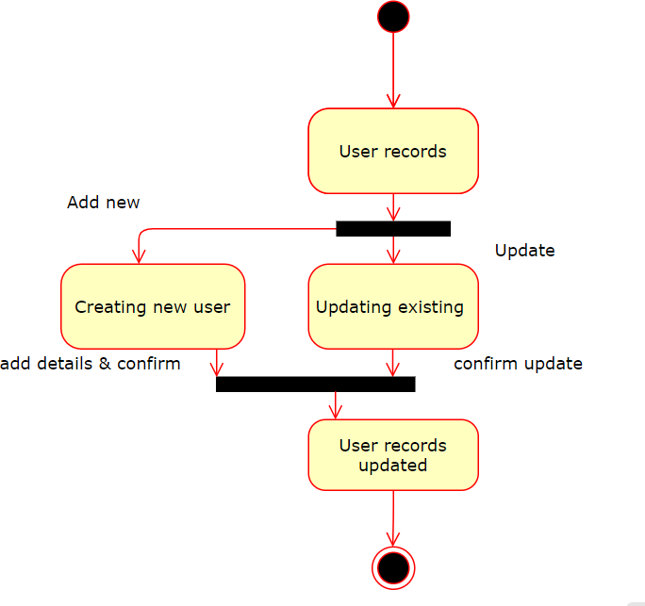

*Figure-5.5 User records Updated State Diagram*

## Control specifications

##### Control specifications for Brand:

System controls starts with placing order event, where it is transferred to order placed state, which will be received by manufacturer. When user triggers authentication events, control is transferred to registered, authenticated or failed state based on validity of credentials.

Scanning QR Code shifts control to authenticated or unauthenticated item states by passing through supply chain back tracking state.

##### Control specifications for Supplier:

When supplier triggers authenticating event, control is transferred to either authenticated or

failed state based on validity of the entered credentials.

Once logged in, supplier can trigger events of add, edit or delete items, which changes the state of current inventory to the supplier inventory updated state. They will also trigger the event of manage order request, control is transferred to either order fulfilled or pending state.

##### Control specifications for Manufacturer:

When manufacturer triggers authenticating event, control is transferred to either authenticated or failed state based on validity of credentials.

Once logged in, manufacturer can trigger events of add, edit or delete on products which changes the state of current records to the updated inventory state. They will also trigger the event of manage brand request, control is transferred to either order fulfilled or pending state.

Scanning QR Code shifts control to authenticated or unauthenticated product states by passing through supply chain back tracking state.

##### Control specifications for Admin:

On triggers authenticating event, control is transferred to authenticated or failed state.

Once logged in, admin can trigger events of add, edit or delete on users and company profile information which changes the state of current records to the updated state.

# CHAPTER 6 - SYSTEM PROTOTYPE MODELING

## Description of System Modeling Approach

We have developed different abstract models to present different views or perspective of the system. We have represented the system modeling using graphical notations (in the form of UML diagrams in the previous chapters’ i.e use-case diagrams, data flow diagrams, state-transition diagrams). This approach is used to get a basic understanding of the system behavior and interaction. System modeling approach has helped us to understand the functionality of the system.

## Prototyping Requirements

In the initial stage our project, we build a prototype of our web application. The prototype developed had the implementation of basic requirements of our application including modules of suppliers, manufacturers, brands and admin, sign in module for users, inventory management and stock management and product tracking through QR code.

Based on this prototype, we refined the requirements, improved our design and enhanced the implementation. Continuing the same flow, we eventually developed our finally application.

Our protype can be depicted by looking at the screenshots attached below.

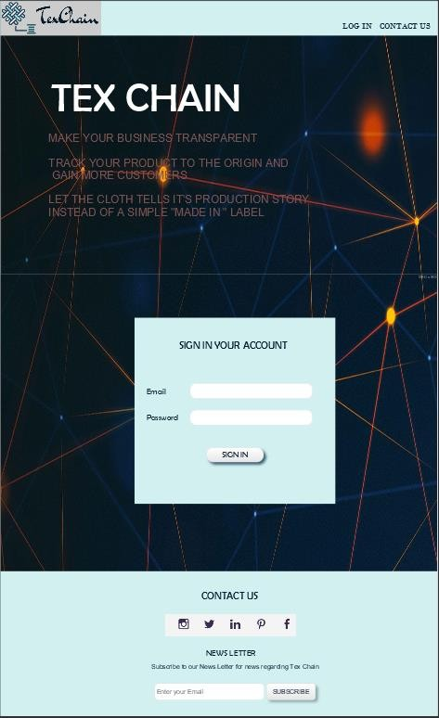

*Figure 6.1-Main Sign in Page*

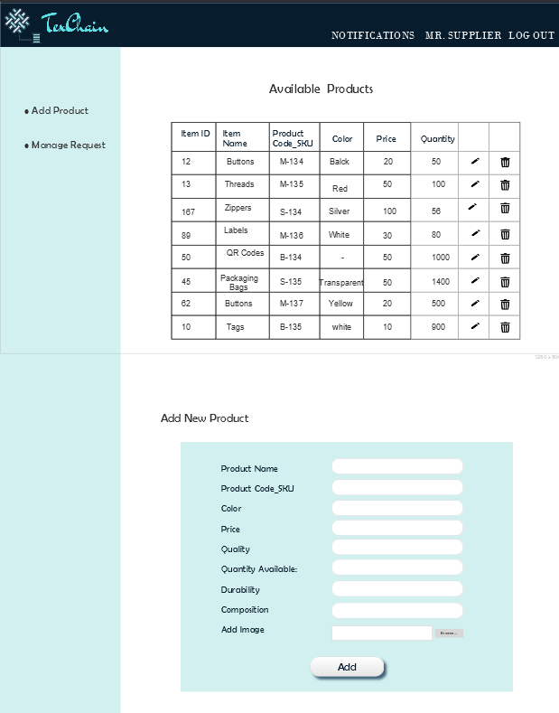

*Figure 6.2-Supplier Inventory*

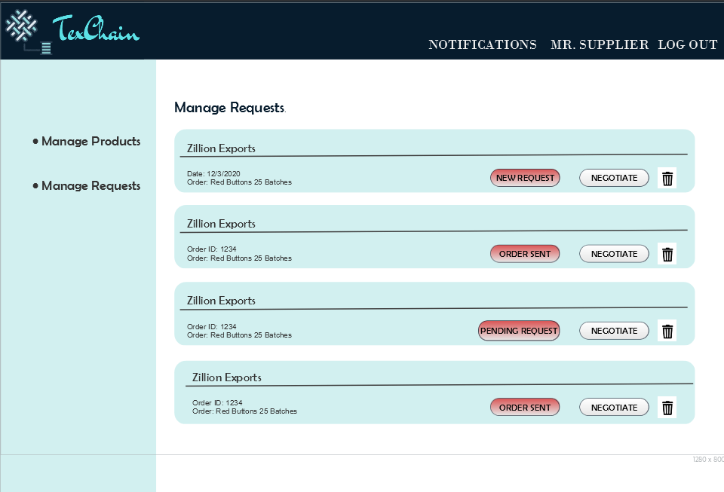

*Figure 6.3-Supplier Request*

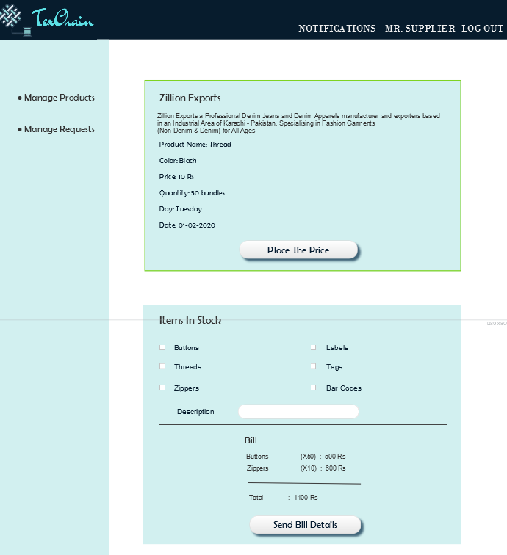

*Figure 6.4-Supplier Negotiate*

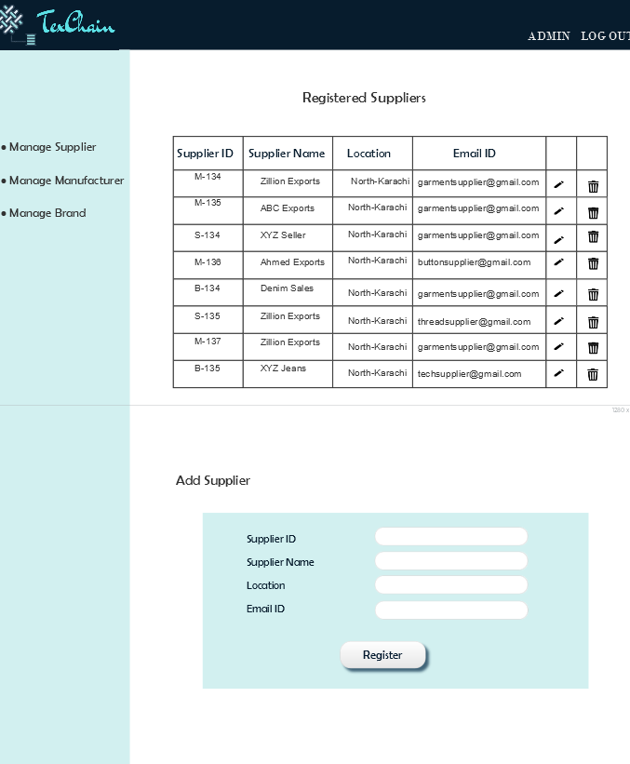

*Figure 6.5-Admin –Manage Supplier*

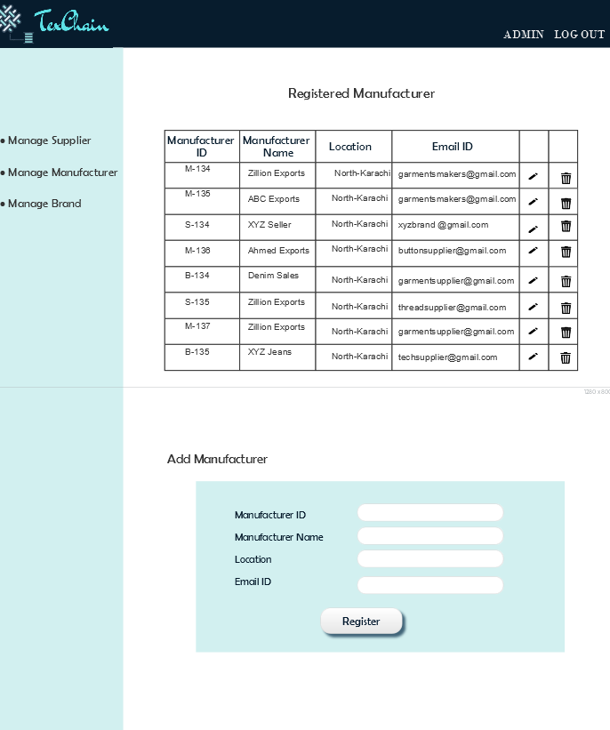

*Figure 6.6-Admin –Manage Manufacturer*

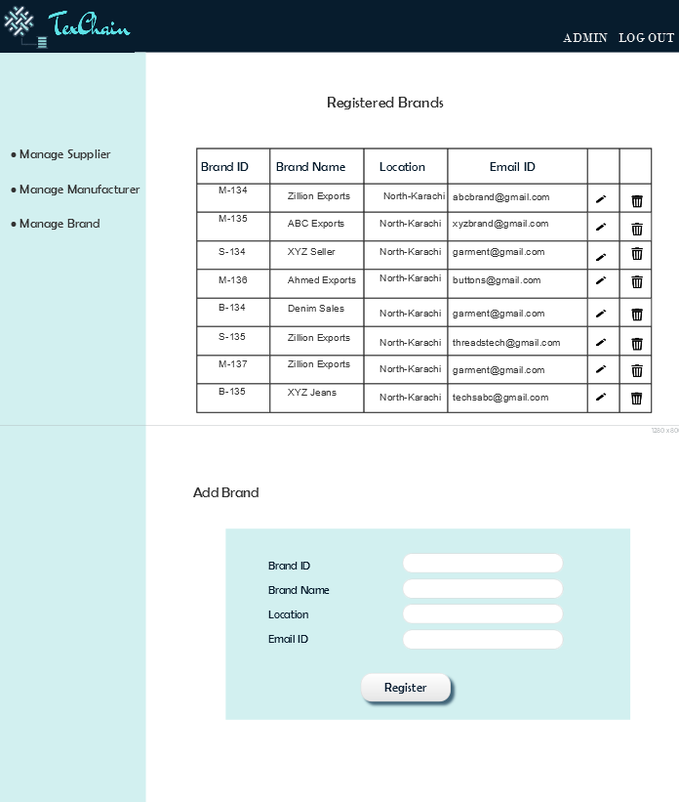

*Figure 6.7-Admin –Manage Brand*

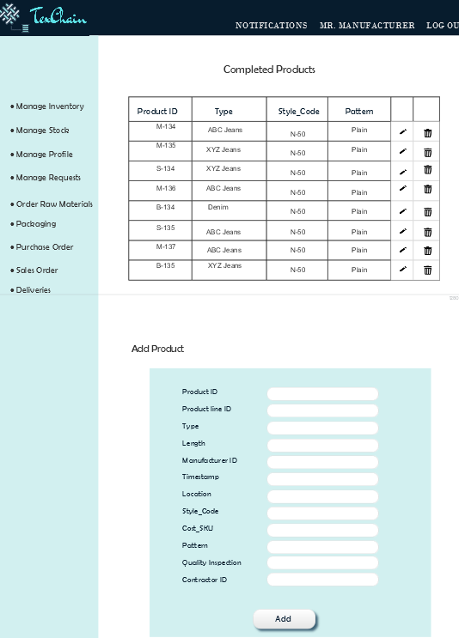

*Figure 6.8-Manufacturer Inventory*

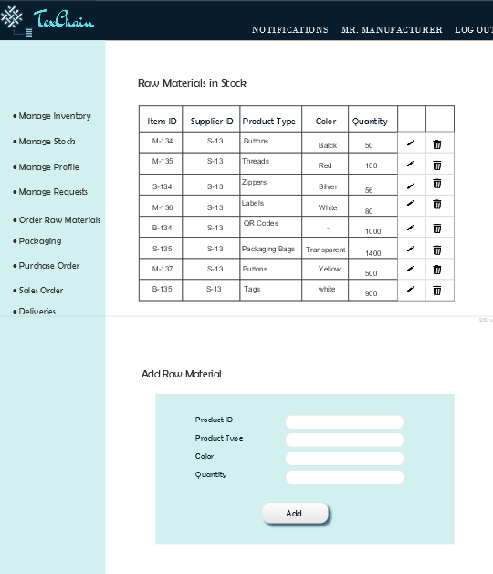

*Figure 6.9-Manufacturer Stock*

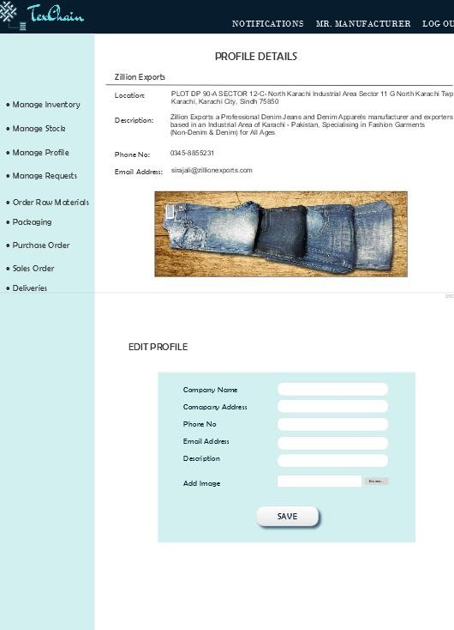

*Figure 6.10-Manufacturer Profile*

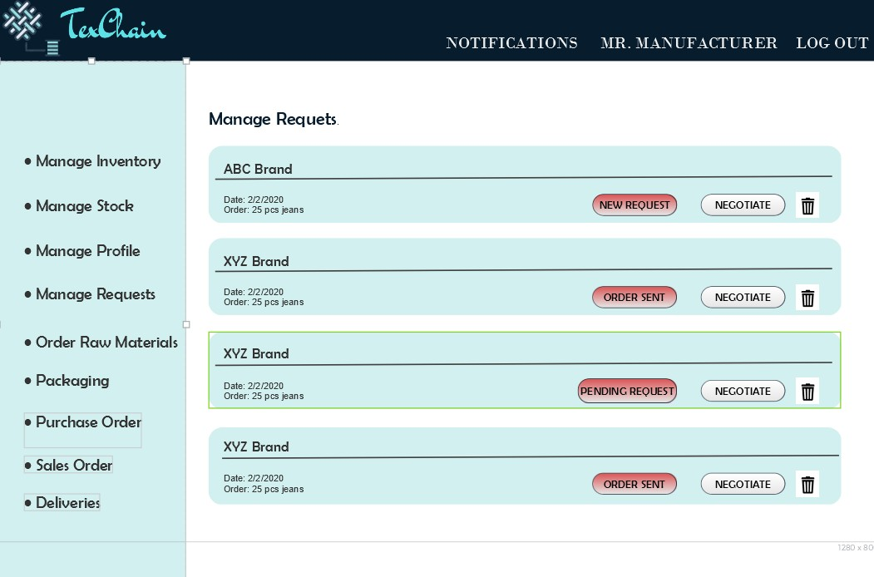

*Figure 6.11-Manufacturer Requests*

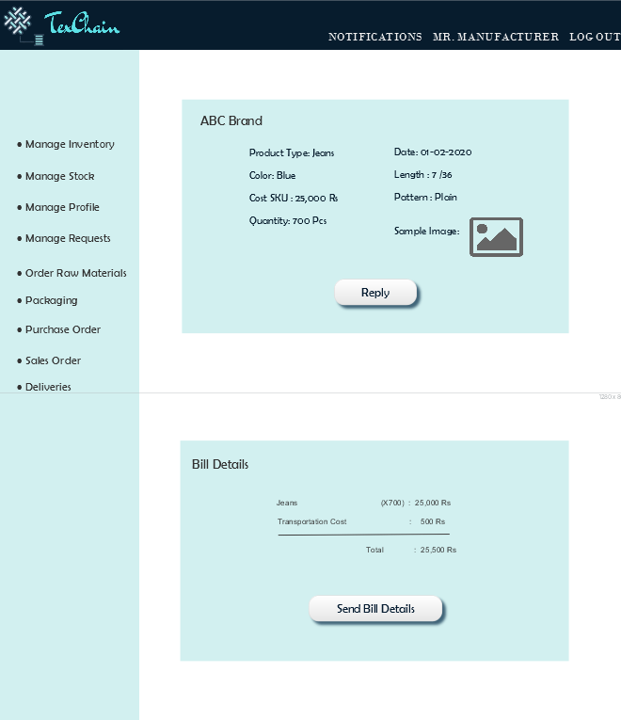

*Figure 6.12-Manufacturer Negotiate*

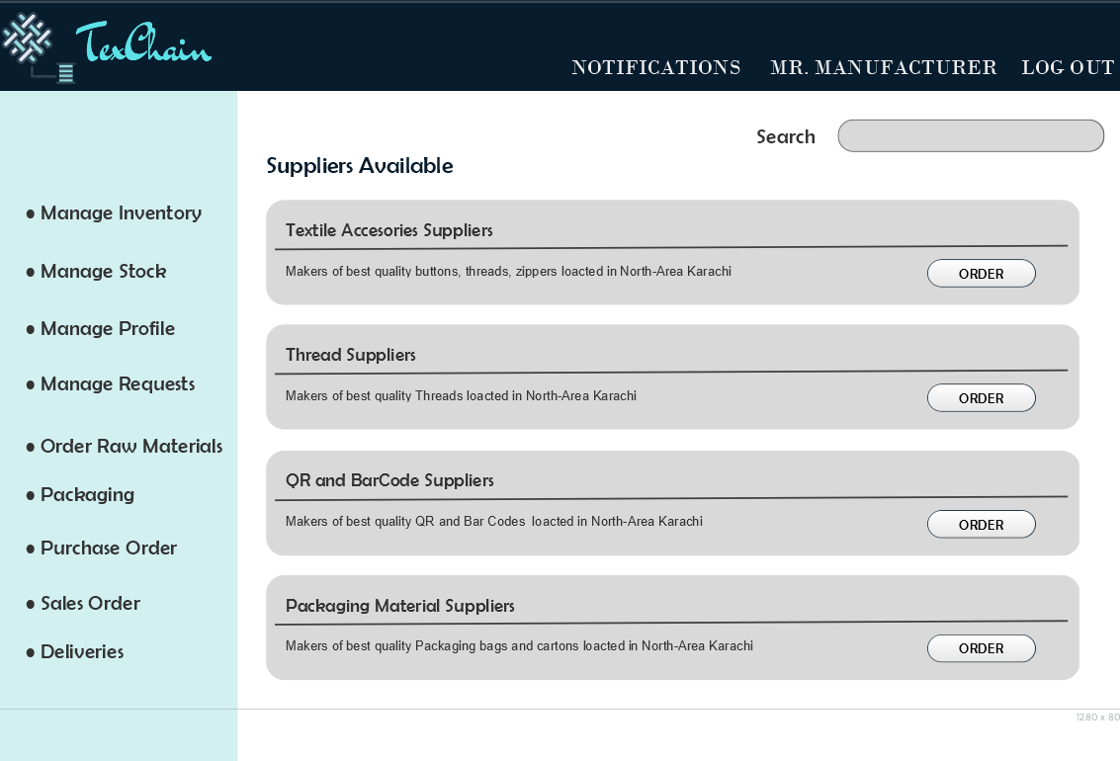

*Figure 6.13-Manufacturer Search Supplier*

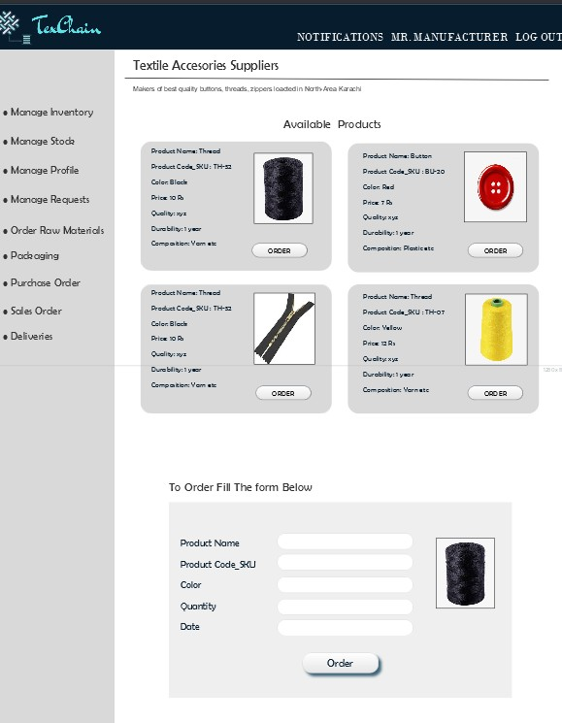

*Figure 6.14-Manufacturer Order Raw Material*

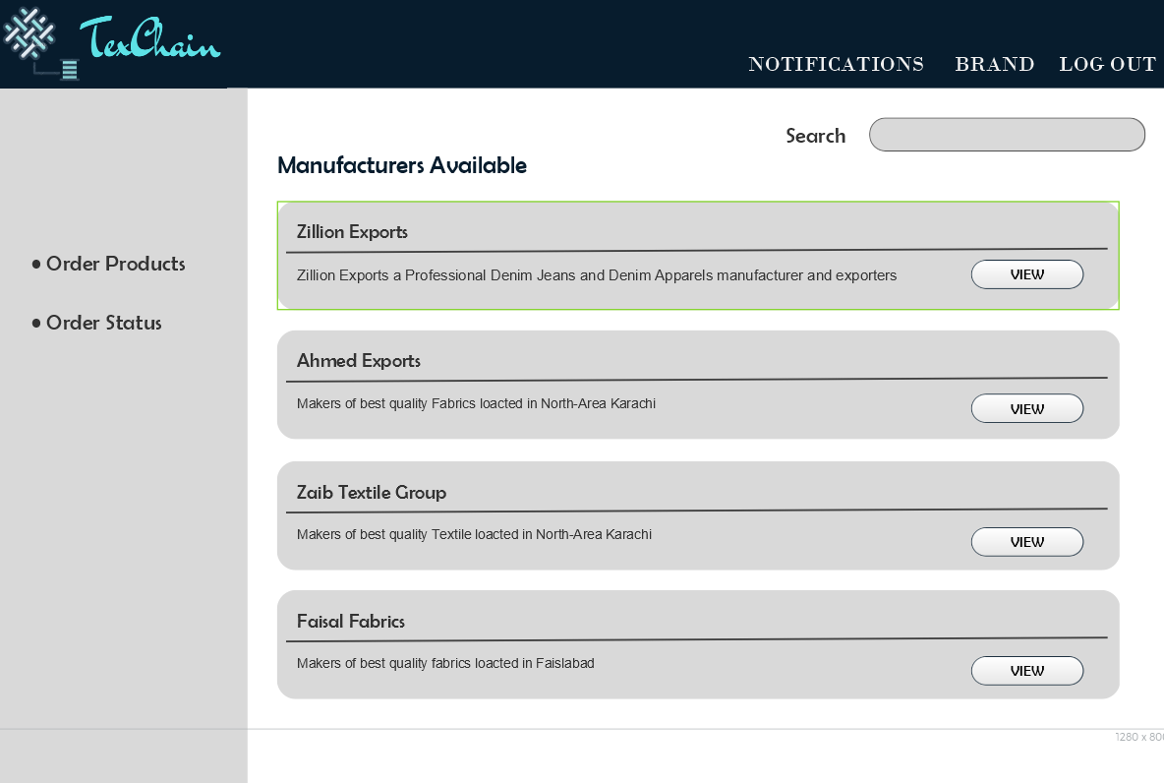

*Figure 6.15-Brand Panel*

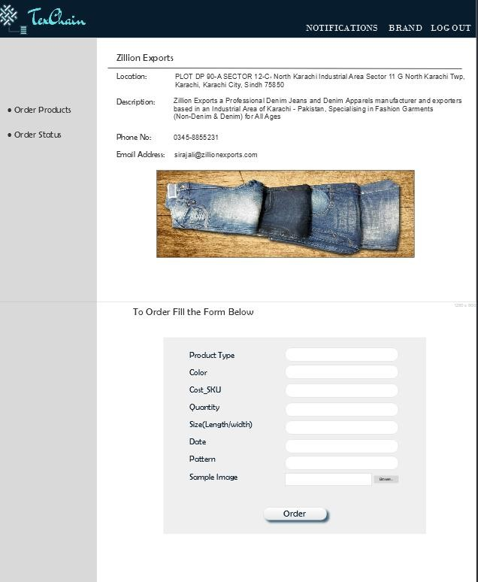

*Figure 6.16-Place Order*

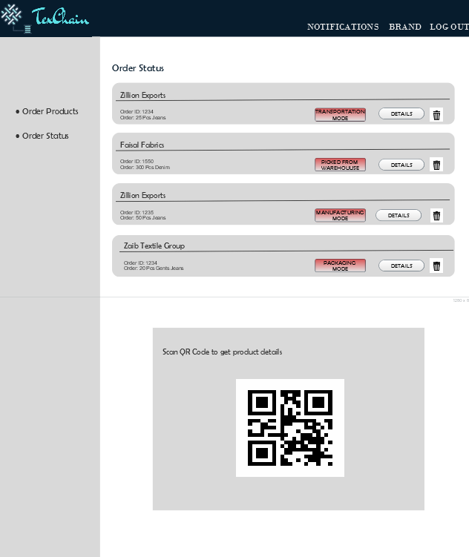

*Figure 6.17-Order Status*

# CHAPTER 7 - SYSTEM ESTIMATES AND ACTUAL OUTCOMES

## System Estimates and Actual Outcomes

This section provides the cost estimates of our application TexChain.

##### Historical Data used for estimates

***Estimation based on COCOMO II***

The COCOMO (Constructive Cost Model) is one among the foremost popularly used software cost estimation models i.e. it estimates or predicts the efforts required for the project, total project cost and scheduled time for the project. COCOMO model estimates efforts based on the number of lines of code. Program size is expressed in estimated thousands of source lines of code (SLOC or KSLOC).

Effort and Schedule are the key parameters that define the quality of software project.

**Effort**: Amount of labor that will be required to complete a things. It is measured in person-months units.

**Schedule**: Simply means the amount of time required for the completion of the job, which is, of course, proportional to the effort put.

***Modes of COCOMOII***

COCOMO-II can be applied to the three classes of software project and any of these three forms can be adapted according to the requirements. The hierarchy of these increasingly detailed and accurate modes can be given as:

* + - Organic projects
    - Semi-detached projects
    - Embedded projects

**Organic Projects** – A software project is said to be an organic type if the team size required is adequately small with good team experience working with less than rigid requirements, the problem is well understood and the deadline is not tight.

**Semi-detached Projects** – A software project is said to be a semi-detached type if the team size required is more than that of organic type. These are "medium" teams with mixed experience working with a mixture of rigid and fewer than rigid requirements. The projects classified as Semi- Detached are difficult to develop.

**Embedded Projects** – It is a combination of organic and semi-detached projects. Such software projects requires a bigger team size than the opposite two models and also the developers got to be sufficiently experienced and artistic to develop such complex models.

Our project TexChain’s estimated cost of COCOMO equation may take the form below:

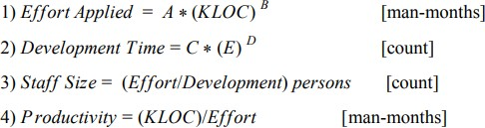

*Table-02 Estimated Costs*

Where, KLOC is defined as the estimated number of delivered lines (expressed in thousands) of code for project. The values of the coefficients A, B, C and D for the organic, semi-detached and embedded projects are given in the following table:

|  |  |  |  |  |
| --- | --- | --- | --- | --- |
| **Software Project** | **A** | **B** | **C** | **D** |
| **Organic** | 2.4 | 1.05 | 2.5 | 0.38 |
| **Semi-detached** | 3.0 | 1.12 | 2.5 | 0.35 |

*Table-03 Values of COCOMO Coefficients*

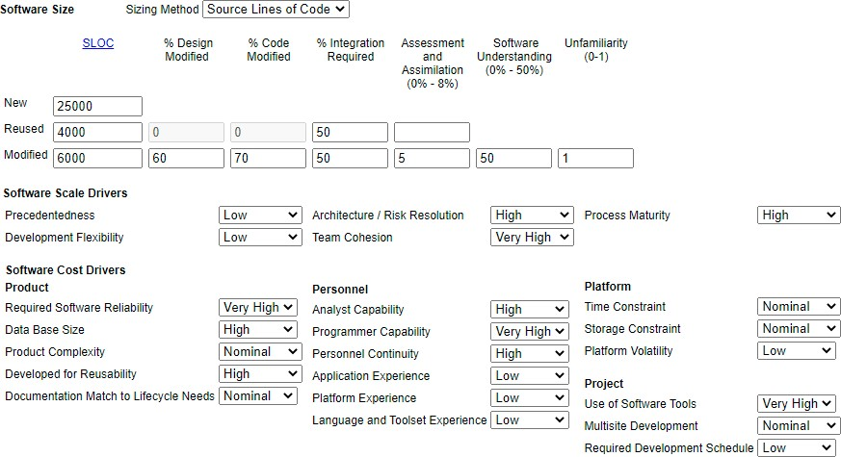

*Figure-7.1 COCOMO Estimation*

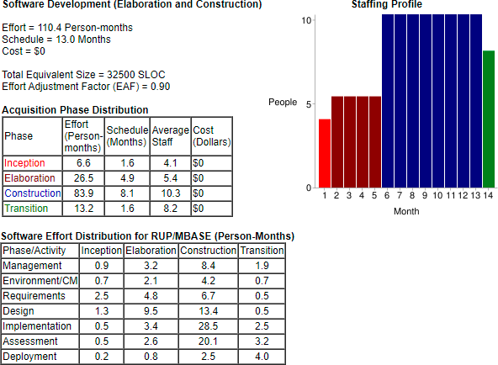

*Figure-7.2 COCOMO Estimation Results*

## Actual Results and Deviation from Estimates

The final cost for the project (at this point in time) is presented here. A deviation chart has been presented to illustrate the comparison between actual cost of TexChain and estimated cost of the TexChain via COCOMOII.

The estimates mentioned above are generated considering the ideal scenario but as the scope of our project is limited so there is a huge variation in the results as compared to the estimated results.

## System Resources (Required and Used)

People, hardware, software, tools, and other resources proposed to build the software are discussed in this section. On the basis of which cost estimations were performed.

##### Man-force Required and Used

5 to 6 members were required for this project each for the front-end development of web app and web-panel, back-end development of admin panels and blockchain integration, testing or quality assurance of project and reporting/documentation. The work would have distributed in the following manner if the required individuals would have been there:

|  |  |
| --- | --- |
| ***Developer*** | ***Work Description*** |
| *Developer 1* | Front-end Developer of Mobile application. |
| *Developer 2* | Back-end Developer of Mobile application. |
| *Developer 3* | UI/UX Designer |
| *Developer 4* | Blockchain Developer |
| *Developer 5* | Tester/ Quality Assurance Analyst |
| *Developer 6* | Reporting or documentation. |

*Table 04- Man-force Required*

Instead of 6 developers, the system was developed by only two individuals.

##### Hardware Required and Used

To develop TexChain system, following hardware were required and used.

|  |  |
| --- | --- |
| *Hardware Resource* | *Description* |
| *Device* | PC/Laptop |
| *Operating System* | Windows 8, Windows 10 |
| *Processor* | Core i5 4200U, 1.60 GHz, 2.30 GHz |
| *Memory* | 4GB , 8GB |
| *Wifi/ Internet* | Good Speed |

*Table 05- Hardware Required and Used*

##### Software/Tools Required and Used

To develop TexChain system, following software/tools were required and used.

|  |  |
| --- | --- |
| *Software Resources* | *Description* |
| *Code Editor* | VS Code, Remix IDE |
| *Database* | MS SQL WORKBENCH |
| *Testing Tool* | Postman for API Testing |
| *Version Control System* | Git |
| *Graphical Tools* | Draw.io, Lucid Chart |
| *Blockchain Node* | Infura |
| *Blockchain Testnet* | Rinkeby Network |
|  |  |

*Table 06- Software/Tools Required and Used*

# CHAPTER 8 - TEST PLAN

This section describes the overall testing strategy and issues that are required to properly execute effective tests.

Testing is a critical phase in a software’s life cycle. A software System is tested in parallel to development and continued to be tested after development and even after deployment system. Therefore, a proper planning has to be done before actually starting the testing the system Testing is done to ensure the quality of a software by constructing a proper test plan and following it in an organized, efficient and timely manner. Testing enables to identify bugs of higher priorities so that they can be removed and fixed before deploying the software.

A test plan is documented with scope, aims and objective of a software. It contains description of testing approaches, strategies and techniques to be followed and estimates for cost and schedule of testing and the related risks.

A testing procedure consists of the following phases:

* + - * Requirement analysis
      * Test planning
      * Test case preparation
      * Test environment Setup
      * Test case execution
      * Test closure

## System Test and Procedure

This system describes the overall testing procedure of our software application. We performed testing in the phases mentioned below:

* + - The requirements were analyzed in order to get an idea about conflicting, missing and ambiguous requirements and possible testcases were identified.
    - GUI of our application was reviewed to test user interface and user experience in terms of ease of use and robustness.
    - The login and authentication functionalities were tested so that users can register on our application without facing any trouble and all types of users (manufacturer, supplier, brand and admin) can login to the application by entering valid credentials.
    - Management of products, inventory of supplier’s raw material , manufacturer’s stock and client's modules were tested for CRUD operations. API testing and testing through front- end forms were done.
    - Search functionality was tested to ensure results were being generated
    - Database was tested if create, update or deleting operations on the data were being saved correctly in a consistent manner in the database and required data fetching with least delay time possible.
    - Testing of all other features was done.

## Testing Strategy

The overall strategy for software testing is described.

The testing strategy of our application followed three levels of testing which are as follows: Unit Testing

Integration Testing System Testing

##### Unit Testing

The strategy and brief procedure for unit tested is described.

A software application is tested on unit level during the implementation or development phase i.e. in parallel to coding. Each unit of code is tested separately to verify proper functioning. Both manual and automated testing is done at this level.

Unit under the test, is executed to check if variables are storing and returning correct required values or not to ensure producing of a desired output

In our application ‘TexChain’, we have performed the unit testing in the similar manner. We have tested the different modules as described below:

* + - 1. Log in Module:

We started testing with this module. Login module was tested to ensure validations working properly on form fields and user is getting logged in on providing valid information. And, finally the logged in user is getting stored into our database with password stored as hash.

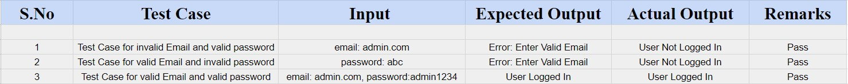

*Table 8.1- Login test Case*

* + - 1. Authentication Module:

Authentication module was tested to ensure that the user is successfully logged into the system on providing valid credentials. On entering one or both of the fields (email and password) incorrect user is not logged in. It was tested that user has option to retry the process.



*Table 8.2- Authentication Module test Case*

* + - 1. Inventory Management:

Inventory Management was tested using both API testing and front-end forms to verify the basic CRUD operations were being performed successfully and products created or updated were stored in the database. Similarly, on deleting products, it was removed from the database and correct data was retrieved for viewing.



*Table 8.3- Inventory Management test Case*

* + - 1. Stock Management:
      2. In the similar manner as inventory management, stock management was tested to verify the basic functionalities for adding new raw materials into supplier inventory, updating the quantity and deleting the record with consistency maintained in the database.

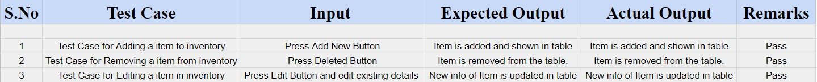

*Table 8.4- Stock Management test Case*

* + - 1. Searching Functionality:

Search module was tested to ensure a product, item, request or any kind of data that is represented in the tables are searched and the searched data is displayed instead of all records. in results were same.

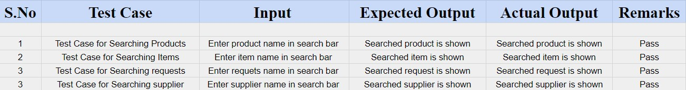

*Table 8.5- Search functionality test case*

* + - 1. Order Placement Module:

This module was tested to verify on placing order of products from brands side and also order of raw material from manufacturer side. Order is created with status set to ‘pending’ and it was listed in Sales Order with its status.



*Table 8.6- Order Placement test case*

* + - 1. Blockchain module:

It was checked that blockchain transactions are created for the required actions like accepting incoming order or creating delivery.

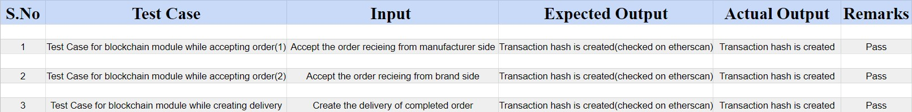

*Table 8.7- Block Chain test case*

* + - 1. Sales/Purchase Order:

These were tested to verify on placing order, order is created with status set to ‘pending’, assigned to the receiver and order history is maintained.



*Table 8.8- Sales/Purchase Order test case*

* + - 1. QR Code Scan

It was tested that brand and manufacturer were able to scan QR Code from their dashboards and system was able to read it and the whole chain has to be presented to them.



*Table 8.9- QR code scan test case*

* + - 1. Product/Items Authentication from Supply Chain:

Movement of supply chain of the product and items are tracked for the authentic QR Code. If QR Code is not genuine, system displays the product and items is unauthentic. This behavior was tested.

* + - 1. Admin Dashboard:

Admin dashboard was tested for its functionalities.

* + - 1. Supplier Dashboard:

Supplier dashboard was tested for its functionalities.

* + - 1. Manufacturer Dashboard:

Manufacturer dashboard was tested for its functionalities.

* + - 1. Brand Dashboard:

Brand dashboard was tested for its functionalities.

* + - 1. User Creation Module:

It was tested that users (supplier, manufacturer, brand, admin) are created on system and synced to the database on providing valid information.

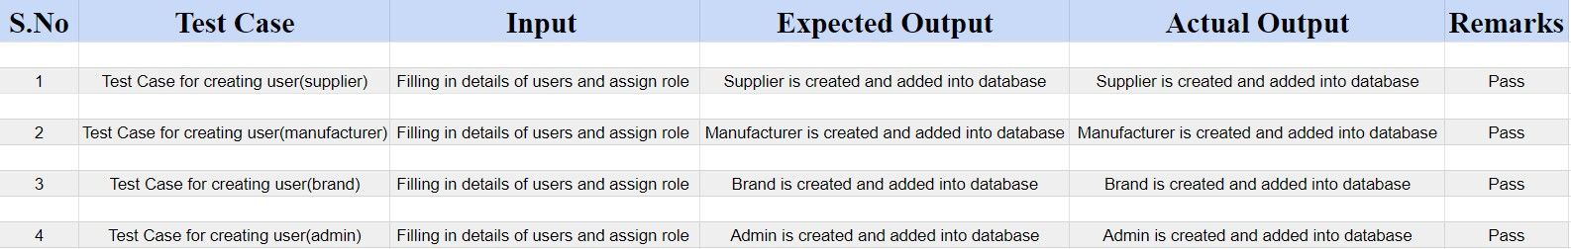

*Table 8.10- User creation Module test case*

* + - 1. Manage Users module:

Functionalities of updating admin users’ information deleting admin users were tested.

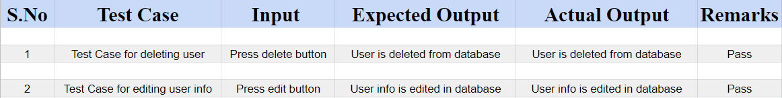

*Table 8.11- Manage User Module test case*

* + - 1. Front-end Module (Web pages and components):

Front end forms were tested for UI and reading correct input from the user. Navigation among the pages were tested. Responsiveness of the application was tested.

Buttons, clickable icons and dialogues were also tested to be functional.

##### Integration Testing

Integration testing is done after unit testing when all or few units are integrated. A technique out of three major techniques for Integration testing can be opted. Bottom up, Top-down or hybrid are followed.

If units are working correctly individually, they might not continue to do so when combined with the other modules of the system. To ensure the correct behavior, modules who are directly related in terms of navigation or dependency for data or actions are integrated to combine and then tested. For integration testing of our application, we also combined unit or modules and integrated them to check correct behavior.

We integrated authentication module with the homepage to validate that on entering correct credentials and logging in, user lands on their respective dashboards.

For supply chain related modules, we validated that on performing actions such as Creation of sales/ purchase order or transfer of stocks transactions are actually created on our blockchain.

Integration testing was done for all type of orders and notification generation to verify that on placing order, respective receivers got to know on their homepage.

Integration of QR Code Scanned by user with blockchain was done to test that the code scanned by user is read successfully and then back-tracked on blockchain to display movements of supply chain.

##### Validation Testing

Validation testing is performed to compare expected and actual results. It is performed hand in hand with development as well as after completion of the project to ensure the output generating is as per the specified or expected behaviour.

It validates that the product offers what it actually intended to.

We have done validation testing during the development for data retrieving operations of our modules. We performed it again once our application was built completely and deployed.

##### High-order Testing (System Testing)

Software is tested on system level to ensure the correct as a whole system as per the requirements specifications (SRS). It is a black box testing where user is unaware of internal details and just test the system for functionalities specified in user requirements.

When performing system testing, we traced the outputs to the business requirements we have defined earlier. It included the testing for the following aspects:

* Major services that are provided to the users (Add products/Items, Place order, verifying product/item by QR code scan and supply chain management).
* Actual outputs are same as desired for a particular input.
* User experience of our application, aesthetic interface and ease in understanding of use.
* Validation on form fields.
* Confirmation messages for each action performed.
  + - 1. Security Testing

Security is a type of testing done to ensure there is no point of breaching into the application. Avoiding unauthorized access to crucial data or breaking into the transactions being done on the system.

It’s never a good idea to leave an application untested for backdoor entry points.

To achieve security in our system, we implemented JWT Authentication in our application. JSON Web Tokens (JWT’s) are used for authorization of users. JWT is an open standard (RFC 7519) that provides a secure method of transmitting data and information between parties as a JSON object. Authentication was tested as per the tokens created.

In-order to protect the user credentials we store user passwords using a one-way cryptographic hash function. If, in case, a hacker is able to hack our database, the person can never get hold of the user credentials because it is impossible to reverse a one-way hash. We tested the hashing implementation to make sure it is working as desired.

* + - 1. Stress Testing

Stress testing was done for load of number of transactions on blockchain. It was also done for uploading data in bulk of products or users' data on the system. It was also done by creating so many orders.

## Testing Resources and Staffing

As such no extra resources were required such as staff. Team members were sufficient to complete the process of testing.

## Test Metrics

In software testing, Metric is a quantitative measure of the degree to which a system, system component, or process possesses a given attribute. In other words, metrics helps estimating the progress, quality and health of a software testing effort.

Following modules of our application are evaluated using standard metrics:

* Authentication Module
* Login Module
* User Creation Module
* Inventory Management
* Stock Management
* Searching functionality
* Order placement module
* Block chain Module
* Sales/Purchase Order Module
* QR Code Scan
* Product/Items Authentication from Supply Chain
* Admin Dashboard
* Supplier Dashboard
* Manufacturer Dashboard
* Brand Dashboard
* User Creation Module
* Manage User module
* Front-end Module (Web pages and components)

## Testing Tools and Environment

Ample of resources/tools are available for manual and automated testing both. For manual testing of REST APIs, we have used Postman, a well-known tool for API creation, management and testing.

Along with this, we manually tested our application and have wrote test cases of the tests performed.

# CHAPTER 9 - FUTURE ENHANCEMENTS AND RECOMMENDATIONS

We have depicted acute diligence in delivering our proposed system functionalities and features. We covered the highlighting features of our application that is to solve the problem of lack of transparency and authenticity in textile supply chain through blockchain technology. We have been successful in deploying the solution to the core problems and are now looking forward to implementing the advancements and improving the user experience and underlying software efficiency.

Right now, we are focusing on three main entities i.e., Supplier, manufacturer and brand. In future we would like to bring some more entities like retailers, distributors, logistics etc., to track the product to the finest level. We would work more to ensure more security. When our application would successfully pass the competence of short scale firms, we would try to bring our product to a bigger market i.e., large scale firms.

Furthermore, AI and Data Analytics can be employed to provide users with better notifications and data-oriented decision making. This can help bridge the gap between the supply and demand of the products and raw materials.

# CHAPTER 10 - CONCLUSION

The main purpose and motivation of this project was to introduce a game changing technology of blockchain in solving the persistent problem of lack of authenticity, transparency and lack of proper mechanisms of authenticating the supply chain of the purchased textile products. The prime focus is to make the textile industry supply chain transparent for both the brands and manufacturers by developing a platform for Textile industries where the manufacturer will have complete transparency as to from where the raw material enters the whole system. It will cover the origin of raw material entering the whole system through the supplier to ensure the quality as to what is claimed by the supplier. It will not only help the manufacturer in buying the material from the supplier through a transparent and a traceable process but also the brands who buy the product from the manufacturers. The manufacturer will also be able to keep track of its stock.

The challenges encountered were that of choosing the right technology stack for developing such a critical, reliability focused and efficient software system. The recommended technology stack that we employed is quite complex and we had no grasp of it until the start of our project. It was a crucial learning experience and we managed to mitigate all the risks associated with it.

We developed a user-friendly application that a brand can give order to manufacturer and can track their product to its origin. Similarly, manufacturers while ordering raw materials from suppliers can track the whole details and status of this purchased item. This functionality is implemented through QR code scan via blockchain smart contracts. The application provides a user-friendly interface for performing all the activities by different users in a secured manner. On the other hand, our system provides complete audit and order details for the regulatory authorities for transparency and quality control which serves our purpose.

#### APPENDICES

* 1. **Project Schedule**

This section gives the overview of project schedule, project milestones, task distribution and the output of project scheduling tool for our application TEXCHAIN.

Timeline Chart/ Gantt Chart

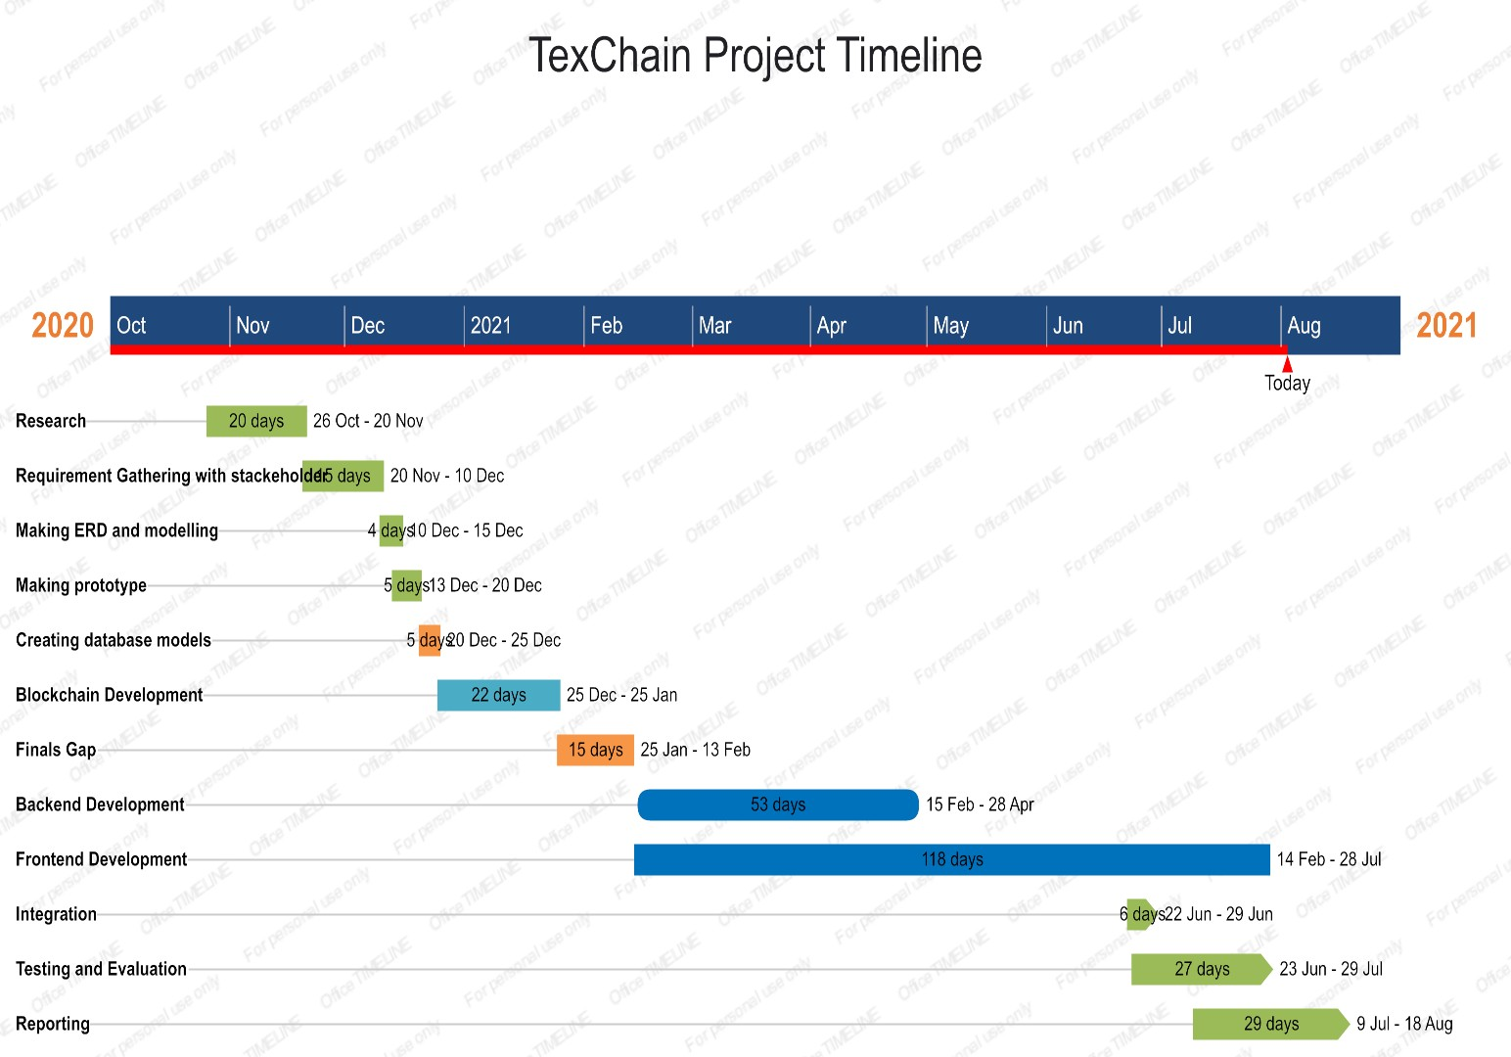

*Figure 45 Gantt Chart of TexChain Application*

Project Group Organization / Workload Distribution

We had two members in our project so we divided our work evenly so that all the members get equal chance to learn and explore things. The division between members was as following:

|  |  |
| --- | --- |
| TEAM MEMBER | WORK ASSIGNED |
| Javeria Zafar | Blockchain architecture designing Smart Contract development Block chain integration  Backend architecture designing Database designing  System integration Backend development  API development and testing Research & Meetings  Report Writing |
| Maryam Nadeem | Front-end architecture designing Front-end development  Secure Authentication implementation Front-end integration  System integration  API development and testing Application Testing Research & Meetings  Report Writing |

#### Working Session/ Snapshots of Deployed System

Below attached are the screenshots of TEXCHAIN running application.



*Brand Panel*



*Profile page*



*Brand sales orders*



*QR Code*



*Scanner*



*Manufacturer panel*



*Add New Product*



*Delete Product*



*Manage stock*



*Edit Quantity*



*Manufacturer Profile Page*



*Brand Request*



*Negotiate Request*



*Order Raw Material*



*Place Order Tab*



*Order Details*



*Sales Order*



*Supplier Delivery Status*



*Supplier Delivery Status QR Code*



*QR Code Scanner page*



*Supplier’s Panel*



*Add New Item*



*Manufacturer’s request*



Check Inventory



*Sales Order*



*Main Sign in Page*



*Admin Panel*

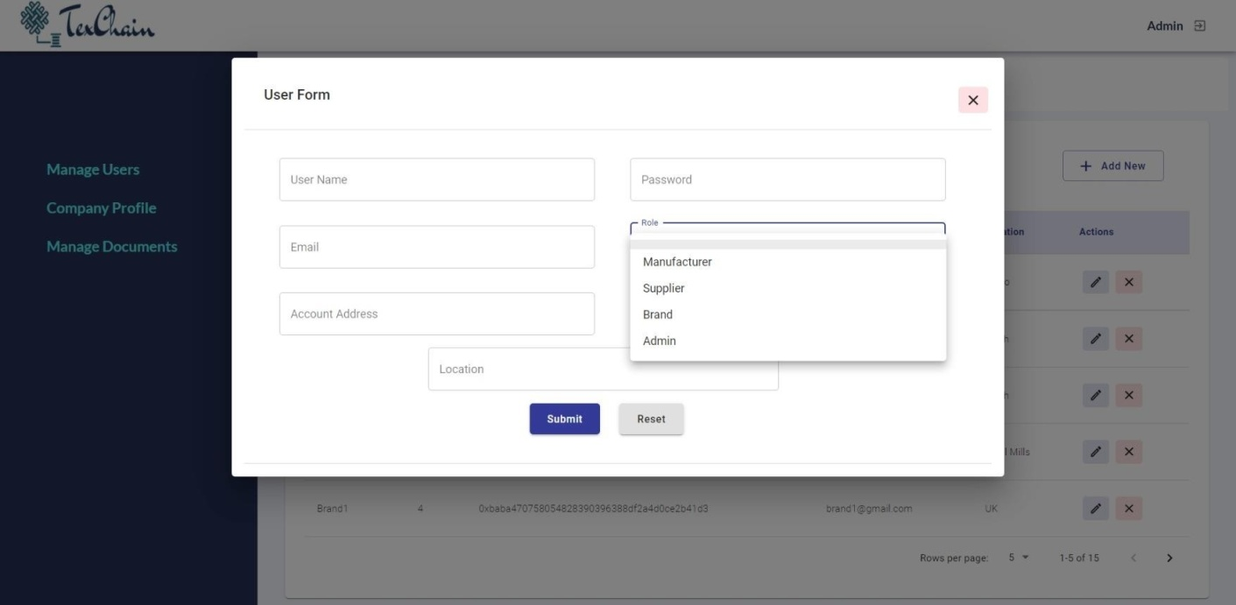

*Adding New User*